LESSON PLAN FOR EMPIRES OF THE WIND NEH WORKSHOP

“GETTING FROM HERE TO THERE”

by Kevin Glynn, Los Angeles Senior High School

Introduction: Of all the various lectures and notes that I heard during the workshop, the one that struck me as having the most potential for a lesson plan was the one regarding the use of maps as emblematic of “wishful thinking” by would-be medieval and Renaissance explorers who expressed their agendas, by design or subconsciously, on their cartographic works. Since I teach World History for 10 grade, there is a component and state standard dealing with the Age of Exploration. Since my class is chiefly comprised of “urban inner-city kids” with little apparent sense of geography beyond that of their own neighborhoods, I’d like to challenge them to come up with their own “mental maps” of how to “get from here to there.”

Materials: Colored markers, large white sheets of paper for map making, rulers for constructing scales, scissors, and old National Geographic magazines for pictures.
Time: About two weeks to discuss associated readings and complete the maps. Thee will be an assessment after the completion of the unit.

Procedure: Divide the class into groups of four or five students. Each group will choose a name based on great navigators and discoverers such as Columbus, Magellan, Drake, Cook, Malaspina, and Cabrillo.
2. Just as the desire to reach the riches of the Indies was the inspirational driving force for the Age of Discovery, so too will be the “riches of Los Angeles” for these groups of students. Students will brainstorm the best attractions of “their world” such as: theme parks, beaches, malls, pizzerias, ballparks, hamburger stands, movie theatres, “where the girls are,” “where the boys are,” etc., etc.
3. Having agreed upon a minimum of ten destinations, each group will then construct a “t-map” such as the medieval example previously discussed during the workshop, which will show their school as “ the center of the world” with arrows indicating the direction and distance to the desired destination. They will then illustrate the wonders of these destinations with pictures, drawing, captions, etc.
4. Students will then write “sailing directions” on how to get to these particular destinations, whether they are walking, driving, or taking the bus. Directions must be as specific as possible so that someone who did not know otherwise “how to get to Magic Mountain” for an afternoon of roller coaster fun, could, with the help of the “sailing directions” know how to best get there (obviously, not by walking as it is too far from the school). They will also have to figure out how to get back home.
5. Having identified their destinations and depicted their attractions, students will then discuss and depict the hazards and dangers of those things that stand between the traveler and his destination. Those things could be gangs, police, highway patrol, traffic jams, or unknown neighborhoods and “strange people.” If, for example, a Spanish-speaking student wanted to go to Little Tokyo to buy some anime manga comic books or eat uni sushi, what might be some key Japanese phrases necessary to complete the transaction?

Display and consolidation: After completion of the groups maps, the various maps will be displayed in the classroom for examination and critical evaluation by the students. Students can write on and critique each destination and associated direction and propose “ a better way” if they believe they have one. They can also add to the “pool of knowledge” about a particular destination such as suggesting a better bus number and time to get to a particular destination or “who to talk to” once your there for better service. Once the maps are evaluated by other students, then the class will, with the teacher in the lead, construct a single class map, which will best direct students to their preferred destinations. Maps will then be printed out and distributed.

Discovery: For extra credit, students will then, on their own free time, use the maps to “voyage out” to a destination. They must bring back some proof that they indeed had arrived at some place, such as a menu, or ticket, or photograph from their smart phone.
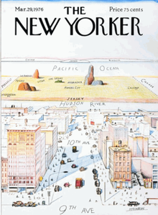
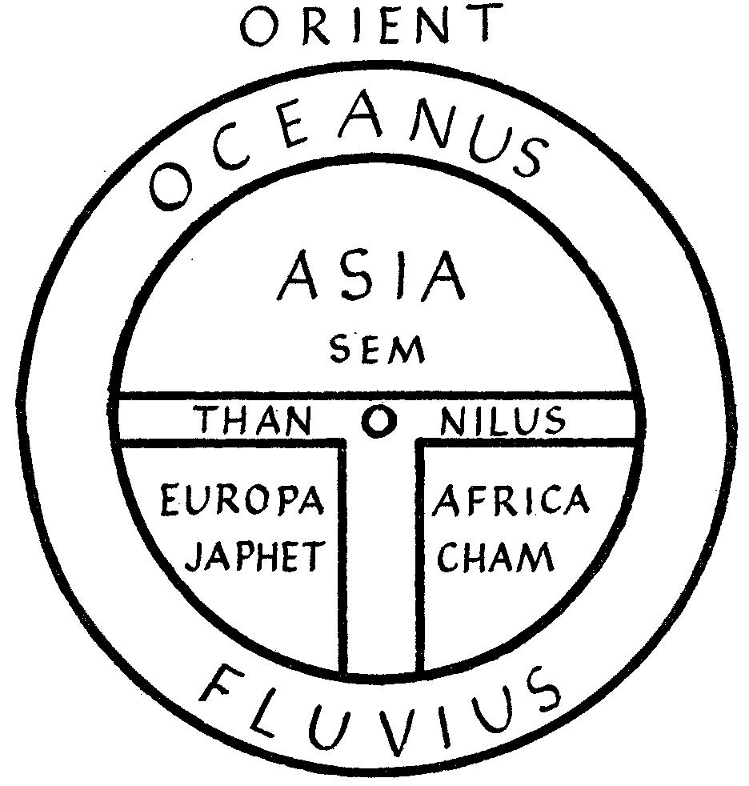
Evaluation: The teacher will then be able to evaluate each groups grade from their constructed maps as well as to assess their engagement in this activity from classwork or from extra credit http://www.pep- /4/4d/Steinberg_New_Yorker_Cover.png/220px-Steinberg_New_Yorker_Cover.png.00500.fig_1.jpg “discovery.”

