Honors Biology Ecology Exam

1. Some birds are known as honey guides because they may be followed by humans to wild beehives. When the humans take honey from the hives, the birds are able to feast on the honey and bees, too. This type of relationship can best be described as ____.
a. parasitism b. symbiosis c. mutualism d. commensalism

2. The repeated movement of water between Earth’s surface and the atmosphere is called
a. the condensation cycle. b. the water cycle. c. precipitation. d. evaporation.

Figure 2-1 GrassMouseCatCoyote
3. Referring to Figure 2-1, suppose 10, 000 units of energy are available at the level of the grasses. What is the total number of energy units lost by the time energy reaches the cat?
a. 90 units b. 9900 units c. 990 units d. 9990 units

4. Referring to Figure 2-1, the mouse would be considered ____.
a. third-level consumers b. decomposers c. second-level consumers d. herbivores

5. The combined portions of Earth in which all living things exist is called the
a. biosphere. b. ecosystem c. biome. d. community.

Figure 5-4
Elm Leaves Caterpillars
Aphid RobinHawkCougar
Dragonfly Bass Fox
AlgaeMinnow Bear
6. Examine the food web shown in Figure 5-4. The disappearance of which of the following pair of species would result in the total collapse of the food web?
a. elm trees and bass b. algae and elm trees c. dragonflies and foxes d. algae and dragonflies

7. Examine the food web shown in Figure 5-4. What would most likely happen to the organisms in this food web if the robin began to disappear?
a. The terrestrial organisms would starve, but the aquatic organisms would survive.
b. Most of the organisms in the ecosystem would starve and die.
c. The hawk would be forced to start eating the dragonfly.
d. There would be an overpopulation of caterpillars, which would kill many elm trees.
8. Which of the following involves a situation in which a density-dependent factor influences a population?
a. Several seasons passed during which rainfall was ample, winters were not severe and food for snow hares was in good supply.
b. A forest fire on the north side of a mountain forced the white-tailed deer from the north side to move into the range of the white-tailed deer on the south side of the mountain, making food more scarce.
c. A hurricane severely disrupted a salt marsh and uprooted most of the marsh grass in an estuary.
d. After a heavy rain, pesticides that were applied to a cotton crop to control weevils ran off into a waterway that flows next to a field.

9. The lowest level of environmental complexity that includes living and nonliving factors is the
a. ecosystem. b. biome c. community. d. biosphere.

10. Cougars are predators that often eat weakened or diseased animals. This is a description of the ____ of cougars.
a. community b. niche c. habitat d. none of these

11. One of the nutrient cycles moves from an atmospheric gaseous form to the soil through biotic processes, moves through the food web, then is returned to the soil or to the atmosphere. Which cycle fits this description?
a. carbon b. nitrogen c. phosphorus d. water

12. To assess a population’s growth rate, an ecologist must know how many individuals are born, how many died, and how many move away in a given period of time. What else must an ecologist know?
a. how many individuals are young or old
b. how many individuals carry communicable diseases
c. how many individuals find mates
d. how many individuals move in from somewhere else

13. If an isolated population’s birthrate is the same year after year, why are a greater number of individuals added to the population in each successive year?
a. Fewer members emigrate away each year.
b. The effective birthrate is increasing each year.
c. The carrying capacity is increasing each year.
d. The rate applies to more individuals each year.
14. Each of the following is a density-dependent limiting factor EXCEPT
a. disease. b. seasonal cycles c. competition. d. crowding.

15. All of the following are limiting factors EXCEPT
a. human disturbances. b. immigration c. predation. d. competition.

16. Which process describes nitrogen fixation?
a. animals eat plants containing nitrogen and return it to the soil through urination
b. bacteria take nitrogen from the air and convert it to a form usable by plants
c. plants take nitrogen from the air and store it in their roots
d. organisms die and are decomposed into ammonia in the soil

17. Analyze each of the sequences in the primary succession of species colonizing a newly formed volcanic island and select the option in the correct order.
a. bare rock, lichens, small annual plants, perennial herbs and grasses, shade tolerant trees
b. bare rock, lichens, perennial herbs and grasses, small annual plants, shade intolerant trees
c. bare rock, small annual plants, lichens, shade-intolerant trees, shade tolerant trees
d. bare rock, lichens, small annual plants, perennial herbs and grasses, shade intolerant trees

18. Which of the following ecological units or relationships is the least related to abiotic factors?
A. community B. symbiosis C. ecosystem D. population

19. Which of the following pairs is an ecosystem?
A. a biotic environment and a community
B. a community and its abiotic environment
C. a niche and a community
D. a population and a community

20. Which of these is a community relationship?
A. river turtles and snails eat tape grass B. snails are concealed among rocks in a river
C. tape grass clogs the water current in a river D. turtle eggs are buried on the river bank

21. Your friend comes to you with a problem. It seems his shrimp boats aren’t catching as much shrimp as they used to. He can’t understand it because originally he caught all the shrimp he could handle. Each year, he added a new boat, and for a long time, each boat caught tons of shrimp. As he added more boats, there came a time when each boat caught a little less shrimp, and now, each boat is catching a lot less shrimp. Which of the following topics might help your friend understand the source of his problem?
A. density dependent population regulation
B. logistic growth and intrinsic characteristics of population growth
C. density independent population regulation
D. Both A and B
Questions 22 and 23 refer to the following choices:
A. competition B. symbiosis C. parasitism D. predator-prey

22. Termites eat wood, but cannot digest it. Microorganisms that live in the termites’ digestive tracts digest the wood. The microorganisms cannot live outside the termites’ bodies.

23. A lamprey eel attaches itself by a sucker to a fish and feeds on blood from the fish.

24. Which is the most important in limiting the size of a community?
A. amount of energy entering it B. biomass of decomposers
C. number of consumers D. size of an individual producer

25. When is carbon dioxide NOT being released into the atmosphere?
A. as plants break sugars down B. as decomposers are active
C. as fossil fuels are burned D. as producers perform photosynthesis

26. Scientists studied a field and found numerous types of grasses and insects. Fifteen years later, the grasses had been replaced by several shrub species and young trees had begun growing. This is the result of
A. primary succession B. secondary succession C. tertiary succession D. speciation

27. Which of the following is NOT part of the nitrogen cycle?
A. nitrogen fixation B. photosynthesis C. decomposition D. ammonification

28. In the nitrogen cycle, the bacteria that replenish the atmosphere with N2 are
A. methanogenic protozoans B. denitrifying bacteria
C. nitrogen fixing bacteria D. nitrifying bacteria

29. In a pond community, the greatest mass present would consist of
A. algae B. insects C. frogs D. fungi

30. A farmer started colonies of rats and mink hoping to feed the rats to the mink and the skinned mink to the remaining rats, thereby getting mink skins for nothing. Is this possible?
A. Yes, because the system would be in balance
B. Yes, because energy lost feeding rats to mink would be recovered by feeding mink to rats
C. No, because carnivores cannot feed on each other
D. No, because much of the food energy is lost as heat

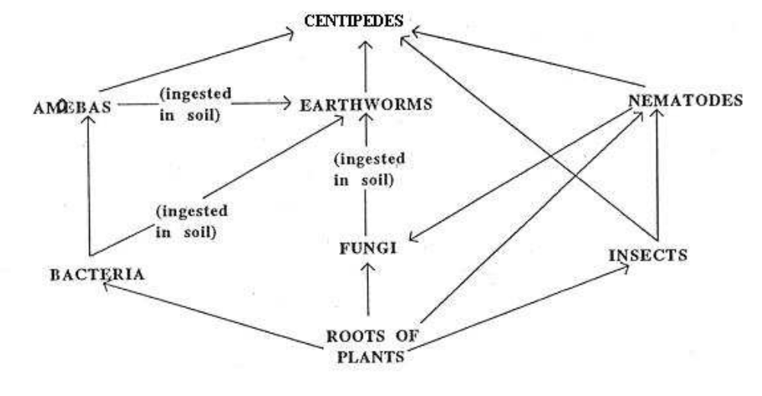
Use above graph to answer questions 31-33
31.What pair of organisms both are in competition with nematodes?
A. earthworms and insects B. amoebas and bacteria
C. insects and centipedes D. fungi and earthworms

32. Which of these pairs of organisms represent a predator-prey relationship?
A. amoebas and nematodes B. bacteria and fungi
C. centipedes and earthworms D. insects and bacteria

33. How many producers are shown in this diagram?
A. 1 B. 2 C. 3 D. 4
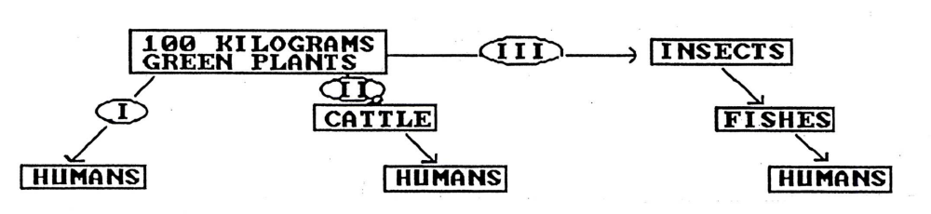
Use graph above to answer 34 and 35
34. Through which pathway would the least energy be available to humans?
A. III B. II C. II or III D. I

35. Which pathway will be favored more if the world human population doubles in size?
A. III B. II C. II or III D. I
36. In a mature forest of oak, maple, and hickory trees, a disease causes a reduction in the number of acorns produced by oak trees. Which of the following would LEAST likely be a result of this?
A. there might be fewer squirrels because they feed on acorns
B. there might be fewer mice and seed-eating birds because squirrels would eat more seeds and compete with mice and birds
C. there might be an increase in the number of hickory trees because the competition between hickory nuts and acorns for germination sites would be reduced or eliminated
D. there might be a decrease in the number of maple seeds as the disease spreads to other trees in the forest.

37. Consider a field plot containing 200 kg of plant material. How many kg of carnivore production can be supported?
A. 2 B. 10 C. 20 D. 200

38. If a population exceeds the carrying capacity of the ecosystem, the most likely outcome would be
A. an increase in resources to meet its needs
B. extinction of the species
C. an eventual decline in population size
D. maintenance of the current population size for a significant period of time

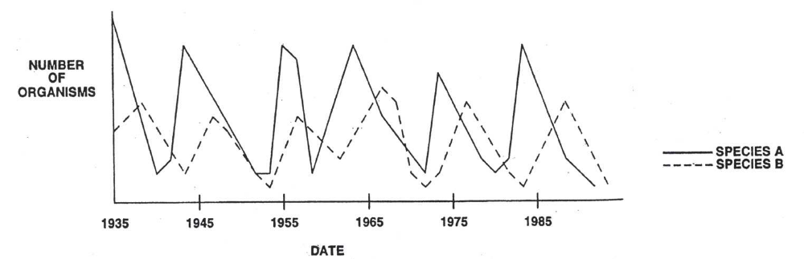 39. Species A and species B are members of the same community. From this graph, we can conclude that
A. species A eats species B
B. species B eats species A
C. species A increases in number every 5 years
D. both species are competing for the same food source

40. Which of the following statements about succession is correct?
A. primary succession occurs in areas where soil remains after a disturbance
B. secondary succession can occur where a disturbance has left soil intact
C. secondary succession occurs where no soil exists
D. primary succession only occurs when new volcanic islands form

41. Which is the correct sequence of how nitrogen is passed through its cycle?
A. Fixation, denitrification, nitrate formation B. Nitrate formation, fixation, denitrification
C. Denitrification, nitrate formation, fixation D. Fixation, nitrate formation, denitrification

42. John Doe went home after school and noticed the level of water in his fish tank had decreased. His bedroom was very hot and the sun was shining directly on his tank. John was trying to determine the cause of water loss from his knowledge of the biogeochemical cycles. Low water is due to
A. Nitrogen fixation by the bacteria in the roots of the water plants
B. Evaporation from the water plants and transpiration from the rocks in the tank
C. Condensation forming on the top of the tank
D. Evaporation from the water and transpiration from the water plants

43. Some water, a small amount of soil, a few green aquatic plants and a fish were placed in a large bottle. The bottle was sealed to prevent the exchange of gases and other materials between its contents and the outside. The bottle was placed in a window to receive light during the daytime. Is carbon dioxide produced by the plants?
A . Yes, but it is produced only at night when the plants can no longer carry on photosynthesis.
B . Yes, it is produced all the time as a result of cellular respiration.
C . No, it is a waste product of animals only.
D . No, plants take in only the waste products exhaled by animals.

44. A carrot plant is exposed to carbon dioxide containing radioactive carbon for 24 hours. After this exposure, the carrot roots are found to have accumulated radioactivity. These carrots are then fed to a rabbit. One week later, the rabbit's tissue is tested for radioactivity and is found to have a higher than normal background count. Which biogeochemical cycle is apparent from this study?
A. oxygen B. Nitrogen C. water D. carbon

45. This diagram shows the number of organisms in a food chain. Which of the following food chains does it represent?

A grass → rabbit → fox B grass → sheep → tick
C oak tree → caterpillar → bird D lettuce → slug → bird

Short Answer:
PLEASE ANSWER IN FULL SENTENCES. RESPONSES SHOULD BE APPROXIMENTLY 2-3 SENTENCES PER QUESTION.
Figure 3-7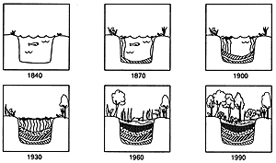
46. What type of succession is illustrated in the ponds in Figure 3-7? How do you know?
47. What is one difference between primary and secondary succession?

