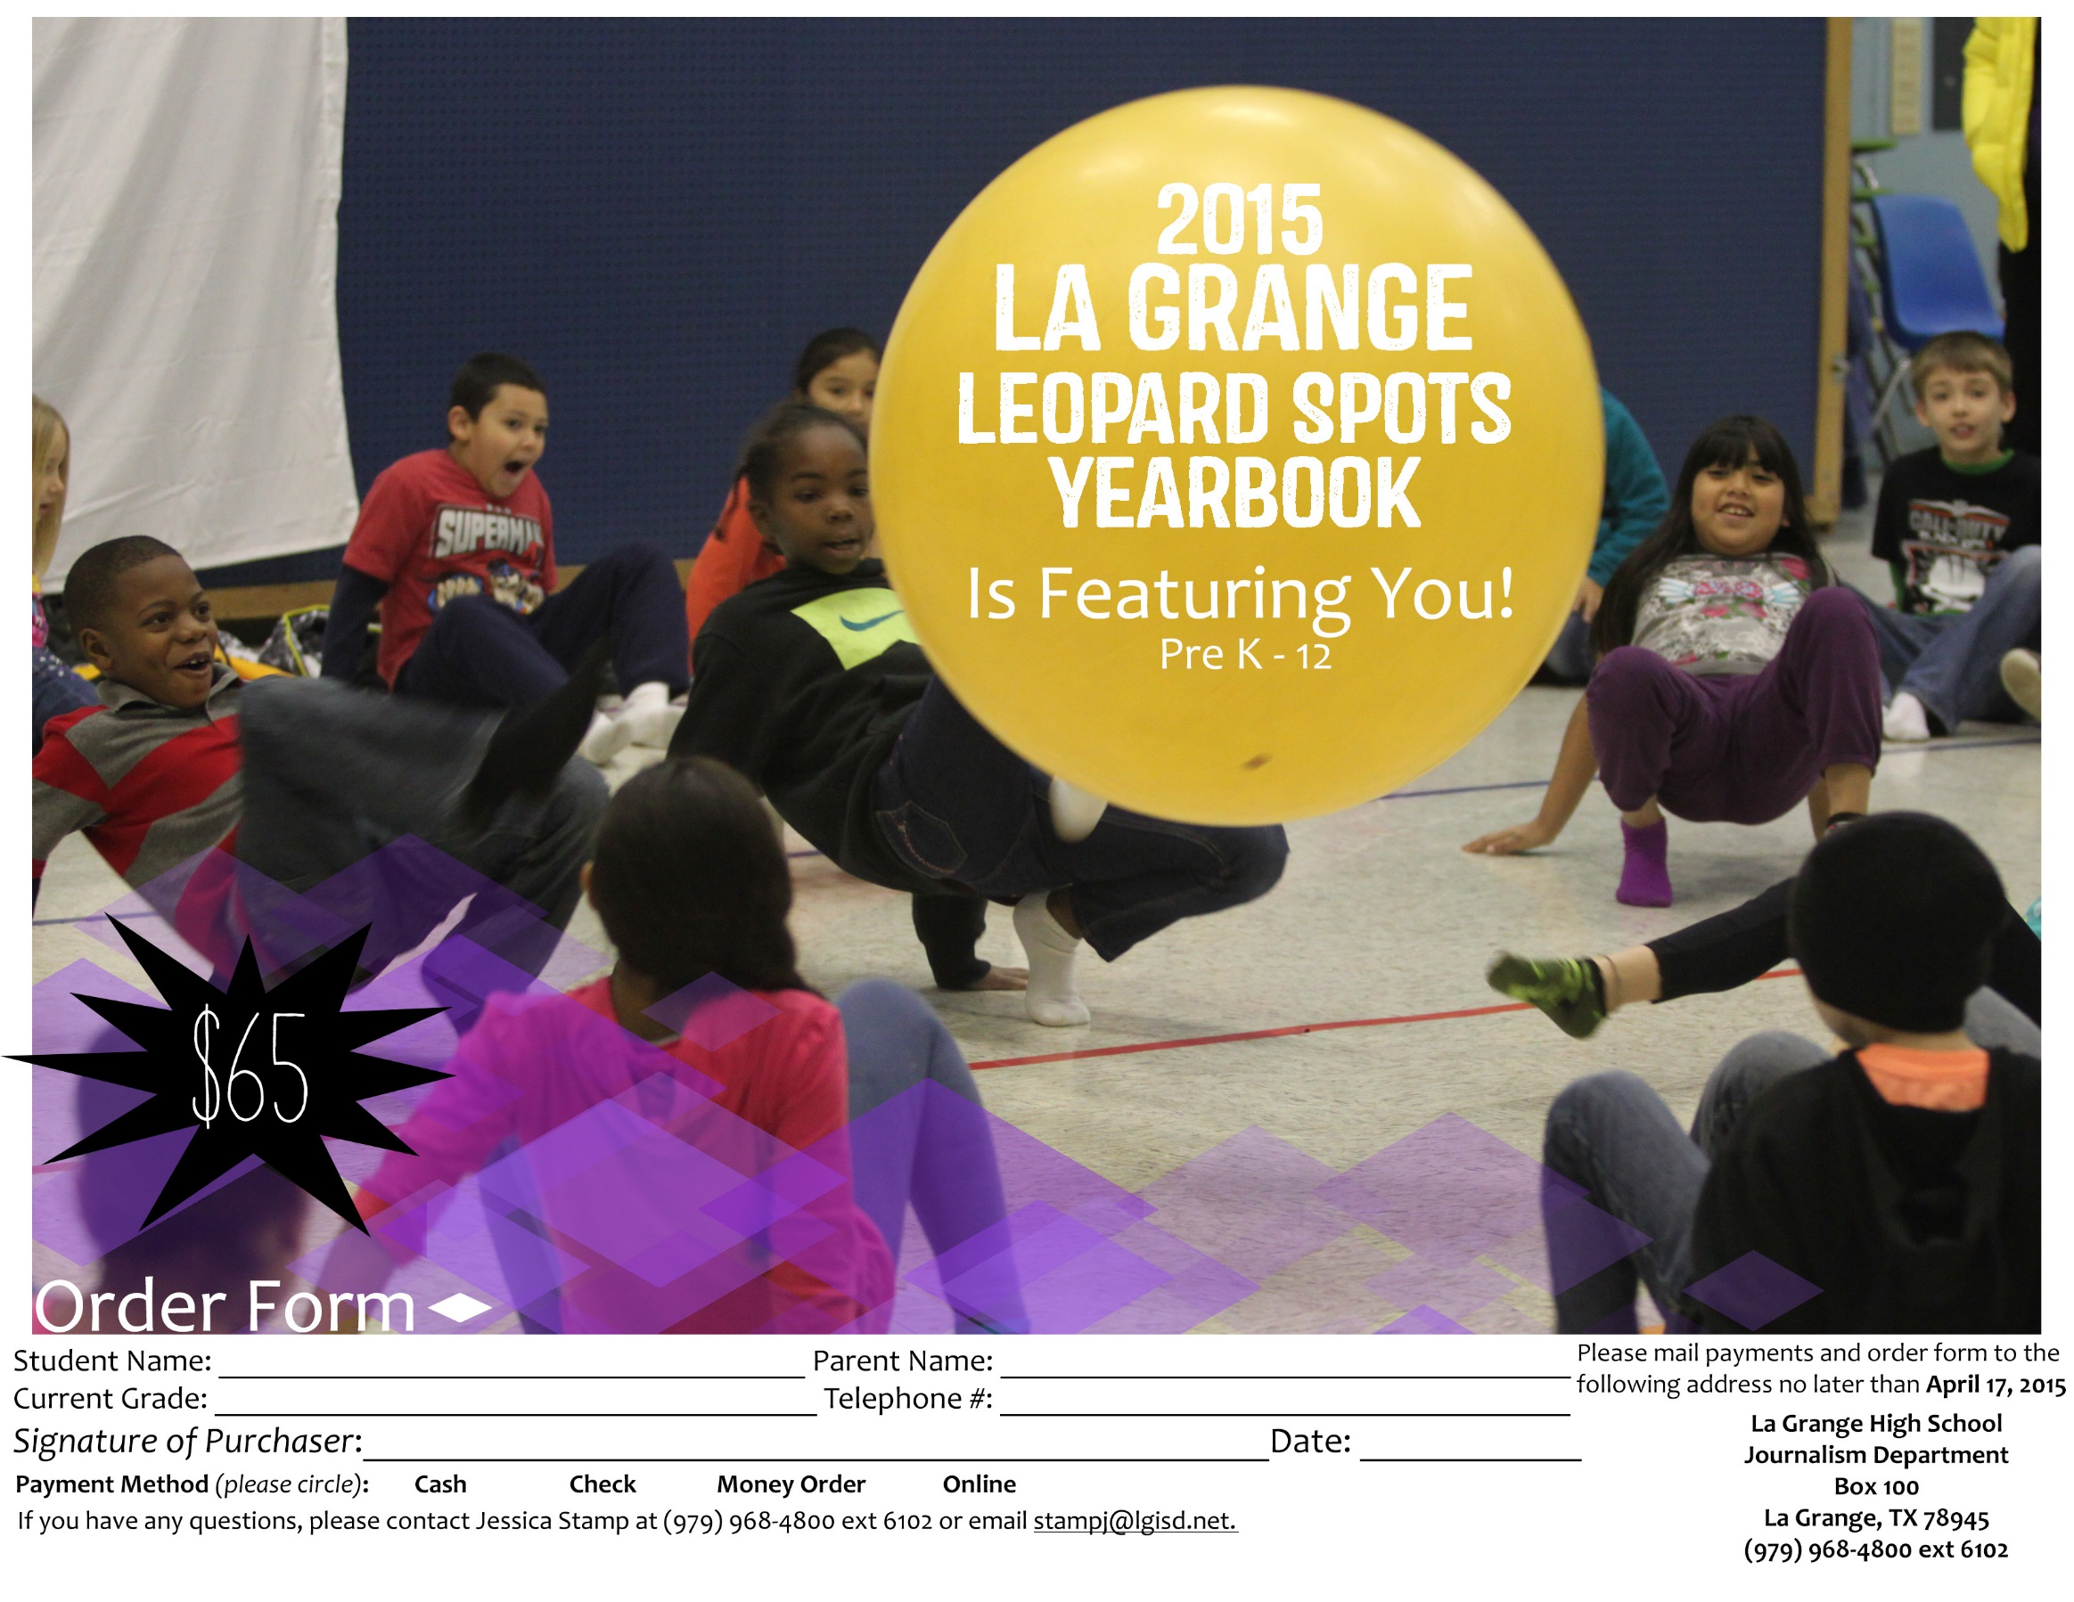

2015 Leopard Spots Yearbook
Featuring Pre-K through Twelfth grades

$65

Remember your child’s school years by reserving your copy of the La Grange ISD
2014-2015 Leopard Spots yearbooks!

ADDITIONAL ORDERING OPTIONS
CIRCLE THE DESIRED FEATURES

- Namestamping – etched/imprinted name on lower right of front cover

First line______________________________________________________ (max 32 spaces)

Second line_______________________________________________________________________________ (max 32 spaces)

- Icons- etched/imprinted activity, sport, or year icon on lower right of front cover (up to 5 with single line of namestamping, only one for two lines)
- Clear Book Protector
- Year in Review – a magazine that features national and world current events
- Autograph Supplement – blank pages with background design

Pricing

Namestamping one line $6.30
Namestamping two lines $13.00
Activity/Year icons $3.75
Clear Book Protector $3.25
Year in Review $3.25
Autograph Supplement $3.25

TOTAL FEATURES $__________ + $65 book price = $__________
GRAND TOTAL

If you have any questions, please contact Jessica Stamp at (979) 968-4800 ext 6102 or email: stampj@lgisd.net
La Grange High School
Journalism Department
Box 100
La Grange, TX 78945

GO LEPS!

