The Classics & Humanism
Revival of Classical Learning:
The end of the Middle Ages brought new energy to learning in Europe. As you recall, education had declined during the Middle Ages. This was due largely to the fact that war and political instability had disrupted society. By the 1200s, however, people had grown eager once again to gain knowledge and understanding.
To achieve greater knowledge, many people turned to the past. They revived the classical ideas of Greece and Rome. They studied a variety of texts from these earlier civilizations in the hopes of gaining a greater knowledge and fulfillment.
The Growth of Humanism:
The study of classical texts and ideas led to a movement known as humanism. Humanism is a way of thought that focuses on human beings and their potential for achievement. It stresses the study of such classical subjects as history, grammar, literature, and philosophy. The goal of humanism is to create well-rounded individuals and encourage people to achieve all they could in life.
The early leader of the humanist movement was an Italian poet and scholar named Petrarch. He was one of the first thinkers to stress the value of classical learning, or the teachings of Greece and Rome. He worked to find and restore he works of many important Greek and Roman writers. In fact, scholars believe that such significant Latin writers as Cicero and Livy might be unknown today if Petrarch had not dug up their lost works buried in monastery libraries.

Humanist Thought:
Humanism stressed the importance of the individual. His way of thinking differed greatly from that of medieval times—which placed kings and institutions such as the Church above everything else. Humanism also promoted a greater balance between intellect and religious faith. Humanist thinkers stressed the importance of leading a Christian life. However, they challenged people to think for themselves and not blindly accept church orders. They also taught that people could enjoy life and still be good Christians. His teaching differed from earlier beliefs that one had to avoid life’s pleasures in order to please God.

- From where did people revive classical ideas at the end of the Middle Ages?
- Define humanism:
- Why was Petrarch considered an early leader of the humanist movement?
- How did humanism differ from earlier beliefs about the place of individuals in society? Use the graphic organizer below to complete your answer:
Impact of Humanism:
Old Thinking | New Thinking

A B
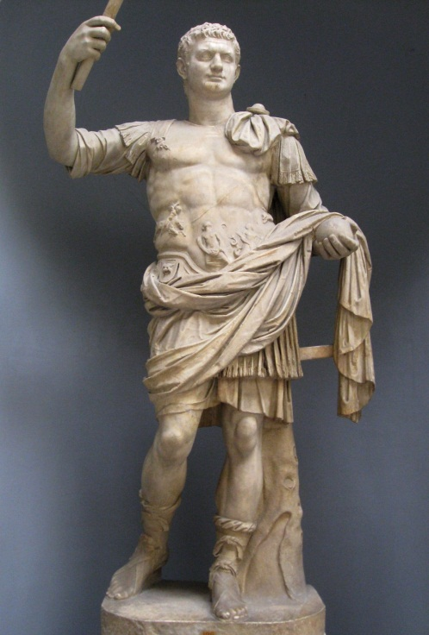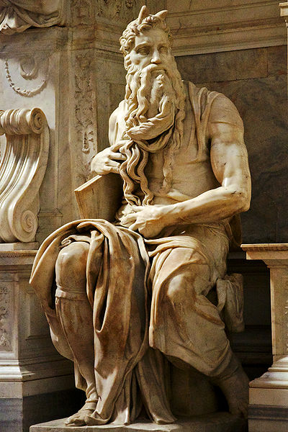
Compare and Contrast the two painting above. List the similarities and list the differences. Which one do you think is a classical work and which one do you think is a work from the Renaissance?

