Assg: BIO & HON Name
BIO Essentials Transport Across a Cell Membranes Date pd.
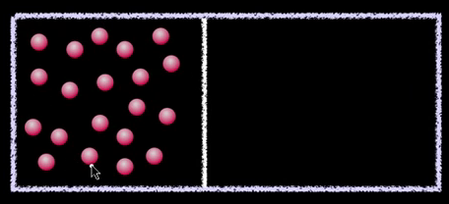 | Mr. Anderson’s first example of diffusion is a certain type of gas in a container. Explain how diffusion occurred when the container is opened
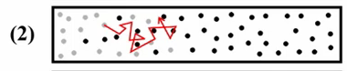 | What does he mean when he talks about the movement of molecules NOT being linear. Refer to the diagram on the left if you need to.
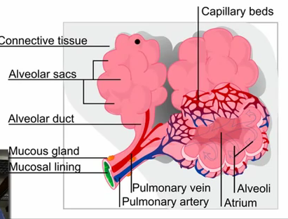 | How does the process of diffusion work in our bodies regarding breathing?
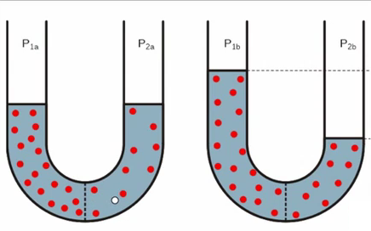 | In the “U” tube experiment you can see over time the water level on the left rises. Explain how this occurred.
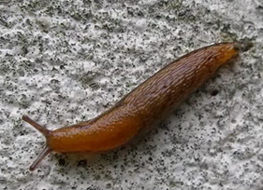 | Explain why a snail shrivels when salt is placed onto it?
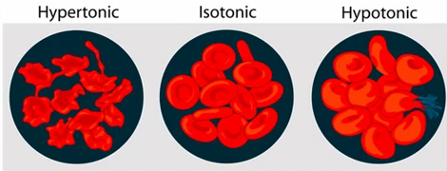 | Our red blood cells are currently in what type of environment? ___________________ What happens to our cells if distilled water was injected into our blood stream?
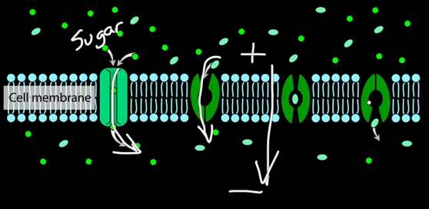 | Use the picture to explain why facilitated diffusion DOES NOT require energy.
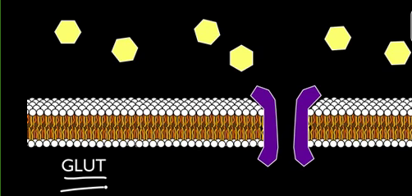 | In the GLUT, why is facilitated diffusion used?  How does the GLUT work?
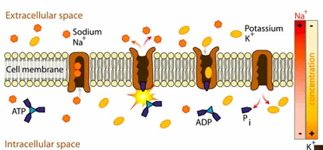 | Why is energy needed to run the sodium-potassium pump?
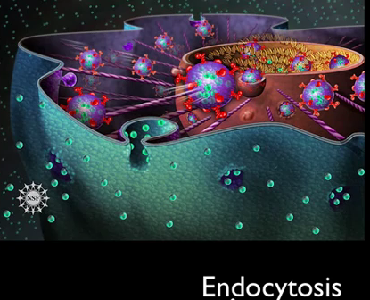 | Explain how our bodies defend against bacteria invasions.
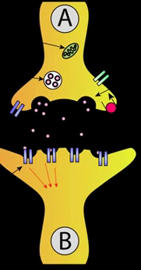 | What example does Mr. Anderson use to explain exocytosis? Why is this important to us? Why is this an example of active transport?

