Steps to Making Study Wheels

Materials Needed
One sheet of paper
Two sheets of 8½ inch by 8½” poster board
One brad
Compass
Ruler
Scissors

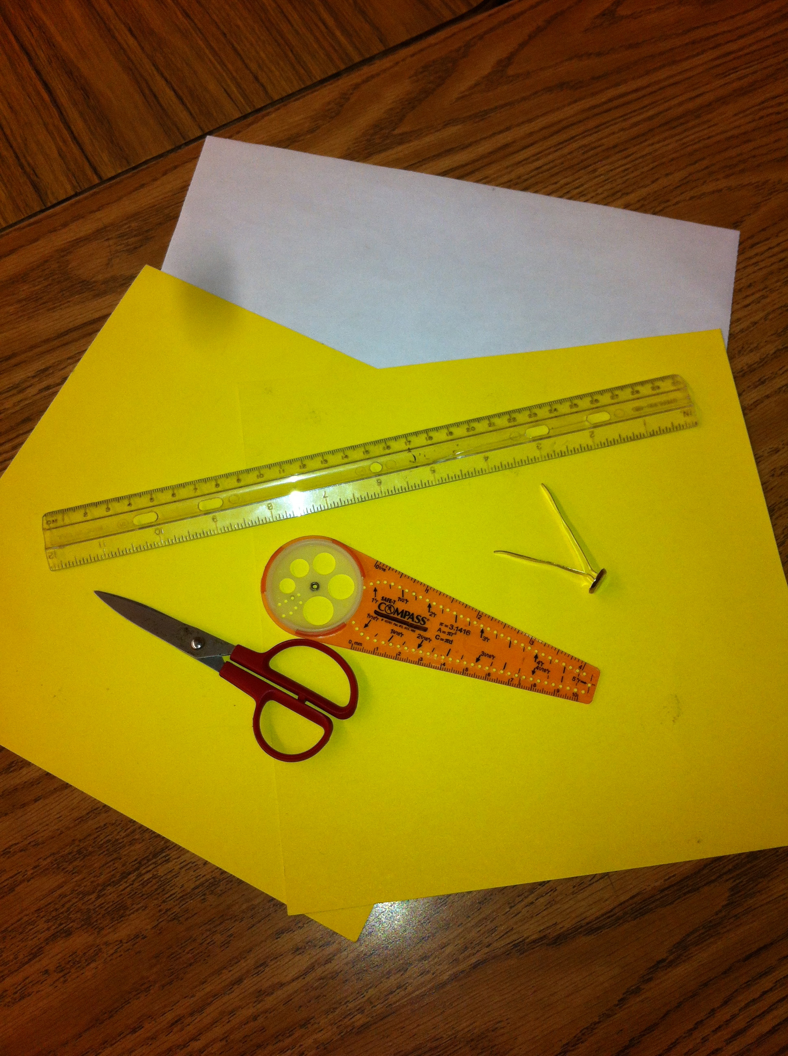 | 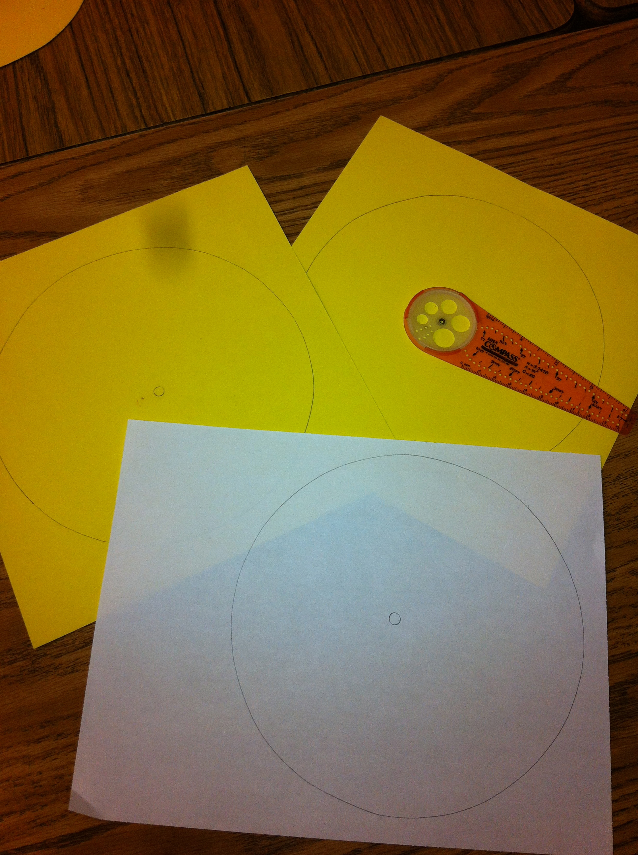 | 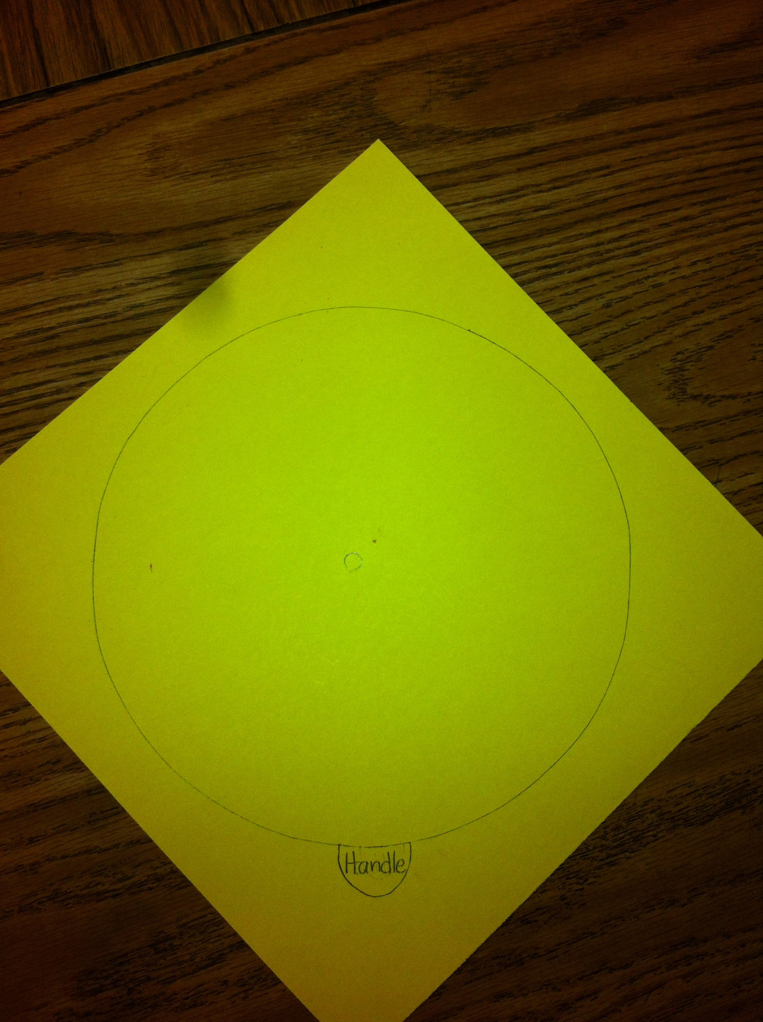

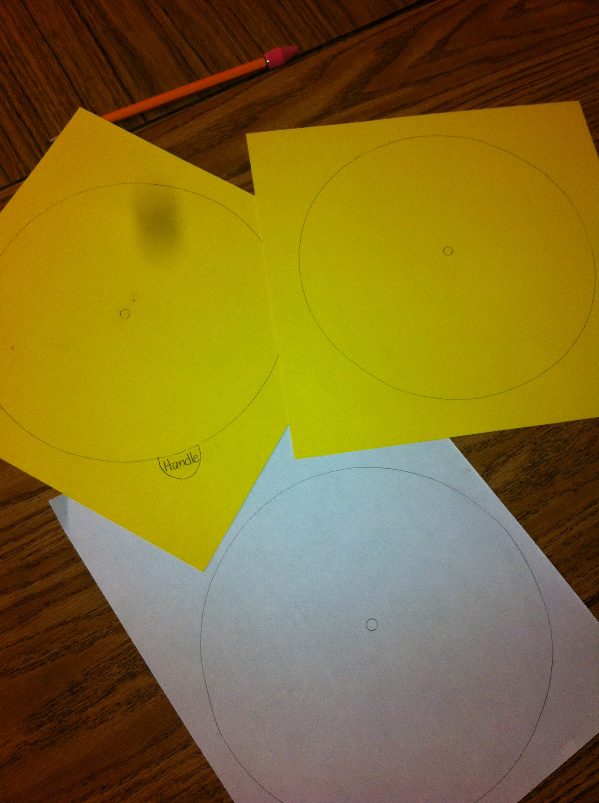 | 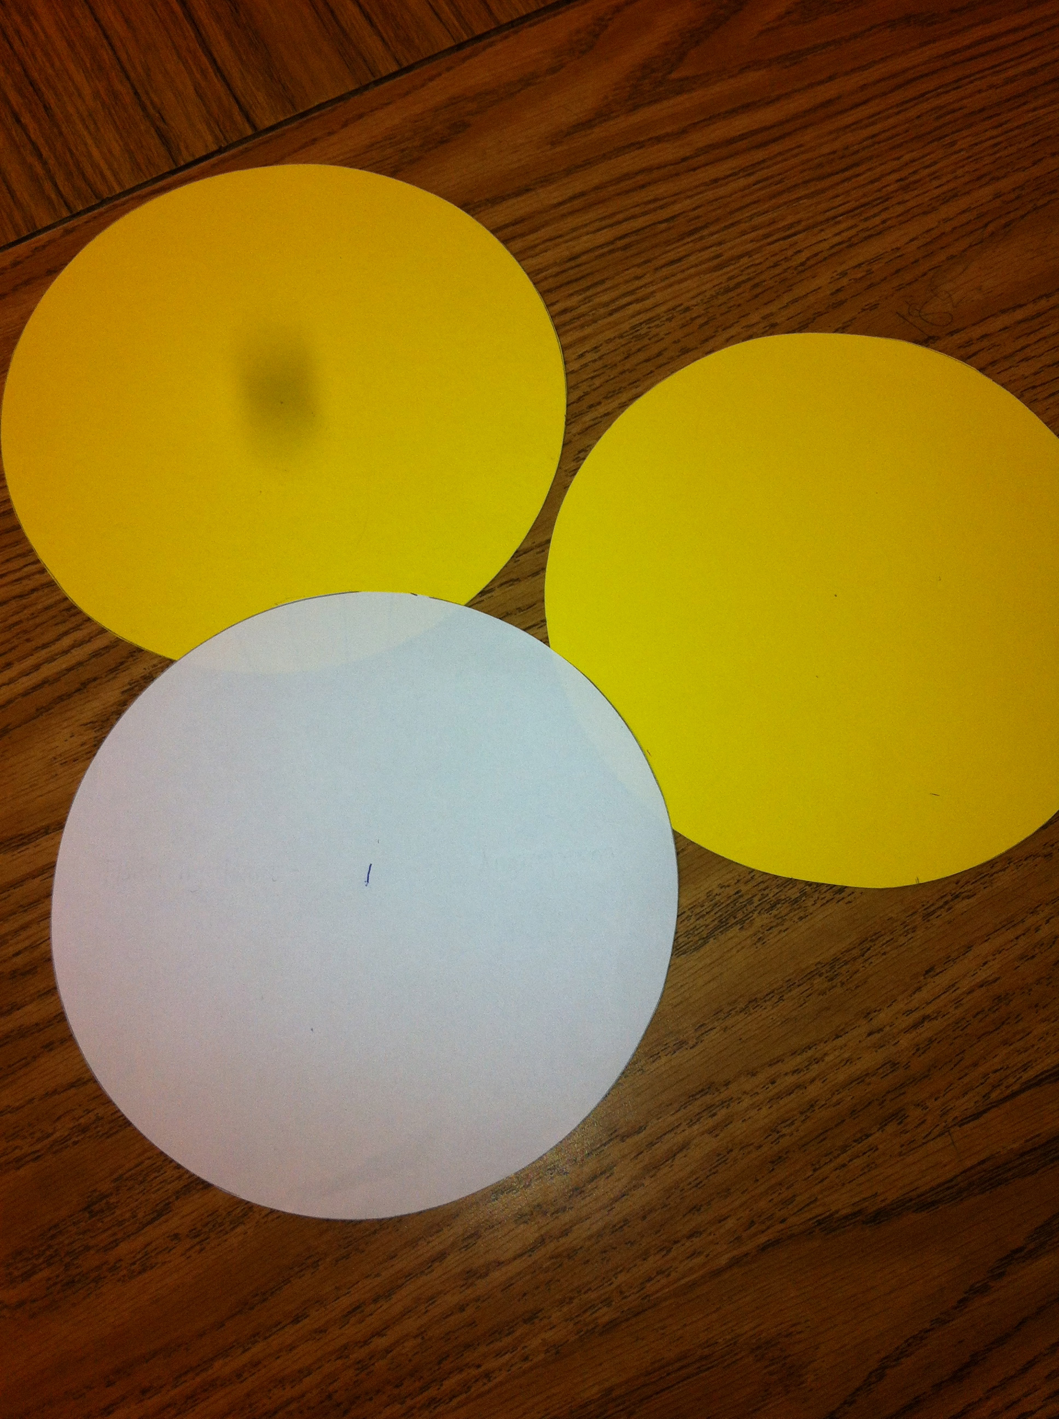 | 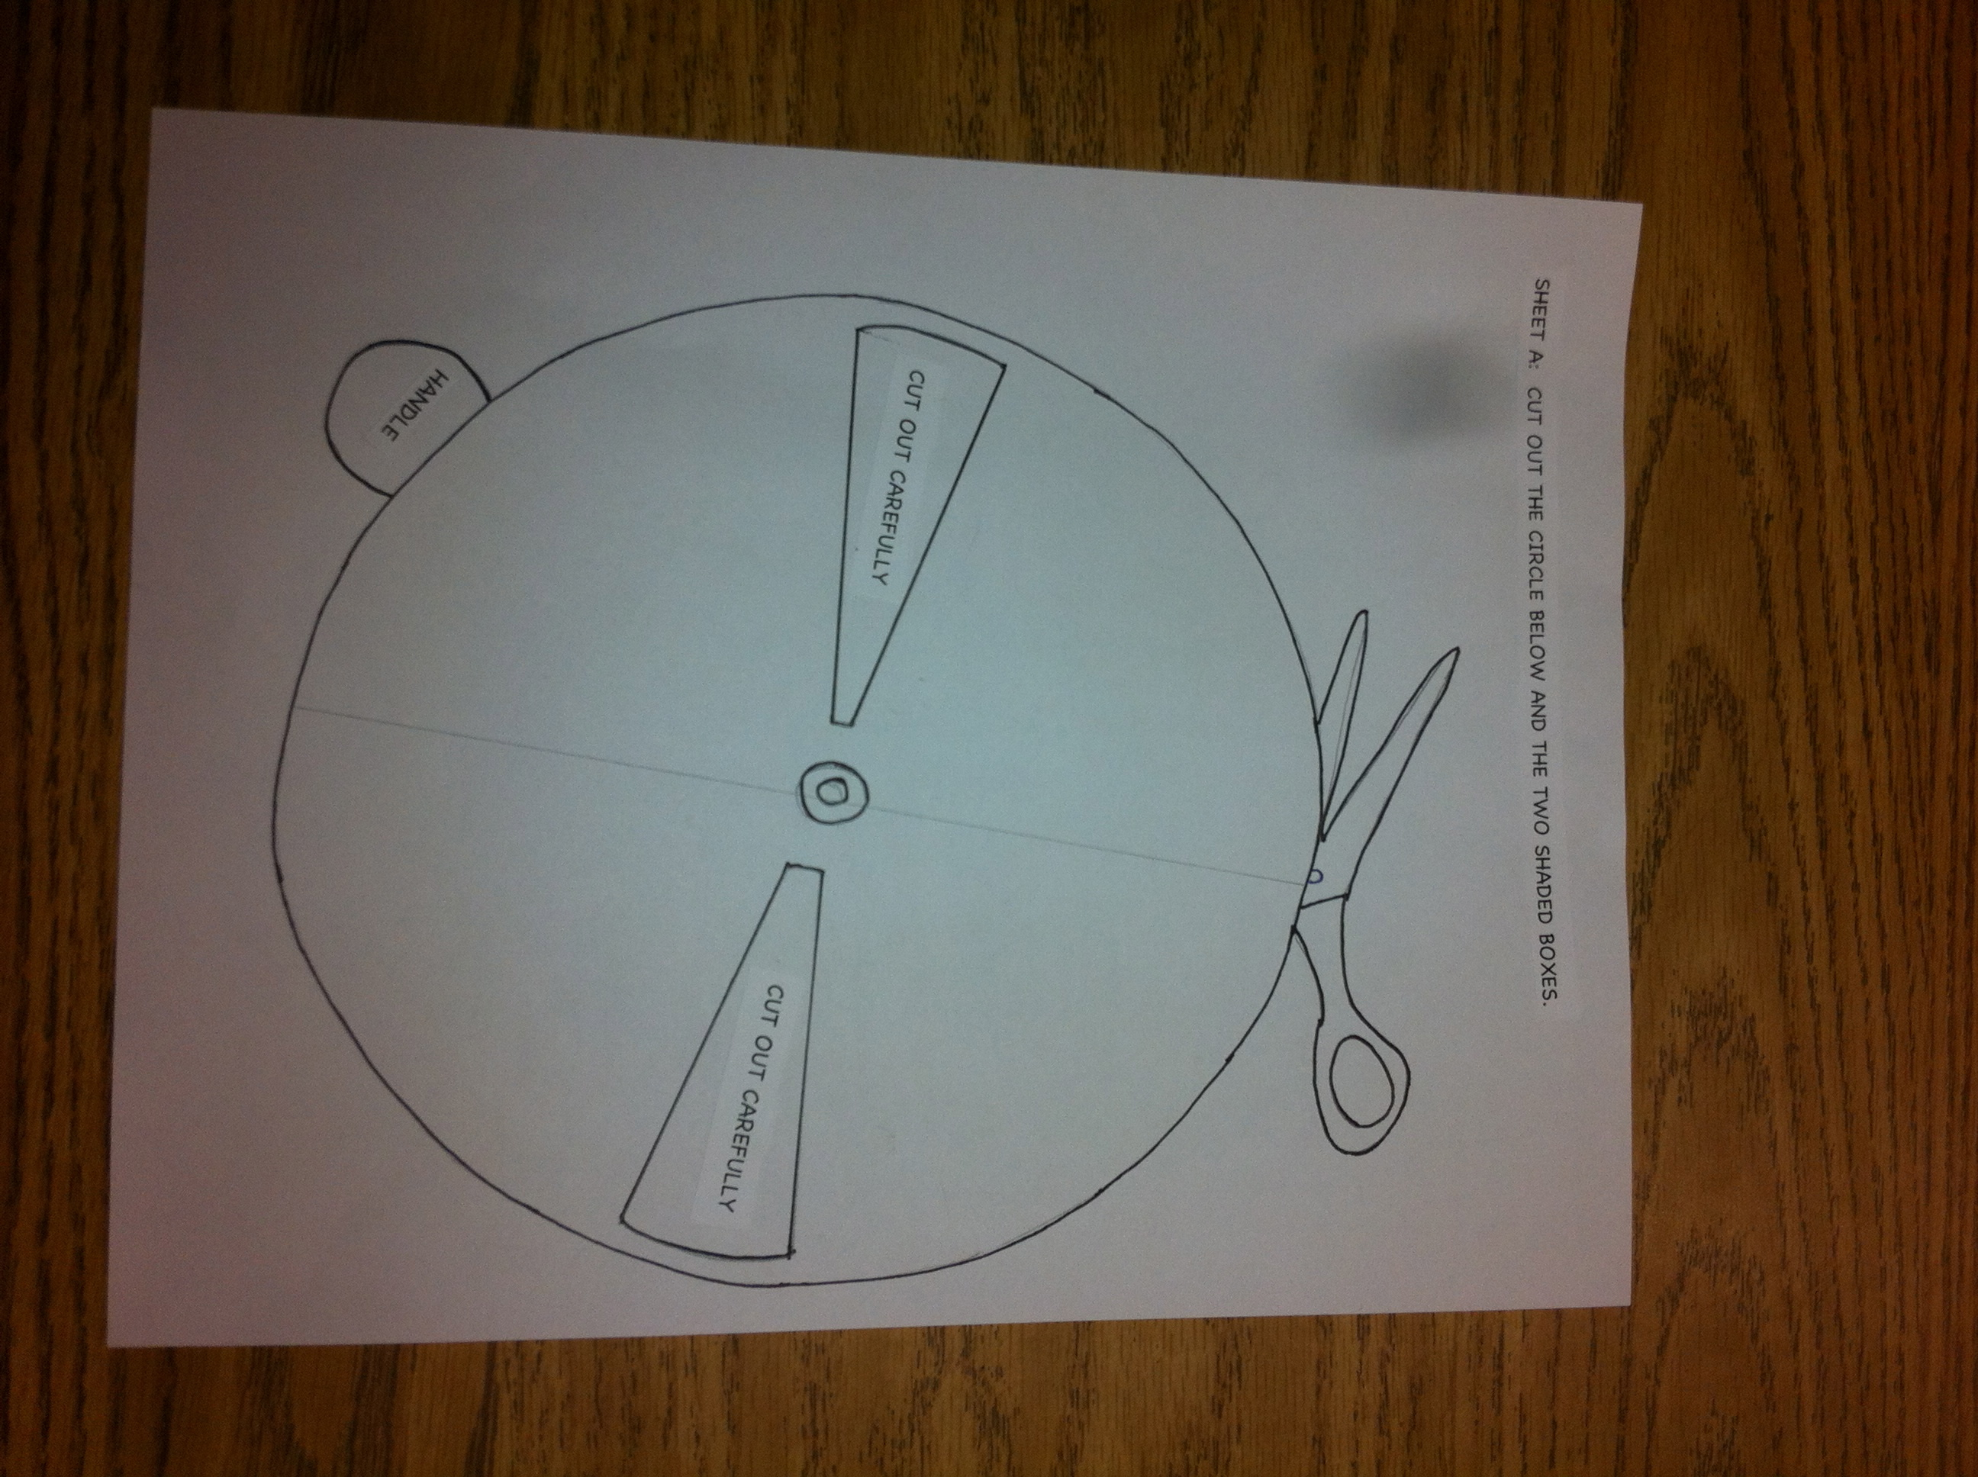

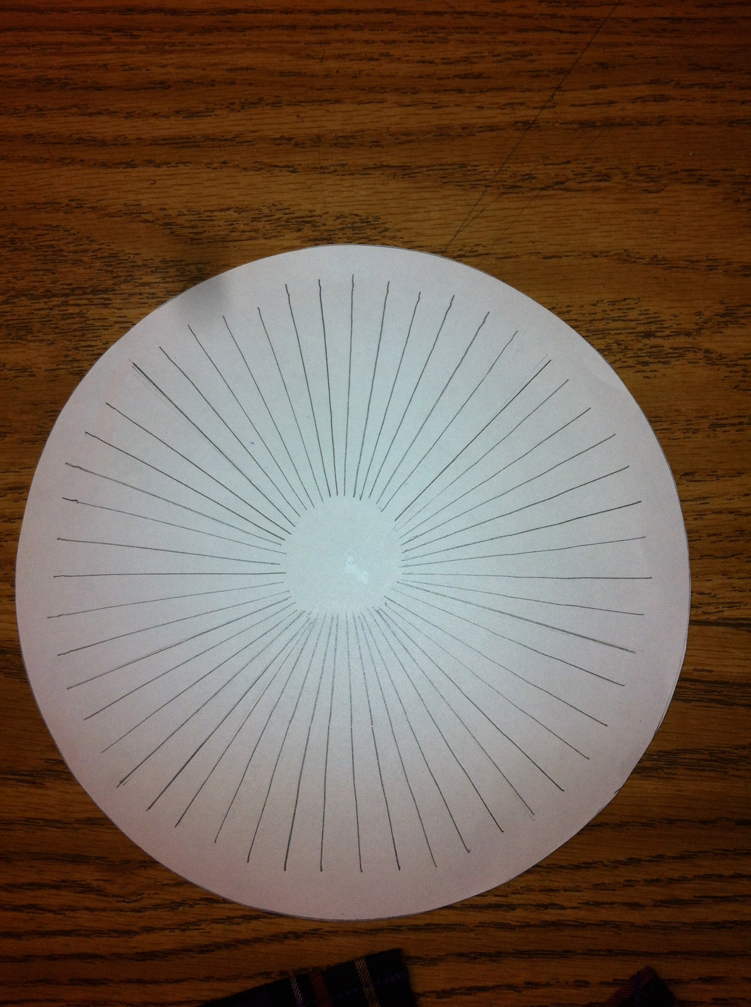 | 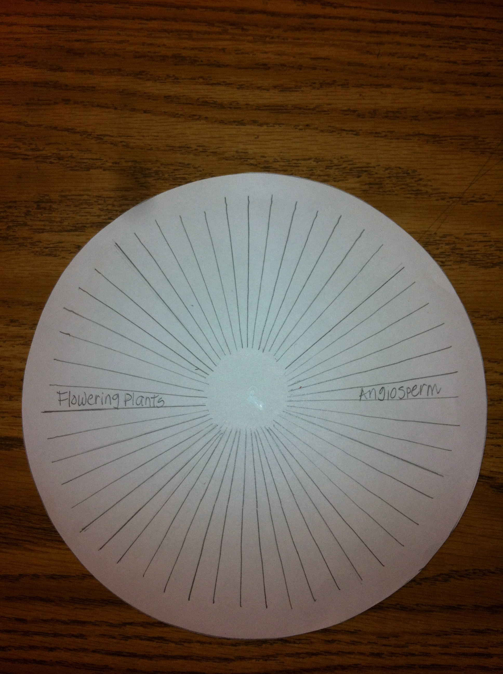

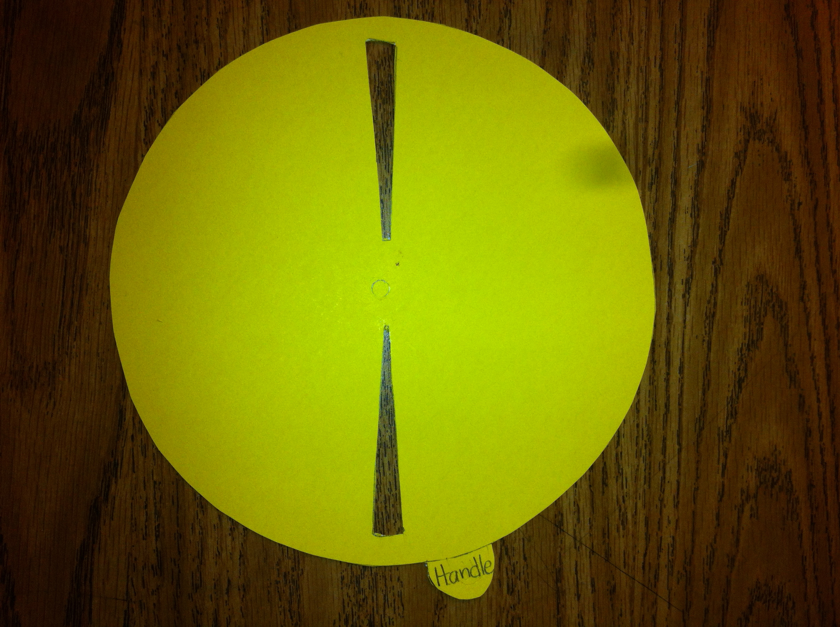 | 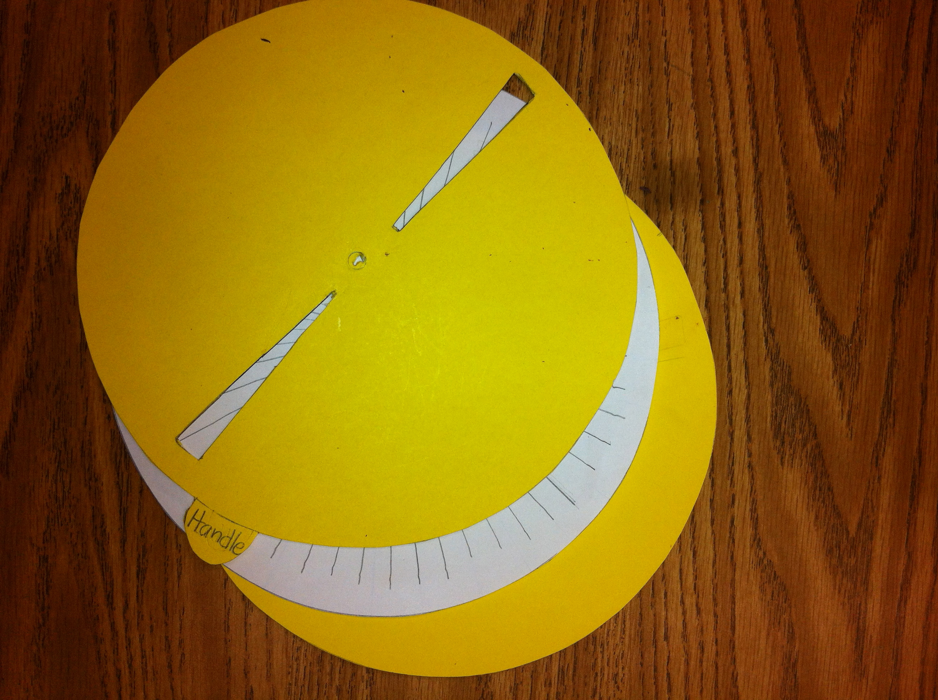

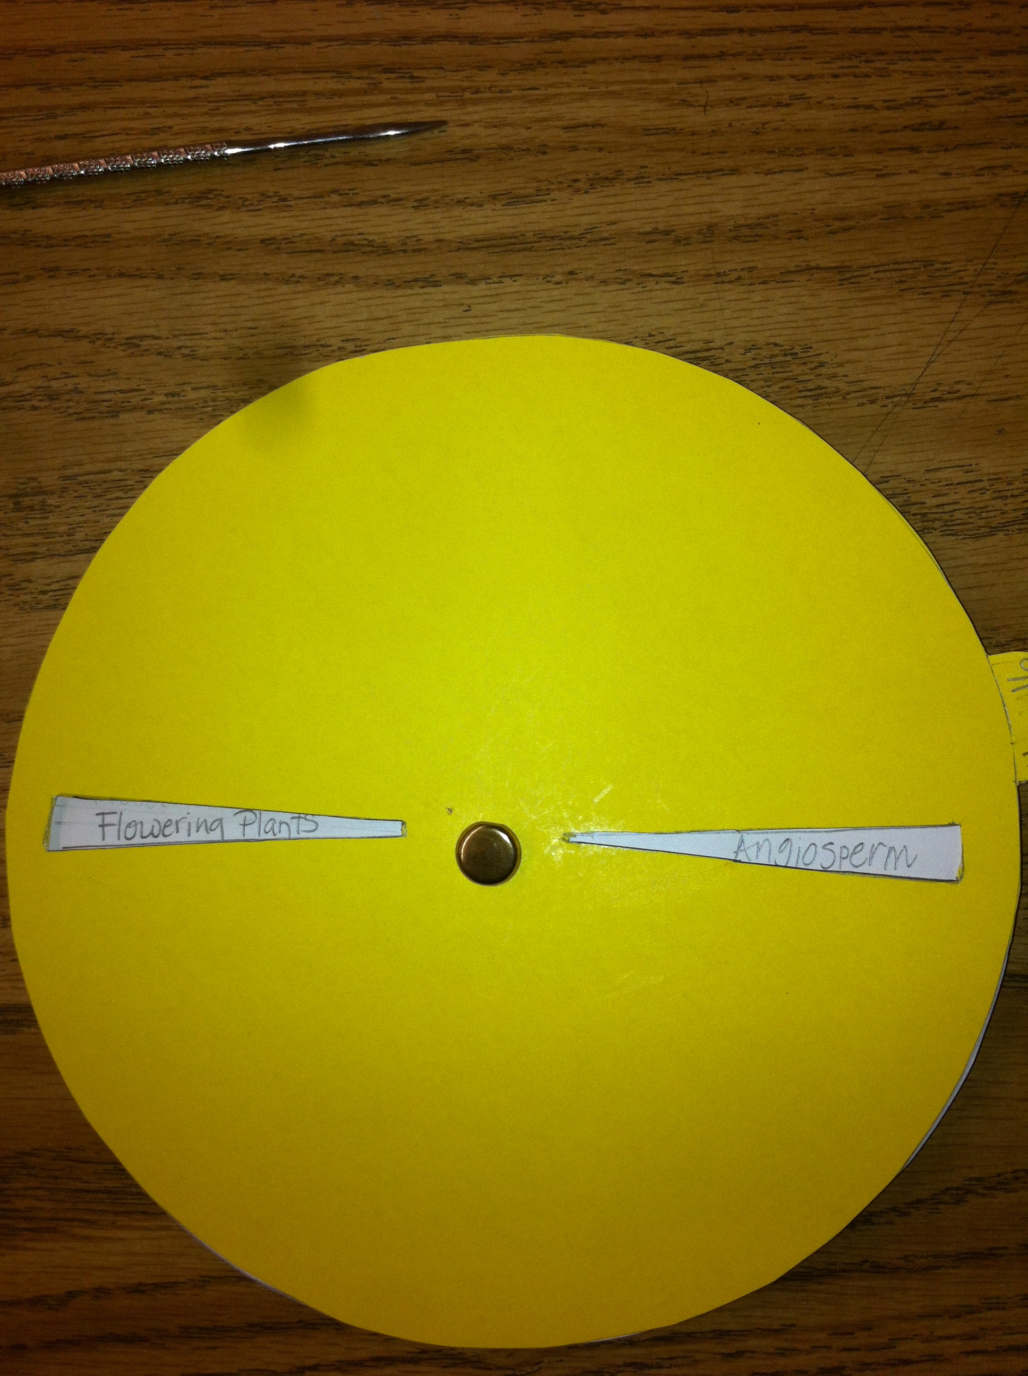 | 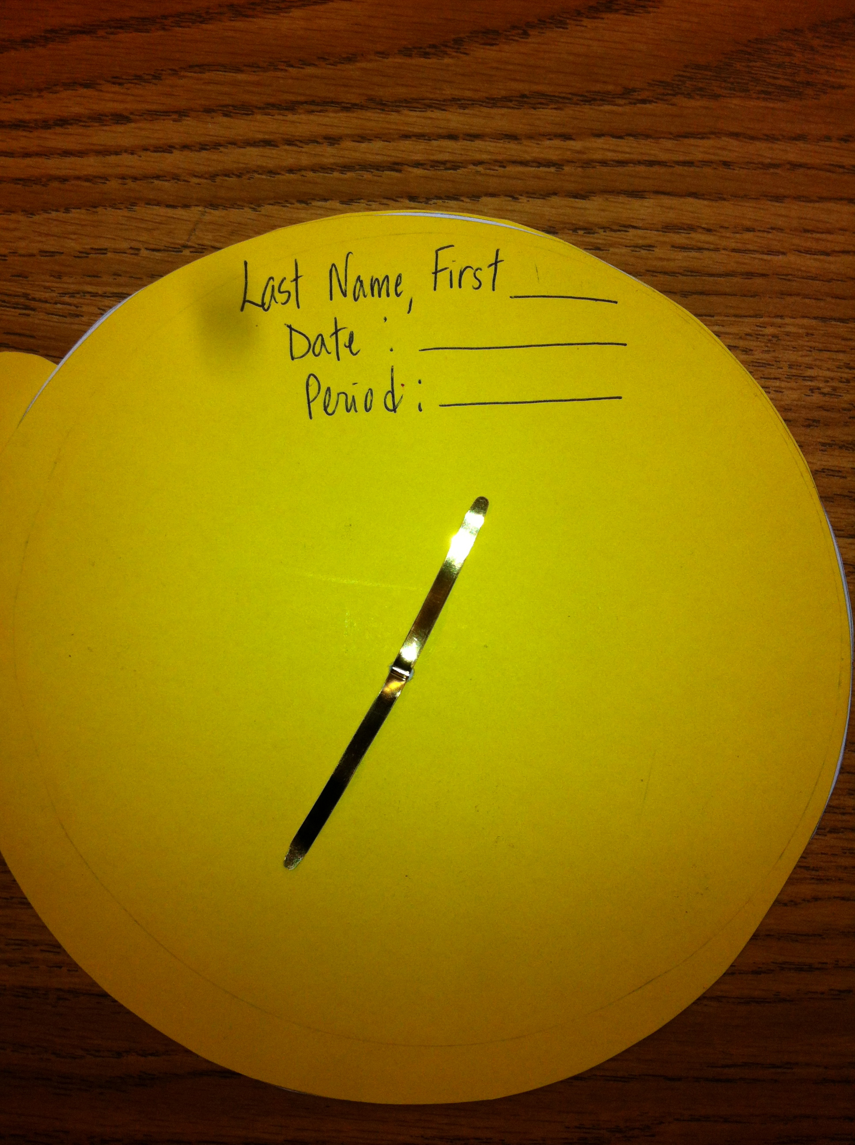

- Measure off a circle on a sheet of paper, & two sheets of poster board paper. Diameter of the circles for each should be 19.5 cm.
- Mark the center of each circle with a pencil mark.
- Then, on the paper circle, mark off 30 sections. Draw lines running from the center to the edge of the paper as if you were cutting a pizza. Need to draw enough sections to accommodate 30 word parts and their definition.
- Measure off a circle on one sheet of the poster board with a diameter of 19.5 cm. This circle will serve as the back (base) of the study wheel.
- Measure off a circle with a diameter of 19.5 cm for the other poster board. Include an “appendage” for the handle. Mark and cut out “windows” that align with sections on this circle only. This circle will serve as the top layer of the study wheel.
- Write one word in each pie section and across from it write its definition.
- Sandwich the sheet with definitions and vocabulary words between the top/bottom circles.
- Insert a “brad” or tool in the middle of the “sandwiched” circles to keep all of the circles together.
- On the back of the bottom wheel write your heading.
- Use the wheel for reviewing for test.

