Assg: HON Assignment to be completed in notebook.
Watch the following the photosynthesis video which can be found on our school website. Answer the following questions in your notebook. Write the question out with the answer OR write with complete sentences. Show me for credit when finished.
- Explain what Mr. Anderson means when he states we are like parasites on plants.
- Why is the statement “Plants do photosynthesis while animals do cellular respiration” incorrect?
- We haven’t talked about cellular respiration yet but explain the difference Mr. Anderson talks about regarding the chemical equation of cellular respiration and photosynthesis.
- The process of cellular respiration and photosynthesis are completely different. The only thing they share in common is what?
- Photosynthesis has two stages. Explain what Mr. Anderson is referring to when he talks about “photo” ……….. “synthesis” and the 2 stages.
- What is NADPH carrying? What is it going to be used for?
- Explain what the phrase “Get electrons really excited” mean with regards to a photon.
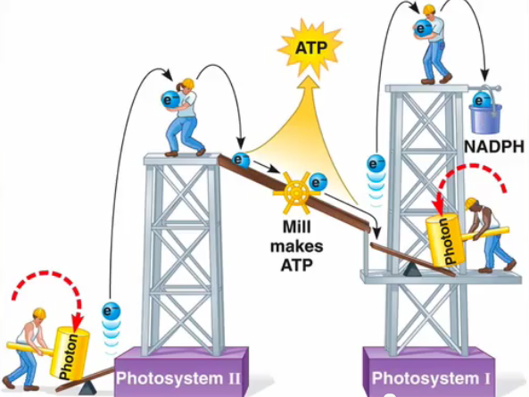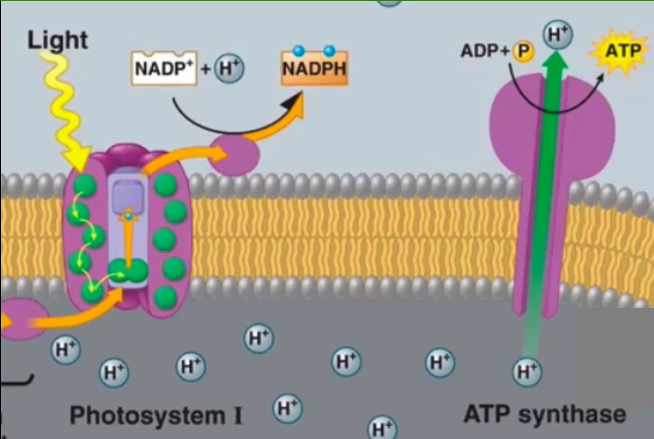
- Use the 2 illustrations above to explain the light dependent stage of photosynthesis.
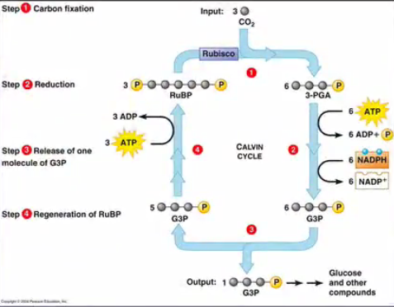
- Use the above illustration to explain how glucose is synthesized in the light independent reaction stage.
- What is photorespiration and why is photorespiration a problem?
- How do plants deal with photorespiration? Compare C₄ plants and CAM plants.

