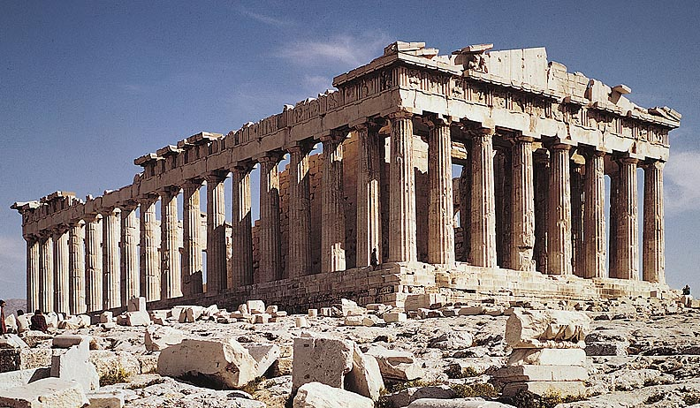

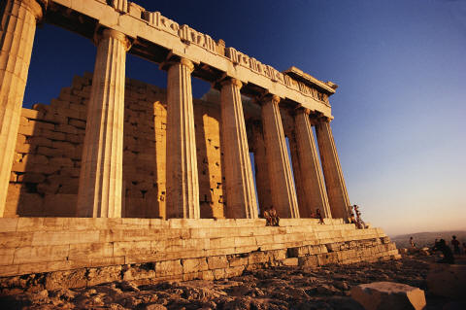

TABLE OF CONTENTS
- COVER PAGE -PG 17
- TABLE OF CONTENTS- PG 18
- GREEK ALPHABET HANDOUT -18B
- ANCIENT GREECE PACKET (WITH ALL THE GODS) 19B
- KWL -20
- APOLLONIAN VS DIONYSIAN HANDOUT -20b
- HEROE’S JOURNEY-21
- PPT ON ANCIENT GREECE- 21B
- HANDOUT ON HEROES,MORTALS, MONSTERS ETC 22
- HANDOUT ASSIGNMENT CHART/ DUE DATES 22B
- PPT ON GREEK GODS=23
- HANDOUT ESSENTIAL QUESTIONS FOR ANTIGONE-23B (THIS WAS DONE ON COMPOSITION BY MAJORITY)
- HANDOUT ON LOVE
- ANTIGONE PPT-24
- HANDOUT ON THE LIE PAGE24B
- HANDOUT FOR ANTIGONE 25 QUESTION PACK-
- HANDOUT FOR ANTIGONE ASSIGNMENT GROUP WORK PAGE 25B
- GREEK TEMPLE HANDOUT 26
- RUBRIC FOR ANTIGONE PROJECT 26B
- ALLEGORY TO THE CAVE QUESTION? 27

