Lesson 4: Solving for Unknown Angles Using Equations

Classwork
Opening Exercise
Four times the measurement of an angle is the complement of the angle. Find the measurement of the angle and its complement.

Example 1
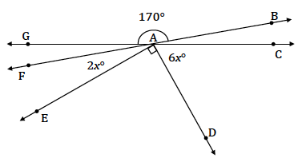
Find the measurement of $∠FAE$ and $∠CAD$.

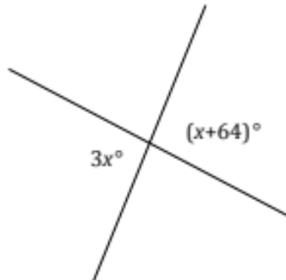
Two lines meet at a point. List the relevant angle relationship in the diagram. Set up and solve an equation to find the value of $x$. Find the measurement of one of the vertical angles.

Exercise 1
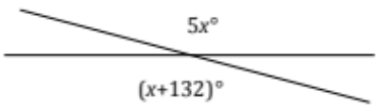
Set up and solve an equation to find the value of$x$. List the relevant angle relationship in the diagram. Find the measurement of one of the vertical angles.

Example 2
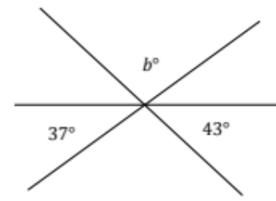
Three lines meet at a point. List the relevant angle relationships in the diagram. Set up and solve an equation to find the value of $b$.

Exercise 2
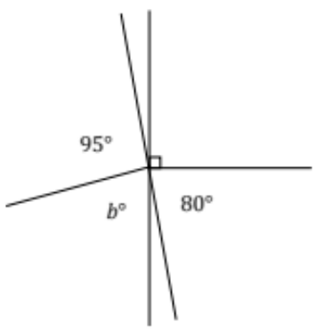
Two lines meet at the common vertex of two rays. List the relevant angle relationships in the diagram. Set up and solve an equation to find the value of $b$.

Example 3
The measurement of an angle is $\frac{2}{3}$ the measurement of its supplement. Find the measurement of the angle.

Exercise 3
The measurement of an angle is $\frac{1}{4}$ the measurement of its complement. Find the measurement of the angle.

Example 4
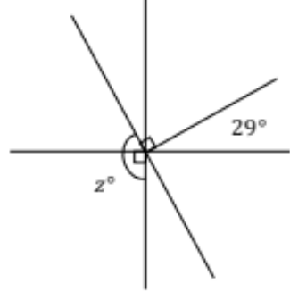
Three lines meet at the common vertex of a ray. List the relevant angle relationships in the diagram. Set up and solve an equation to find the value of $z$.

Exercise 4
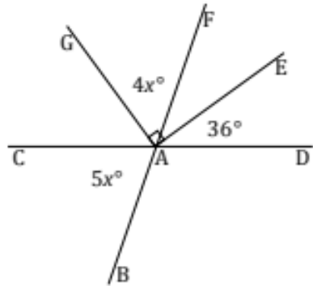
Two lines meet at the common vertex of two rays. Set up and solve an equation to find the value of $x$. Find the measurement of $∠GAF$ and of $∠BAC$.

Problem Set

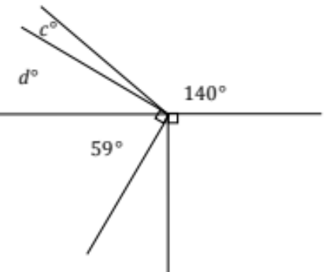
- Four rays have a common vertex on a line. Set up and solve an equation to find the value of $c$.

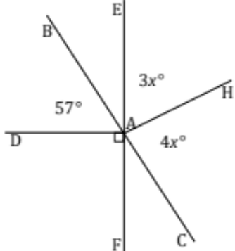
- Lines $\overset{⃡}{BC}$ and $\overset{⃡}{EF}$ meet at $A$. Set up and solve an equation to find the value of $x$. Find the measurements of $∠EAH$ and $∠HAC$.

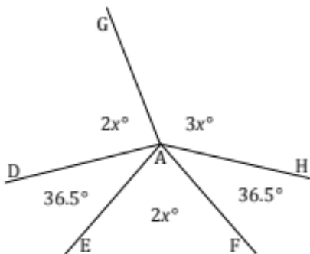
- Five rays meet at a point. Set up and solve an equation to find the values of $x$. Find the measurements of $∠DAG$ and $∠GAH$.

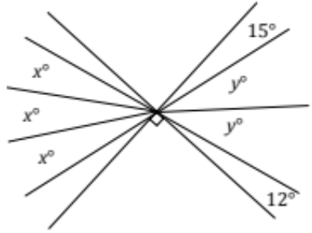
- Two perpendicular lines meet at the common vertex of seven rays. Set up and solve an equation to find the values of $x$ and$y$.

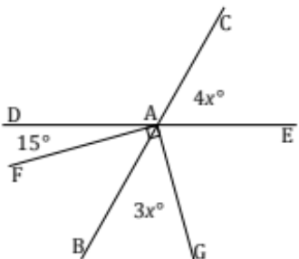
- Two lines meet at the common vertex of two perpendicular rays. Set up and solve an equation to find the value of $x$. Find the measurements of $∠CAE$ and $∠BAG$.

- Three angles are at a point. The second angle is $20°$ more than the first, and the third angle is $20°$ more than the second. Find the measurements of all three angles.

- Five angles are at a point. The measurement of each angle is one of five consecutive, positive whole numbers.
  - Determine the measurements of all five angles.
  - Compare the expressions you used for the three angles and their combined expression. Explain how they are equivalent and how they reveal different information about this situation.

- Let $x°$ be the measurement of an angle. The ratio of the measurement of the complement of the angle to the measurement of the supplement of the angle is $\frac{1}{3}$. Use a tape diagram to find the measurement of this angle.

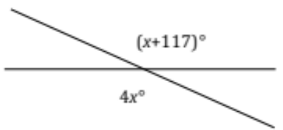
- Two lines meet at a point. Set up and solve an equation to find the value of $x$. Find the measurement of one of the vertical angles.

- The difference between three times the measurement of the complement of an angle and the measurement of the supplement of that angle is $20°$. What is the measurement of the angle?

