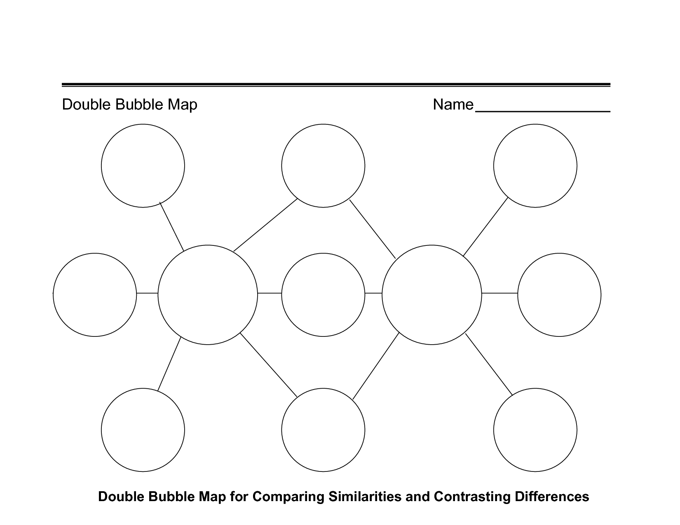
U.S.
Democracy
Greek
Democracy

