Welcome to the Principles of Democracy and Economics
It is with pleasure that I welcome you and your student to my Government/Economics class during the 2013- 2014 school year. I am looking forward to a very exciting year! Students will be given the opportunity to learn and enjoy Government/Economics through a variety of activities.
Course Description-
“Students in grade twelve pursue a deeper understanding of the institutions of American government. They compare systems of government in the world today and analyze the history and changing interpretations of the Constitution, the Bill of Rights, and the current state of the legislative, executive, and judiciary branches of government. An emphasis is placed on analyzing the relationship among federal, state, and local governments, with particular attention paid to important historical documents such as the Federalist Papers. These standards represent the culmination of civic literacy as students prepare to vote, participate in community activities, and assume the responsibilities of citizenship.
In addition to studying government in grade twelve, students will also master fundamental economic concepts, applying the tools (graphs, statistics, equations) from other subject areas to the understanding of operations and institutions of economic systems. Studied in a historic context are the basic economic principles of micro- and macroeconomics, international economics, comparative economic systems, measurement, and methods.” -California Department of Education
We will be using the RUSD adopted textbooks, as well as various supplemental and primary sources. This program closely follows the Social Studies/History California State Standards. The study of civics, democratic principles, economics, cause and effect relationships, making inferences, and interpreting information will be taught in connection to the textbook and students’ writing so that it becomes meaningful to them. Active, respectful participation in class and online discussions is an essential aspect of the learning process and the course. Vocabulary building will also be an integral part of our Social Studies class.

Attendance-
All students are expected to come to class every school day. If a student is truant, make up work will not be accepted- including tests. If you have an excused absence, you will have as many days to make up the work. Makeup tests or quizzes may be in an alternative form of the one originally issued and must be completed before (quizzes) or after school (tests). Students are expected to be seated and ready to work when the bell rings. Students not seated in his/her assigned desk when the bell rings will be marked tardy. School policy will be enforced. The teacher reserves the right to deduct one full letter grade for chronic attendance issues.

Homework-
Homework assignments will vary in amount and frequency. It is your student’s responsibility to write down all assignments in his/her agenda. Late work will not be accepted for full credit. Unless the student is absent or prior arrangements have been made, the late assignment will receive a maximum of 60% (D-).

Grading Scale-

100% - 90% --A
89% - 80% -- B
79% - 70% -- C
69% - 60% -- D
59% & below --

Interactive Student Notebooks (ISN)-
Each student will be required to keep an interactive notebook where most of his or her assignments and projects will be kept. Students are required to bring this notebook to each and every class. These notebooks will be reviewed and graded regularly. It is imperative that students keep these ISNs updated and neatly organized. In class, I will show the students how to put his/her Interactive Student Notebook effectively use and organize their ISN.
Materials-
2 spiral bound notebooks: college-ruled, 150 pages (suggested: Mead Five Star 3 subject or Elite from Staples)
- Ballpoint pens (blue, black and red)
- Pencils & erasers
- Highlighters
- Colored Pencils
- Scissors (small)
- Glue sticks & roll of Scotch tape
        - Post-it Notes (3”x 3” recommended)
- Flash Drive (512 MB minimum)

It is my goal that your child will have a successful semester in Govt./Econ. The time you spend helping and encouraging your student is greatly appreciated. With your support and encouragement, I anticipate a great year. Periodically, you will receive an update on your student’s progress. If you ever have any questions or concerns, the best way to contact me is through email at: lsmith@rowland.k12.ca.us. If email is not an option, you can leave a message for me with your name and phone number at the office.
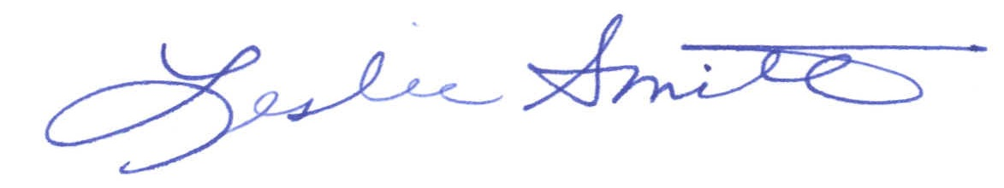
Sincerely,

Leslie Smith
Social Studies Department
Do not detach.

(Please check)
______ My child has access to the Internet at home. (For homework and research purposes.)
______ My child does not have access to the Internet at home.
Name of student (printed): ______________________________________________
Parent / Guardian Email address: ___________________________________
Parent / Guardian signature: _______________________________________

