Name ___________________Period __
Points Possible___ Points Received ___
Cold War Learning Centers
Data Sheets
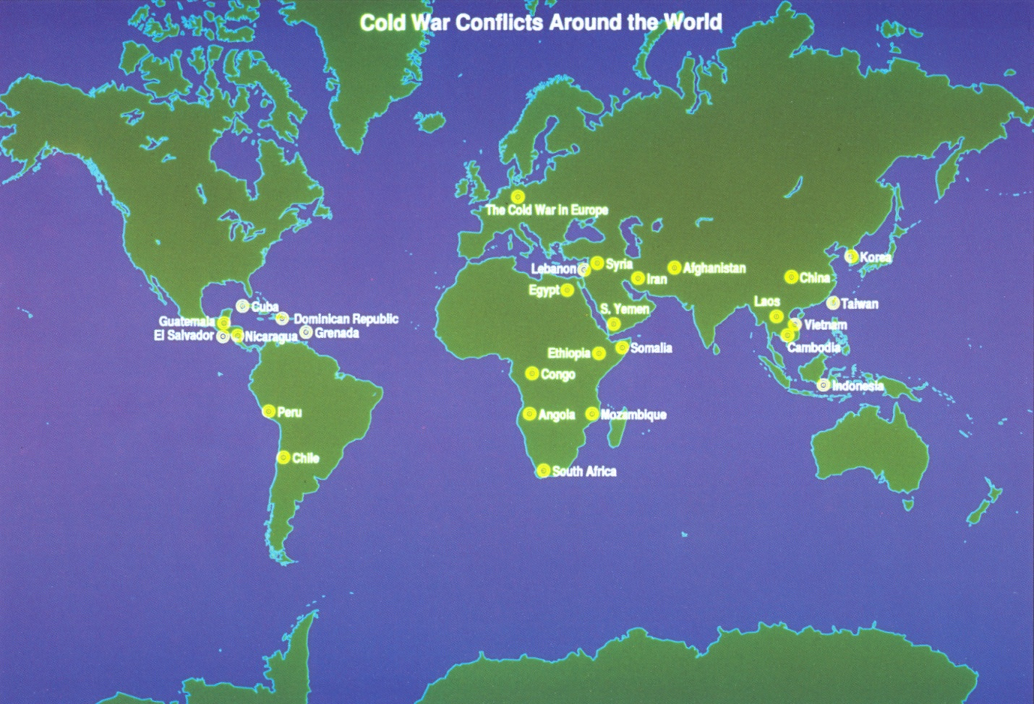

Data Sheet #1: Latin America
Directions: As you read the information about the Cold War in Latin America, complete the chart below with the important dates, people, words and a one sentence summary.
Country | Date | Important People | Three important words | One sentence summary
Cuba
Paragraph 1

Cuba
Paragraph 2

Chili

Nicaragua

Data Sheet #2: Southeast Asia
Directions: Create a memorial commemorating the Vietnam War. Be sure to include:
- A symbolic or representational monument memorializing the contributions of the people, places or events of the war that can either be placed in Vietnam or America.
- A dedication space that should include:
  - an appropriate name for the memorial
  - 2-3 concrete examples of specific contributions
- Be creative! Use color, perspective, anything that will make this memorial design stand-out.


Data Sheet #3: The Middle East
Directions: After you read about the Cold War in the Middle East, list important words or phrases that relate to each country below.
Egypt
Afghanistan

________________________________
________________________________
________________________________
________________________________
________________________________
________________________________
________________________________

________________________________
________________________________
________________________________
________________________________
________________________________
________________________________
________________________________

________________________________
________________________________
________________________________
________________________________
________________________________
________________________________
________________________________

Iran
The Middle East

Data Sheet #4: Africa
Directions: Summarize the main points of the topics below. Then create a symbol to represent the information you learned about the Cold War in Africa.

SYMBOL
Introduction
Congo

Angola
Mozambique
Data Sheet #5: Korea
Directions: As you read about the Cold War in Korea, summarize the events in order in the sequence chart below.

Data Sheet #6: Israel
Directions: Tell how each of the following people might answer this question:
Do you think the Palestinians have a right to a homeland? Why or why not?

From what you have read, create one quote as a response to this question and list their character qualities/traits as evidence of the way you think they might respond.
Sir Arthur Balfour  Character Traits: | Anwar Sadat  Character Traits:
Yasir Arafat  Character Traits: | President Jimmy Carter  Character Traits:

