AP Psychology Name________________________________

Good Will Hunting: Movie Analysis of Erik Erikson’s Theory

Background: Will Hunting (Matt Damon) is a headstrong, working-class kid from a tough Boston neighborhood with a difficult background. He also happens to be a genius! After one too many run-ins with the law, Will’s last chance is a psychology professor (Robin Williams) with issues of his own. We are going to analyze four characters; where they may have become fixated on Erikson’s stages, and how they have attempted to meet the challenges of the stages they are currently in.

Will Hunting: age 20-21 (Matt Damon)

1. Will has definitely had trouble progressing through stages one thru six. Which of the first four stages is he fixated at? Why?

2. Describe how this fixation is causing Will problems at both stage five & six.

3. List and explain two different examples of defense mechanisms that Will uses to protect his ego.

Professor Gerald Lambeau: age is upper 40’s (Stellan Skarsgard)

1. Which stage early stage of developemnt does Lambeau find hemself is fixated once he meets Will?

2. Professor Lambeau is also going through stage seven of personality development. Describe if you think he is stagnating or growing. Use evidence from the movie to support your answer.

Sean Maguire: age is upper 40’s (Robin Williams won an Oscar for this performance)

1. Sean is at stage seven of Erikson’s theory of personality development. However, he is stagnating because of something that happened at one of the lower stages. What stage did this fixation happen? Why did it happen?

2. Provide evidence for the movie why Sean is stagnating at stage seven.

3. Sean snaps out of his stagnation during the movie. What motivates him to do this? How will he now show growth instead of stagnation?

Skylar: age is early 20’s (Minnie Driver)

1. How has Skylar mastered the conflict of stage five?

2. How does Skylar attempt to master the conflict of stage six?

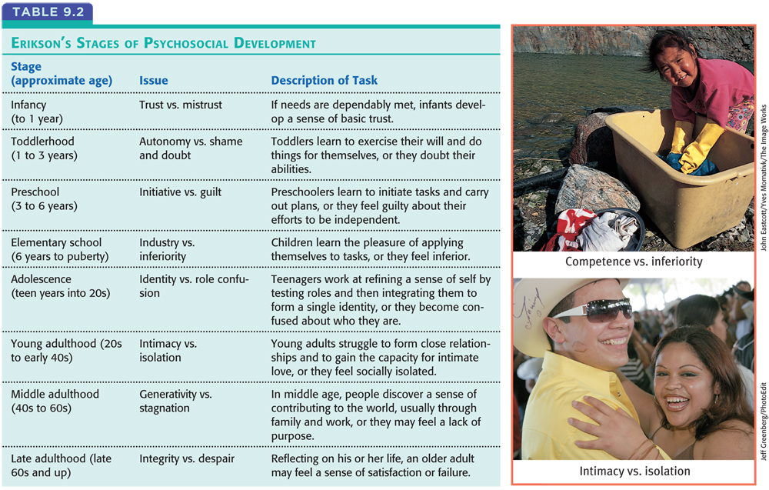

Freudian Defense Mechanisms
• Regression allows us to retreat to an earlier, more infantile stage of development. Facing the anxious first days of school, a child may regress to the oral comfort of thumb-sucking. Juvenile monkeys, when anxious, retreat to infantile clinging to their mothers or to one another (Suomi, 1987). Even homesick new college students may long for the security and comfort of home.
• Reaction formation, the ego unconsciously makes unacceptable impulses look like their opposites. En route to consciousness, the unacceptable proposition “I hate Dad” becomes “I love him.” Timidity becomes daring. Feelings of inadequacy become bravado.
• Projection disguises threatening impulses by attributing them to others. Thus, “He doesn’t trust me” may be a projection of the actual feeling “I don’t trust him” or “I don’t trust myself.” An El Salvadoran saying captures the idea: “The thief thinks everyone else is a thief.”
• Rationalization occurs when we unconsciously generate self-justifying explanations to hide from ourselves the real reasons for our actions. Thus, habitual drinkers may say they drink with their friends “just to be sociable.” Students who fail to study may rationalize, “All work and no play makes Jack [or Jill] a dull person.”
• Displacement diverts sexual or aggressive impulses toward an object or person that is psychologically more acceptable than the one that aroused the feelings. Children who fear expressing anger against their parents may displace it by kicking the family pet. Students upset over a test may snap at a friend.
• Sublimation is the transformation of unacceptable impulses into socially valued motivations. Sublimation is therefore socially adaptive and may even be a wellspring for great cultural and artistic achievements. Freud suggested that Leonardo da Vinci’s paintings of Madonnas were a sublimation of his longing for intimacy with his mother, who was separated from him at an early age.
• Denial protects the person from real events that are painful to accept, either by rejecting a fact or its seriousness. Dying patients may deny the gravity of their illness. Parents may deny their child’s misconduct. Spouses may deny evidence of their partner’s affairs.

