Interstate Commerce Act

Members of the Grange, known as Grangers, demanded governmental control over the railroad industry. They were angry with railroad companies for setting high prices that kept farmers in debt. Grangers also wanted companies to stop charging different customers different rates.

The United States Congress passed the Interstate Commerce Act in 1887. This act established the right of the federal government to supervise railroad activities and established a five-member Interstate Commerce Commission for that purpose.

If you have time after completing the graphic organizer, read the following:

Excerpts from the Act:

All charges made for any service rendered or to be rendered in the transportation of passengers or property as aforesaid [by railroad], or in connection therewith, or for the receiving, delivering, storage, or handling of such property, shall be reasonable and just; and every unjust and unreasonable charge for such service is prohibited and declared to be unlawful.

SEC. 2. That if any common carrier subject to the provisions of this act shall, directly or indirectly, by any special rate, rebate, drawback, or other device, charge, demand, collect, or receive from any person or persons a greater or less compensation for any service rendered, or to be rendered, in the transportation of passengers or property, subject to the provisions of this act, than it charges, demands, collects, or receives from any other person or persons for doing for him or them a like and contemporaneous service in the transportation of a like kind of traffic under substantially similar circumstances and conditions, such common carrier shall be deemed guilty of unjust discrimination, which, is hereby prohibited and declared to be unlawful.

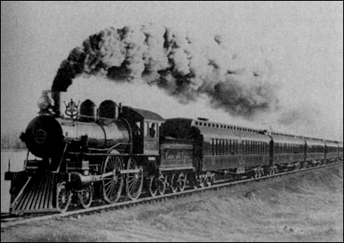
Sherman Antitrust Act

This act, passed in 1890, made it illegal to form a trust that interfered with free trade between states or with other countries. A trust, or monopoly, is when one group has control over several business firms, usually in the same industry. Businesses that have monopolies are able to raise prices for consumers because there is no competition.

Prosecuting companies under the Sherman Act was difficult because the act didn’t clearly define the word trust. Eventually, the government stopped trying to enforce the act and the consolidation of businesses continued.

If you have time after completing the graphic organizer, read the following:



The Fate of Apple and Antitrust: Overcoming Confusion About the eBooks Case

Chris Sagers Posted: 06/23/2013 5:24 pm
In April 2012, the U.S. Department of Justice and 33 states brought civil antitrust action against Apple, alleging violations of the Sherman Antitrust Act. In July 2013, Apple was declared guilty of violating the federal law by conspiring with book publishers to eliminate competition and raise the prices of e-books.

As the Justice Department's so-called "eBooks" antitrust trial winds down in a Manhattan federal courtroom, it is remarkable how many people have failed to see how easy the case really is. Defendant Apple, as the government has shown by overwhelming evidence, orchestrated a price-fixing conspiracy among five of the six large publishing companies that dominate electronic books. They had motive to do it and the evidence is strong that they successfully raised retail prices for a long time…And yet, any number of perfectly intelligent observers have bent over backwards to defend Apple's conduct. Why should that be?
It is not because the case is complicated. While Apple urges that electronic publishing is very complex and special -- the kind of argument that antitrust defendants have always made as long as there's been antitrust -- the case is simple. Cheap eBook prices, especially those offered by the market leading retailer Amazon, threatened the reliable revenues that publishers had enjoyed from hard-cover new releases. Publishing companies were at Amazon's mercy, in light of its massive market share, until they found a partner in Apple, which just then was launching its new iPad. With the iPad's eBook sales potential, and Apple's eagerness to coordinate agreement among them (in exchange for a cut of the spoils), the publishers found they could get their retail prices up and impose them on Amazon lest it lose access to their eBooks. In other words, as has happened throughout modern capitalism, this group of incumbent sellers faced the threat of disruptive, desirable innovation by collectively coercing the innovator. It's simple, and it's happened thousands of times.

Andrew Carnegie

Andrew Carnegie was born in 1835 in Scotland. After moving to the United States, he worked a series of railroad jobs. While working for railroads, Carnegie began making investments. By 1889 he owned Carnegie Steel Corporation, the largest of its kind in the world. His business revolutionized steel production in the United States. Carnegie built plants around the country, using technology and methods that made manufacturing steel easier, faster and more productive. For every step of the process, he owned exactly what he needed: the raw materials, ships and railroads for transporting the goods, and even coalfields to fuel the steel furnaces. This start-to-finish strategy helped Carnegie become the dominant force in the industry and an exceedingly wealthy man. It also made him known as one of America's "builders," as his business helped to fuel the economy and shape the nation into what it is today.

In 1901 he sold his business and dedicated his time to expanding his philanthropic work, including the establishment of Carnegie-Mellon University in 1904.
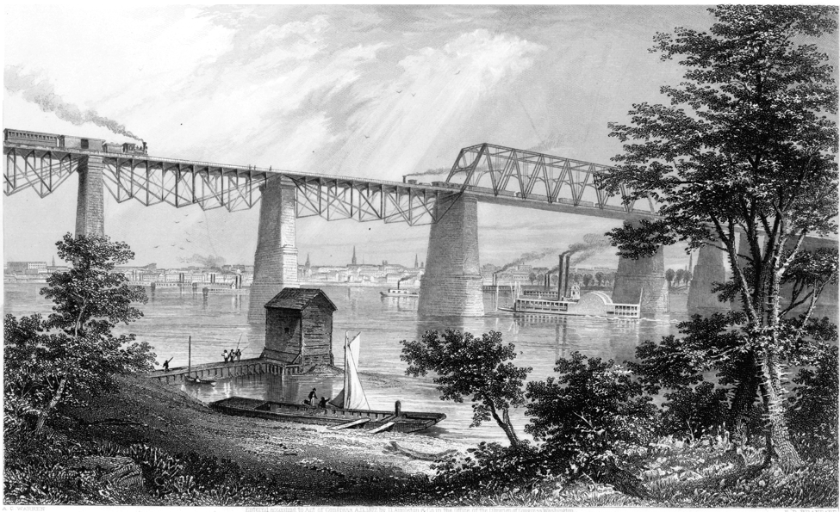
[Steel was used to create the railroad]
If you have time after completing the graphic organizer, read the following:

Homestead strike
The Homestead Strike was a bitterly fought labor dispute between Carnegie Steel Company and its laborers. On June 29, 1892, workers belonging to a union struck the Carnegie Steel Company at Homestead, Pa. to protest a proposed wage cut. Henry C. Frick, the company's general manager, determined to break the union. He hired 300 Pinkerton detectives to protect the plant and strikebreakers. After an armed battle between the workers and the detectives on July 6, in which several men were killed or wounded, the governor called out the state militia. The plant opened, nonunion workers stayed on the job, and the strike, which was officially called off on Nov. 20, was broken. The Homestead strike led to a serious weakening of unionism in the steel industry until the 1930s.

John Rockefeller
John D. Rockefeller was born in 1839 in New York. In 1870 he created the Standard Oil Company. By 1882 he had a near-monopoly of the oil business in the U.S. Standard's dominance stemmed from its near control (and ownership) of almost every aspect the business. Under Rockefeller's leadership, the company established a system of pipelines to transport its product. It owned train cars, and scooped up thousands of acres of forest for fuel.
But as Rockefeller's power and wealth increased, his standing with the public nose-dived. By the early 1800s states began to enact antimonopoly legislation, paving the way for the 1890 passage of the Sherman Antitrust Act.
Late in life Rockefeller devoted himself to philanthropy.
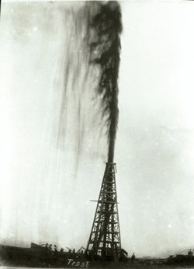
If you have time after completing the graphic organizer, read the following:

Excerpt from Ida Tarbell’s The History of Standard Oil:
With Mr. Rockefeller’s genius for detail there went a sense of the big and vital factors in the oil business and a daring in laying hold of them which was very like military genius. He saw strategic points like a Napoleon and he swooped on them with the suddenness of a Napoleon. Mr. Rockefeller’s capture of the Cleveland refineries in 1872 was as dazzling an achievement as it was a hateful one. The campaign … viewed simply as a piece of brigandage, was admirable. The man saw what was necessary to his purpose and he never hesitated before it. His courage was steady -- and his faith in his ideas unwavering. He simply knew what was the thing to do, and he went ahead with the serenity of the man who knows.

J.P. Morgan
J.P. Morgan was born in 1837 in Connecticut; he was the son of a banker, and he went into the family business. In 1871, Morgan began J.P. Morgan & Co., one of the leading financial firms in the country. It was so powerful that even the U.S. government looked to the firm for help with the depression of 1895. He was criticized for creating monopolies by making it difficult for any business to compete against his. Morgan was hailed as a master of finance at the time of his death, and continues to be considered one of the country's leading businessmen. J.P. Morgan & Co. is now called Chase Bank.



If you have time after completing the graphic organizer, read the following:

Source: www.chase.com

About Chase
Chase is the U.S. consumer and commercial banking business of JPMorgan Chase & Co., a leading global financial services firm with assets of $2.3 trillion and operations in more than 60 countries. We are the neighborhood bank for thousands of communities across the country. We serve approximately one of out of every six Americans through more than 5,600 bank branches; 20,000 ATMs; mortgage offices; online and mobile banking; as well as relationships with auto dealerships, schools and universities.

