Assg: ALL Assignment to be completed in notebook.

Bozeman: Mitosis
http://youtu.be/wJq4siahCSE

Watch the following video on MITOSIS which can be found on our school website. Answer the following questions in your notebook. Write the question out with the answer OR write with complete sentences. Show me for credit when finished.

- What is mitosis?
- Write true or false. All cells divide by a process of mitosis.
- Bacteria divide by what process. Explain how this happens.
- Draw the following picture and table in your notebook. On the picture, identify the phases of the cell cycle. Then in the table, describe the events that occur during each phase of the cell cycle.
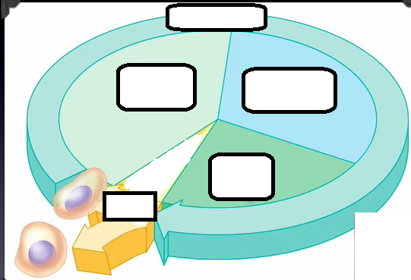 | Phase of the cell cycle | What happens during that phase?
 | G₁
 | S
 | G₂
 | M
- Write true or false. A cell spends most of its time during the mitotic phase (M).
- Describe how the cell and its DNA looks like during interphase.
- At what part of the cell cycle do sister chromatids originate?
- Describe what a homologous chromosome is? Where did it come from? What information does it carry?
- Draw the following table in your notebook. Describe the events that occur during each phase of mitosis.
Phase of mitosis | What happens during that phase?
“P” or ____________
“M” or ____________
“A” or ____________
“T” or ____________
cytokinesis
- Explain the difference between cytokinesis during plants and animals.
- What are growth factors? Why are they important?
- What is the G₀ phase? What cells are in this phase in our bodies?
- How is cancer related to mitosis?

