Movie: World in the Balance (5)

1. What countries have the highest population growth?

2. What cultural factors affect population growth?

3. What role does gender play in population growth?

4. What role does education (literacy) play in population growth?

5. What technology can be used to limit population growth?

6. What is the global fertility rate?

7. How will developing countries fight large population increases in the future?

8. Which countries are experiencing a population decline?

9. What is an age structure pyramid and why are they important in calculating population growth?

10. What environmental factor might cause a large indent in a population pyramid?

11. What is the average family size in the industrialized world?

12. How will industrialized countries maintain an educated workforce in their future?

13. Is it easier to cut fertility or to raise it? Explain your reasoning.

14. What environmental factors affect population size?

15. What environmental problems are caused by a population explosion?

16. What is family planning?

17. What factors influence the success of family planning?

18. How has HIV/AID affected population growth in Africa?

19. What cultural and environmental factors promote the transmission of HIV/AIDS?

20. What is a country strongest resource in controlling population growth?

21. How does poverty affect population growth?

22. How does international policy affect population growth in developing countries?

23. At what point do we think global population growth will stabilize?

See extension questions on the back
- Examine the age structure diagrams of Sweden and Kenya below, and answer the question that follow.
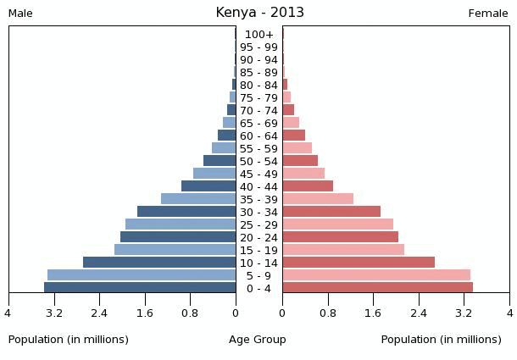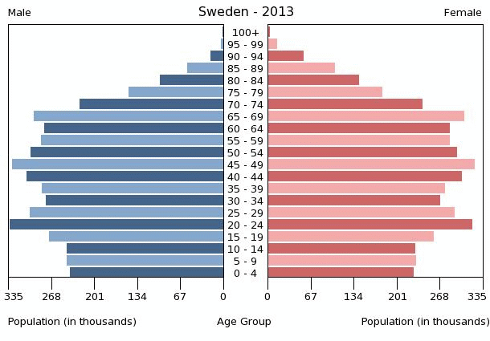
- Compare and contrast the two age structure diagrams in terms of two population dynamics-birth & death rate.
- What factors affect birth and death rates?
- Discuss methods that have been employed in another country to curb population growth.
- The diagram below illustrates the demographic transition model of the relationship between economic status and population.
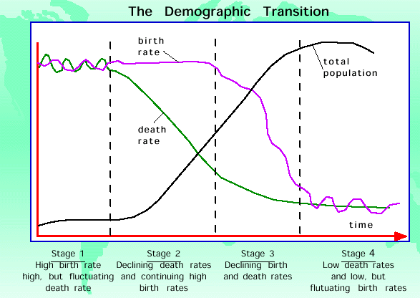
Post-industrial
Industrial
Transitional
Pre-Industrial
- In phases 2 and 3, there is a large difference between the birth and death rate. Describe the effects on the overall population as a result of this difference. Explain why the population doubling time during these phases is short.
- Choose one of the four phases and describe an economic factor that would account for the differences between birth and death rate.
- Describe one biological method of birth control.
- Population experts have reported that in some developing countries, the population is experiencing a reverse transition from phase 2 to 1. Describe what would happen to a country’s population and describe one event that would cause this transition.

