Slide | Notes | Critical Thinking Queston
A: Bob La Follette  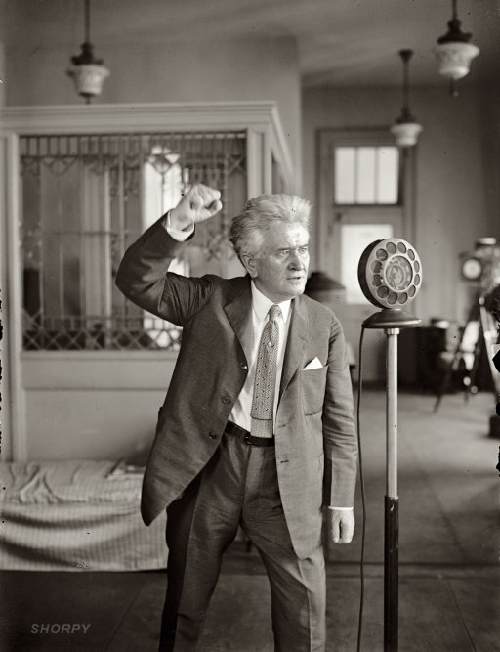 |  | Write what you think he is talking about.
B: Ida Tarbell  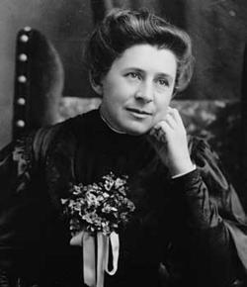 |  | Why do you think they were called “muckrakers?”
C: Coal Miner  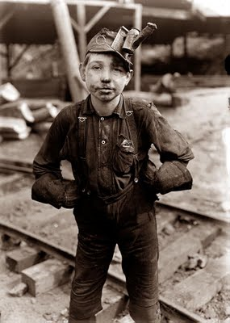 |  | What problems might this boy face now and in the future? Who should protect him?
D:Meat Scandal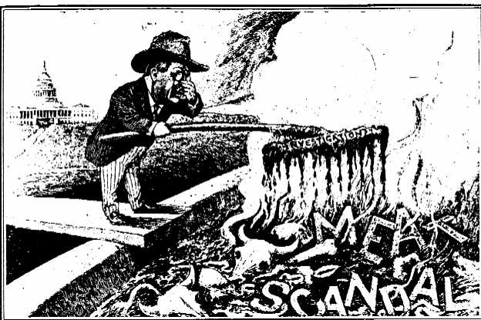 |  | Does the cartoonist support changes to help consumers or is he poking fun at the meat scandal investigation?
E: Teddy Roosevelt  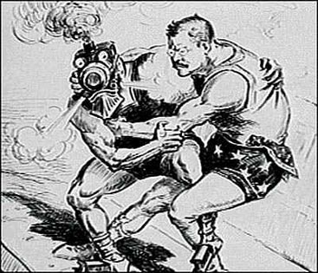 |  | What do you think is the cartoonist’s intended message?
F: Women’s Suffrage  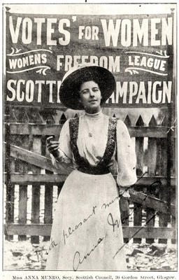 |  | Why did the Progressive movement concern itself with suffrage?
G: Teddy Roosevelt and John Muir  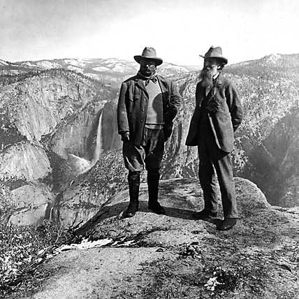 |  | How were America’s natural resources affected by industrialization and urbanization?
H: W.E.B. Du Bois  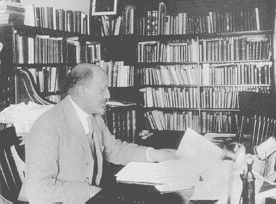 |  | Why didn’t the Progressives fight for civil rights for blacks?

