TORTILLA ESPAñOLA
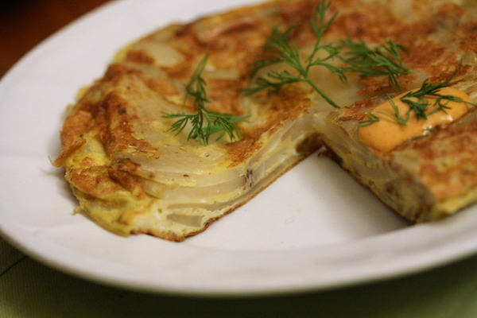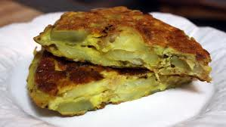
Watch this video: http://video.about.com/spanishfood/Tortilla-Espanola.htmredients:
- 4 to 5 med. Potatoes
- 1 sm. Onion
- 6 eggs
- 1 clove of garlic
- 2 teaspoons Salt
- 3 cups Olive oil
Instructions: Cut up the potatoes in small pieces, put them in a fry pan with olive oil. Dice the onion and the garlic clove and add them to the fry pan with the potatoes. Then add a little salt let everything fry until the potatoes are golden brown. While the potatoes, onions and garlic are cooking, beat the 6 eggs. When potatoes are golden bown, add the eggs (beaten) and mix everything well. Let it cook for 3 to 5 minutes on medium. At this point you will need to flip the tortilla over to cook the other side. In order to do this, put a plate on top of the fry pan and flip it over. Then slide the tortilla back onto the fry pan and let it cook for another 3 to 5 minutes until done.

ESPAÑA É Í Ó Á ¿ é ó á í
aña
GAZPACHO
Watch this video: http://allrecipes.com/video/125/how-to-make-gazpacho/detail.aspx
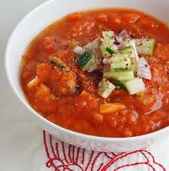
Ingredients:
Stale (day old) baguette of French bread
3 cups diced peeled tomatoes
3 cloves of garlic
2/3 cup diced green bell peppers
2/3 cup peeled and diced cucumber
1/3 cup diced red onion
1 ½ cups of tomato juice
Hot pepper sauce
Salt and pepper
Instructions :  1. Cut a piece of stale French bread into cubes  2.cover with water and let stand until bread is soft (about 5 mintues)  3. squeeze out the water  4. in a food processor combine the bread with 3 cloves of garlic, 3 cups of diced peeled tomatos, 2/3 cup dice dgreen bell peppers, 2/3 cup peeled and id iced cucumber, ½ cup diced red onion.  5. Process the mixture until it becomes a coarse puree. | 6. Pour into a large serving bowl  7. Stir in 1 ½ cups of tomato juice  8. add 2 tablespoons of extra virgin olive oil  9. add 2 tablespoons of red wine vinegar  10. add Hot pepper salt to taste  11. add Salt and pepper to taste  12. Cover and refrigerate until well-chilled  12. Garnish with cucumber (optional)  13. Drizzle with olive oil (optional)

PAN CON TOMATE

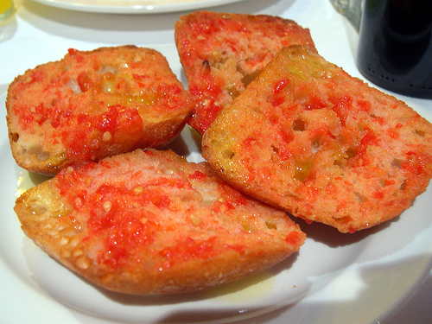
You can follow this recipe or one at this website http://spanishfood.about.com/od/tapas/ss/pancontomate.htm
Whether it's breakfast, lunch, tapas, or dinner, a Spanish meal is pretty much unimaginable without a slice of country bread rubbed with a tomato half and drizzled with fruity olive oil.
- Ingredients:
• 12 to 16 thick slices of crusty, very coarse-textured bread such as ciabatta
• 2 to 3 cloves of garlic (optional)
• 4 very ripe, juicy medium tomatoes
• Extra-virgin olive oil to drizzle
• Coarse salt
- Directions:
1. Toast bread slices in the oven, turning once, or in a toaster until golden brown
- 2. Peel garlic, if using, and rub desired amount on toasted bread. Cut tomatoes in half crosswise and rub toast with cut side of tomatoes, squeezing gently so that each piece of toast is coated with juice, bits of tomato flesh, and seeds. Drizzle toast with olive oil and sprinkle with salt to taste.
Source: Recipes © 2005 from The New Spanish Table by Anya von Bremzen. Featuring over 300 unique recipes, The New Spanish Table protrays the food and culture of Spain at its most vibrant. The perfect pairing for delicious Spanish wines!. (Workman Publishing Co. Inc.)

PAN CON JAMÓN SERRANO Y QUESO MANCHEGO

Ham and cheese with Bread Recipe
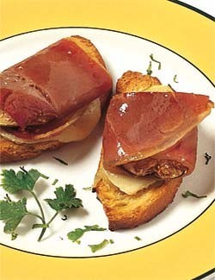 | Adapted from: http://spanishfood.about.com/od/tapas/r/jamonqueso.htm  Prep Time: 15 minutes Cook Time: 10 minutes Total Time: 25 minutes  Ingredients:  - 2 French-style baguettes  - 1/2 lb (250 gr) Manchego cheese. You MUST use manchego – do not substitue with another kind of cheese.  - 1/4 lb (125 gr) Serrano ham (if you can’t find this substitute prosciutto) Serrano Ham: Depending on where you live, Serrano Ham may be a bit difficult to purchase locally. If after a few calls to speciality supermarkets and/or ethnic grocery stores in your area does not turn up anything, substitute prosciutto for the serrano ham
Instructions: in order to accommodate non-meat eaters, please have two plates. One plate with the baguette slices with the manchego on top and a separate plate for the jamón serrano.
- Slice the crusty baguette, making the slices about a 1/3-inch thick. Put the slices of bread into a basket.
- Slice the Manchego cheese, approximately 1/8 – 1/4-inch thick. Slicing the cheese thinly may prove tricky because it is dry and crumbly. Don´t worry, you´ll only need small pieces to place one on each piece of bread.
- If you have a whole piece of jamón, you’ll want to slice it in paper-thin slices. If you purchased the jamón already sliced, cut the slices into pieces small enough to fit on the top of a baguette slice. Put the jamón onto a different plate than the jamón.

PATATAS BRAVAS

http://allrecipes.com/recipe/authentic-patatas-bravas/?scale=4&ismetric=0
- 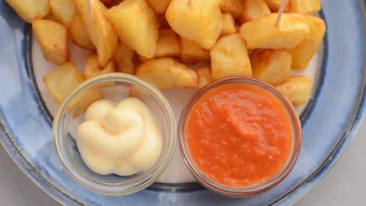

- Ingredients for 4 servings  - 4 russet potatoes, peeled and cut into 1-inch cubes  - 4 cups olive oil  - 2 tablespoons salt  - 1/4 cup and 2 tablespoons olive oil  - 2 onion, diced  - 2 teaspoons salt  - 2 cloves garlic, finely chopped  - 2 red chile, minced  - 1 teaspoon smoked paprika  - 2 (14 ounce) cans whole peeled tomatoes, drained  - 1/2 cup mayonnaise | Directions  NOTE: Recipe directions are for the original serving size of 2.  - Combine potatoes, 4 cups olive oil, and 2 teaspoons salt in a large cold skillet. Heat on low and cook until potatoes are softened, 12 to 15 minutes. Increase heat to high and fry until golden, 5 to 6 minutes. Drain on paper towels.  - Heat 3 tablespoons olive oil in a large saucepan over medium heat. Cook and stir onion with 1 teaspoon salt in the hot oil until onion has softened, 3 to 4 minutes. Add garlic, chile, and smoked paprika; simmer for 1 to 2 minutes. Stir in tomatoes and return to a simmer. Transfer tomato mixture to a blender, cover, and puree until tomato sauce is smooth.  Serve patatas bravas with tomato puree and and mayonnaise for dipping

ENSALADILLA RUSA http://spanishfood.about.com/od/soupssalads/r/ensaladillarusa.htm
Ingredients:  - 7 medium potatoes  - 2 roasted red peppers (bottled is fine)  - 1 16 oz can of peas and carrots, drained  - 2 hard-boiled eggs  - 1 6 oz can tuna, drained  - 1 ½ cups mayonnaise  - 4-5 spears white asparagus for garnish | 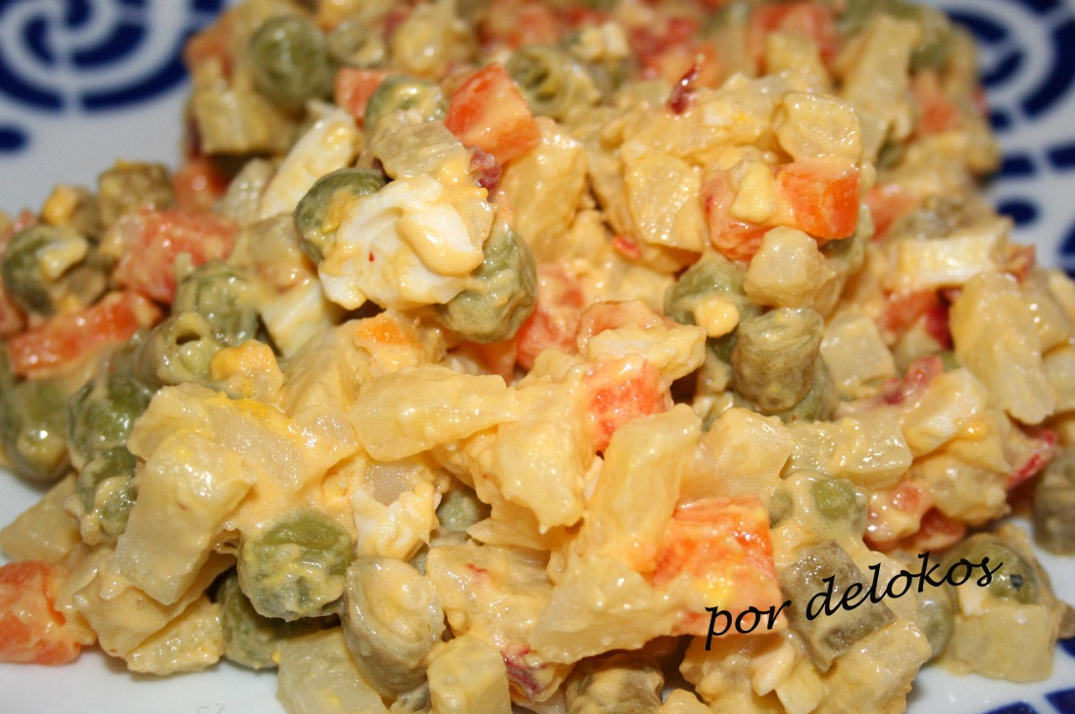

Preparation:
This Spanish potato salad recipe makes 6 servings.
Scrub the potatoes to clean off any lose dirt and sand. Pour water into a large pot, cover and bring to a boil on high heat. Place potatoes in the pot and boil them with skins on until they are cooked, but not too soft. Test the doneness by pricking with a fork to make sure they are cooked, but still firm. Don’t overcook the potatoes or when mixing the salad, you’ll end up with mashed potatoes!
Boil the eggs until hard. Cool the eggs.
Drain the water from the pot and add cold water to the pot, covering the potatoes. Change every few minutes until the potatoes are cool enough to handle with your bare hands. Refrigerate for a few minutes to cool further.
Remove from refrigerator and peel potatoes. Cut into small (approximately 1/2") cubes. Return to refrigerator while you prepare the other ingredients.
Put approximately 1 1/2 cups of mayonnaise into a bowl. Slice 1 of the roasted pepper into strips about 1/3 inch wide, then cut into smaller pieces and add to bowl. Drain tuna thoroughly, then crumble with a fork and add to bowl. Drain carrots and peas and add to bowl. Peel 1 egg, chop and add to bowl. Mix all ingredients together.
Add the mayonnaise mixture to the potatoes and mix thoroughly. If necessary, add more mayonnaise. Smooth top of potato salad, preparing for decoration.
Slice remaining red pepper into thin strips and arrange on top of salad. Drain the white asparagus and slice hard-boiled eggs carefully. Use both to decorate the salad.

CHAMPINONES AL AJILLO – FRIED MUSHROOMS
http://www.food.com/recipe/champinones-al-ajillo-tapas-style-garlic-mushrooms-369646
INGREDIENTS | Instructions
6 tablespoons extra virgin olive oil  1 pound medium mushrooms Stemmed, quartered  8-12 garlic cloves - peeled and thinly sliced  4-6 teaspoons fresh lemon juice  4 tablespoons dry sherry (do not use cooking sherry)  ½ cup vegetable Broth  1 teaspoon Paprika  ½ teaspoon crushed Red pepper flakes  2 teaspoons Salt to taste  1 teaspoon Ground black pepper – to taste  2 tablespoons fresh flat leaf parsley | the olive oil until hot but In  1. In a sauté pan heat the olive oil hot but not smoking.  2. Sauté the mushrooms for about 1 minute, add the garlic and cook 1-2 minutes more being careful not to burn.  3. Garnish with the fresh parsley. Serve with lemon slices. Scoop the mushrooms onto your bread and enjoy!

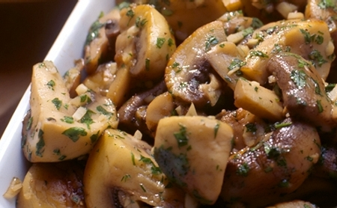

Croquetas
Video: http://seriouslyspain.com/how-to-make-the-best-spanish-croquetas-croquettes-video
This video is narrated by a man who uses the metric system (which is what just about everyone except for the US uses), so he refers to grams and liters. I’ve converted them for you below.
Ingredients:
7 ounces of ham ( in the video the guy says 200 grams)
3 ½ ounces of flour (in the video the guy says100 grams)
Flour to roll your croquettes in before rolling in breadcrumbs
1 Egg
Unsalted Butter = 3/12 ounces of unsalted butter (in the video the guy says 100 grams)
Breadcrumbs
2 cups o milk (in the video the guy says ½ liter)
2 teaspoons of Nutmeg
Instructions: follow the instructions in the video
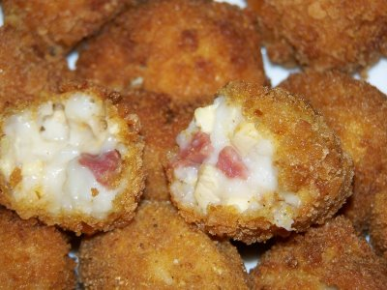 | 