Duccio and Lorenzetti
Altars and Altarpieces
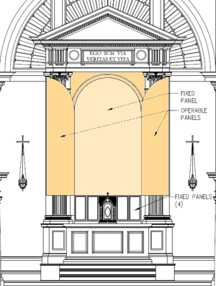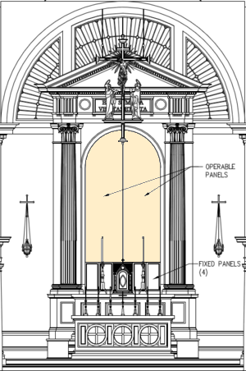
Is the altarpiece represented to the right a
diptych, a triptych, or a polyptych?
How can you tell?

Please label the predella.
Please label the altar.

What is Marian Literature?

Gothic Style
How can we characterize the Gothic Style?
- figures become more animated in pose and facial expression;
- they tend to be smaller in relation to the background of scenes, and
- they are arranged more freely in the pictorial space, where there is room
- in illuminations, decorative page framing that is reminiscent of the architecture of the period is used;
- figures are elongated and detailed
What do you notice about each of these works?

Angel from the Visitation Group
1211-25
Cathedral, Reims
Jean Pucellle
Pages with Betrayal and Arrest of Christ
and Annunciation
from The Book of Hours of Jeanne d’Evreux
c. 1325-1328

Virgin and Child
Abbey Church of St. Denis
c. 1339
Is Giotto Gothic?
In 1204, the Crusaders captured Constantinople? How did this victory affect the production of art in Italy?
As a result there was an influx of Byzantine art and artists in Italy

- faces and figures are strictly frontal and symmetrical;
- modeling from light to dark is accomplished through repeated colored lines of varying width in three different shades: dark medium and light;
- details of faces, hair, hands and muscles are turned into elegant patterns

Byzantine Style:

See Christ’s stomach:
Christus Patiens -- Crucifix
Coppo di Marcovaldo 1250-1300
What do you notice about this work?

Duccio
Duccio di Buoninsegna (active 1278-1319)

Where did Duccio work?

Maesta
two-sided altarpiece
front: Life of the Virgin
back: scenes from the Ministry of Christ—the Passion, Resurrection, and
post-Resurrection

What do we notice about his style?
What is influenced by the Gothic?
What is influenced by the influx of
Byzantine art and artists in Italy?

Ambrogio Lorenzetti
Allegory of the Good Government
1338-40 Palazzo Pubblico, Siena
Effects of Good Government on the City Life
1338-40 Palazzo Pubblico, Siena

Effects of Good Government in the Countryside
1338-40 Palazzo Pubblico, Siena

Why are these frescos so significant?

What about these frescos is Gothic?
What predicts the Renaissance?

Can you articulate the argument that these frescos make about the government of Siena?

Detritus
What do guilds have to do with stained glass windows?

When did the Black Death (or the Bubonic Plague) begin in earnest?
How did the Black Death affect the production of art?
How did the Black Death affect the art of Pietro and Ambrogio Lorenzetti?

