Unguarded Gates

By Thomas Bailey Aldrich, 1895

Wide open and unguarded stand our gates,
Named of the four winds, North, South, East and West;
Portals that lead to an enchanted land
Of cities, forests, fields of living gold,
Vast prairies, lordly summits touched with snow,
Majestic rivers sweeping proudly past
The Arab's date-palm and the Norseman's pine—
A realm wherein are fruits of every zone,
Airs of all climes, for lo! throughout the year
The red rose blossoms somewhere--a rich land,
A later Eden planted in the wilds,
With not an inch of earth within its bound
But if a slave's foot press it sets him free.
Here, it is written, Toil shall have its wage,
And Honor honor, and the humblest man
Stand level with the highest in the law.
Of such a land have men in dungeons dreamed,
And with the vision brightening in their eyes
Gone smiling to the sword.

Wide open and unguarded stand our gates,
And through them presses a wild motley throng—
Men from the Volga and the Tartar steppes,
Featureless figures of the Hoang-Ho,
Malayan, Scythian, Teuton, Kelt, and Slav,
Flying the Old World's poverty and scorn;
These bringing with them unknown gods and rites,
Those, tiger passions, here to stretch their claws.
In street and alley what strange tongues are loud,
Accents of menace alien to our air,
Voices that once the Tower of Babel knew!
O Liberty, white Goddess! Is it well
To leave the gates unguarded? On thy breast
Fold Sorrow's children, soothe

The New Colossus
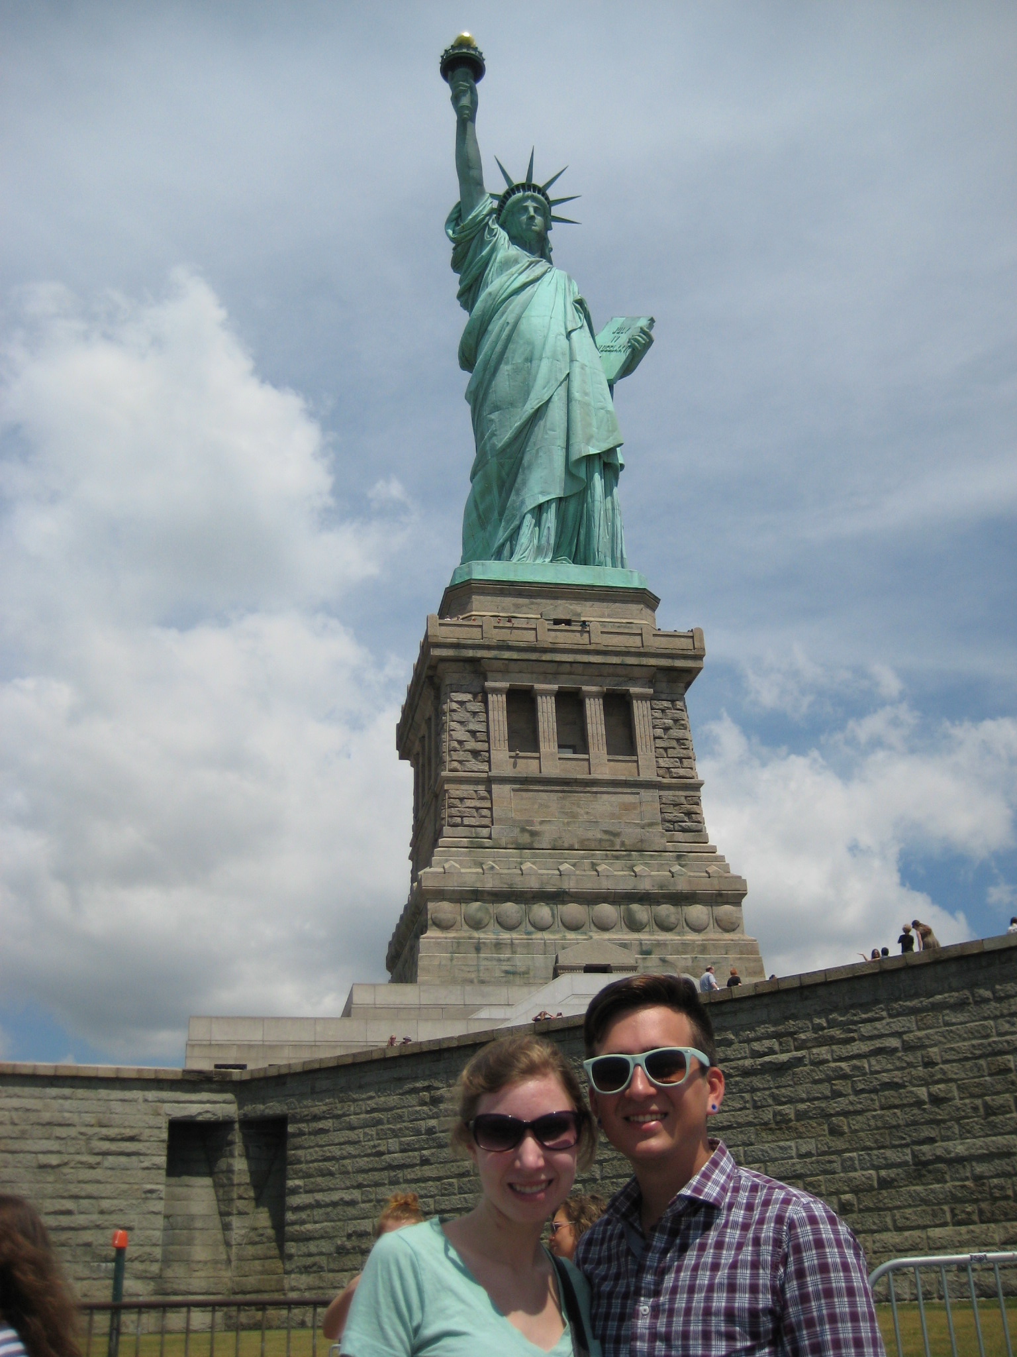
By Emma Lazarus, 1883

Not like the brazen giant of Greek fame,
With conquering limbs astride from land to land;
Here at our sea-washed, sunset gates shall stand
A mighty woman with a torch, whose flame
Is the imprisoned lightning, and her name
Mother of Exiles. From her beacon-hand
Glows world-wide welcome; her mild eyes command
The air-bridged harbor that twin cities frame.
"Keep ancient lands, your storied pomp!" cries she
With silent lips. "Give me your tired, your poor,
Your huddled masses yearning to breathe free,
The wretched refuse of your teeming shore.
Send these, the homeless, tempest-tost to me,
I lift my lamp beside the golden door!"

Mr. Townsend and I visit the Statue of Liberty!
After reading both poems, answer the following questions:

- What language does Unguarded Gates use to describe immigrants?

- What language does The New Colossus use to describe immigrants?

- Which poem do you think is more favorable toward immigration?

- What factors might influence whether someone is for or against immigration?

