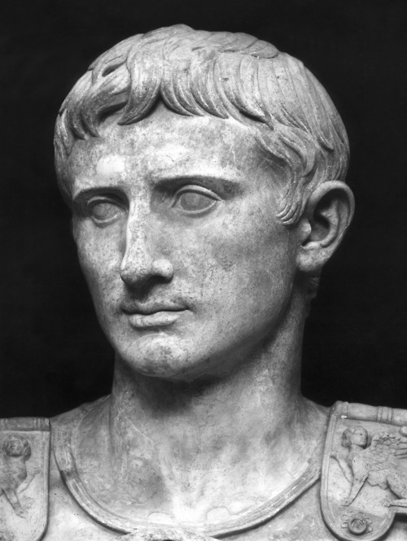
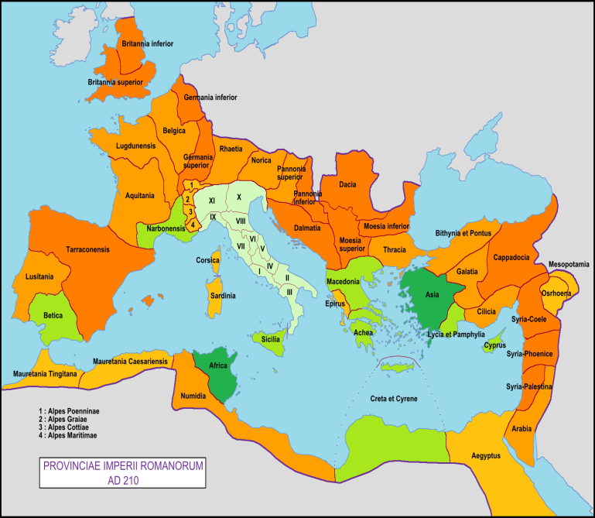

TABLE OF CONTENTS
- COVER PAGE
- TABLE OF CONTENTS
- PPT ON ROMAN EMPIRE (leave 1page front &back)
- JULIUS CAESAR PPT
- WRITE A REFLECTION ON THE STORY OF JULIUS CAESAR .
- 10 QUESTIONS ON JULIUS CAESAR (FILM)
- INTRO TO DANTE ALLIGHIERI
- HANDOUT ON DANTE ‘S INFERNO
- SEVEN DEADLY SINS AND VIRTUES
- DANTE’S INFERNO POWER POINT
- DANTE’S INFERNO ASSIGNMENT(HANDOUT)
- DANTE’S INFERNO REFLECTION

