( ILLUSTRATE THIS PAGE WITH YOU AND THE PLACES IN THE WORLD THAT YOU WOULD LIKE TO VISIT)

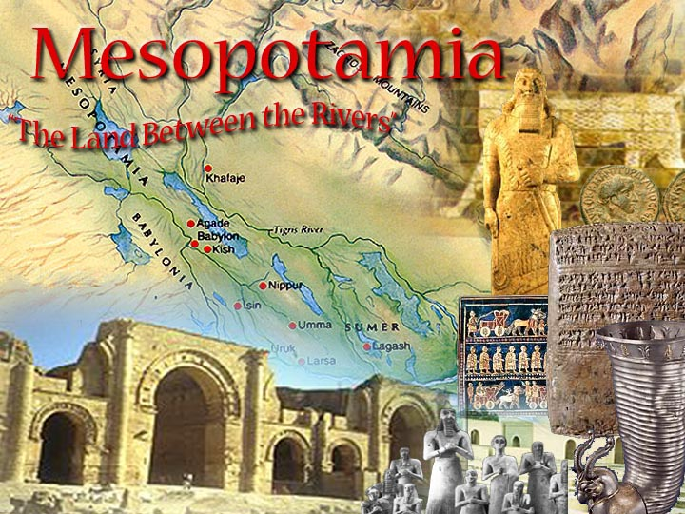
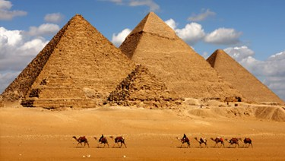

TABLE OF CONTENTS
- SYLLABUS (PAGE 1&2)
- ME AND THE WORLD (ILLUSTRATED PAGE) (3)
- UNIT ONE (COVER PAGE) (4)
- TABLE OF CONTENTS (5)
- POWER POINT WHO I AM (6)
- POWER POINT MESOPOTAMIA (6B)
- CUNEIFORM HANDOUT (7)
- CUNEIFORM NAME (YOUR NAME) (7B)
- HAMMURABI CODE ASSIGNMENT HANDOUT & VOCABULARY (PG 8)

