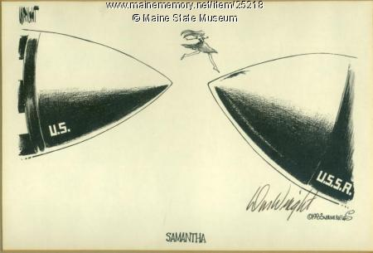

The political cartoon shows Samantha Smith jumping from a US missile to a USSR missile. She is represented as the go between or bridge for the U.S. and U.S.S.R as she mailed Yuri Andropov about Nuclear Weapons and opened discussion about ending nuclear warfare. This can also be an interpretation of when she visited the Soviet Union. The large missiles contrast with the small, whimsical girl and perhaps can be a sign of the U.S. reaching out to the U.S.S.R for peace as the U.S. and U.S.S.R. are about to collide
This orginated as an editorial cartoon in the Miami Herald in 1983.
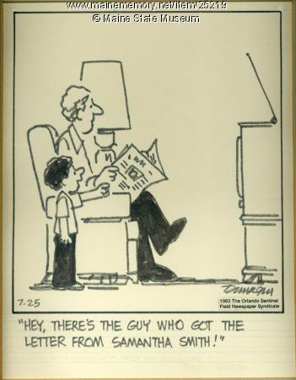
This cartoon shows that Andropov is known for answering Samantha’s letter instead of being the USSR leader and also how well known Samantha had become. Andropov wrote back assuring her he wanted peace and invited her and her parents to visit the Soviet Union.
This originated from the Orlando Sentinel , drawn by Ralph Dunagin.
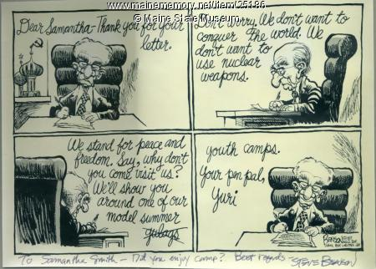

It shows Andropov writing back to Samantha. It shows a nicer side to Andropov as he invites her to the USSR and reassures her of peace. However, another side is shown as he accidentally mentions gulags which are concentration camps. He quickly replaces it with youth camps in order to continue the nice image. It questions whether Andropov’s reply is sincere in wanting peace or if he is just taking advantage of the situation to use as propaganda in order to make the Soviets seem nice.
Steve Benson of the Arizona Republic sent Samantha Smith, 11, of Manchester, the original editorial cartoon he drew satirizing Soviet leader Yuri Andropov's letter to her about war and nuclear weapons.

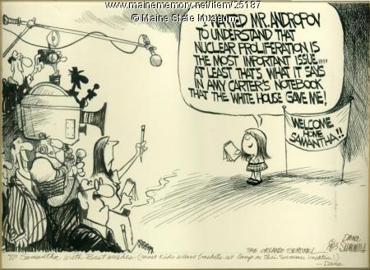
Samantha is answering the press about her talk about nuclear weapons.
Dana Summers of the Orlando Sentinel wrote a note to Samantha Smith, 11, of Manchester, on the bottom of an editorial cartoon he drew about her trip to the Soviet Union in July 1983. His note reads, "To Samantha with Best Wishes (most kids weave baskets at Camp on their Summer Vacation!) -- Dana."
Samantha had written a letter to Soviet leader Yuri Andropov asking him about his plans for war and advocated for peace. Andropov replied and assured her that he wanted peace and invited her to the Soviet Union. This is poking fun more at Jimmy Carter than Andropov but is equating both leaders. Andropov is taking advice from little Samantha while Carter took advice from his young daughter Amy.
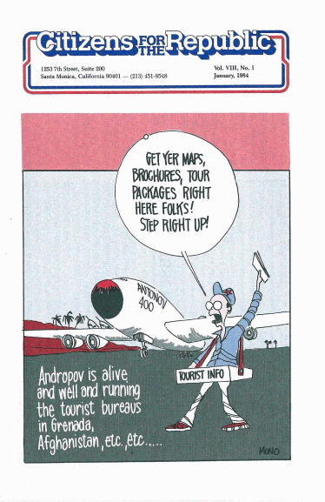
Originated from American perspective, used in a weekly publication called the Citizens for the Republic as a part of Reagan’s campaign
It is addressing the issue of the USSR in getting more soldiers into Afghanistan. It is a play on propaganda since they are trying to make Afghanistan look appealing when in reality there is a war going on.
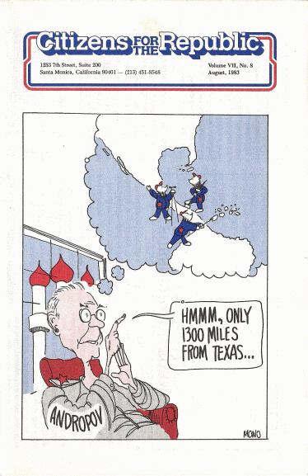
This political cartoon pokes fun at Andropov being a cadre by depicting him as a frail old man. While sitting in USSR, he is scheming about taking over the United States and the Panama Canal.

