Carbon, Nitrogen, and Phosphorus: Art Project

- Objective: Learn about these important cycles by creating an artistic representation such as a poster, 3D model or other approved means (we discussed powerpoint, video, etc. – get approved). One of these cycles will be assigned to you, however you may choose within reason the medium of art you would like to use. Your chosen visual must be accompanied by a descriptive plaque (this is a piece of paper/construction paper/cardboard between 5”x7” to 8”x11”), which describes 2A -2E below:

- Conduct research on your assigned cycle.
- Write down or print out all the stages in the cycle.
- Write down or print out all of the ways in which humans contribute to, affect, or disrupt the natural cycle.
- Write down or print out how humans contribute to, affect or disrupt the cycle from B.
- Write down or print out why humans contribute to, affect, or disrupt the cycle (what do we gain or lose?)
- Write down or print out any fun facts or interesting things about your assigned element or the cycle itself (for example: Hennig Brand discovered phosphorus in 1669, in Hamburg, Germany, preparing it from urine.)

Examples: poster, models, & descriptive plaque
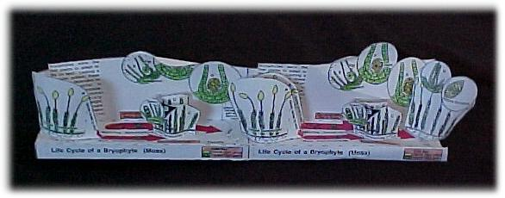
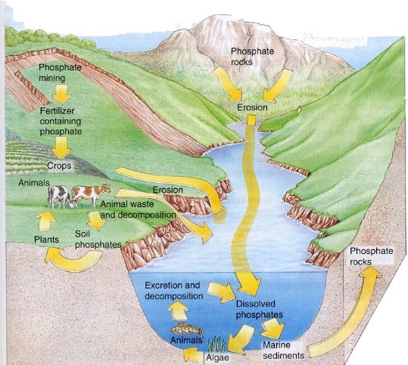

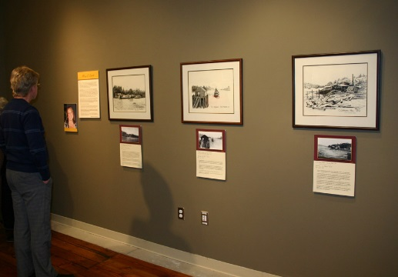
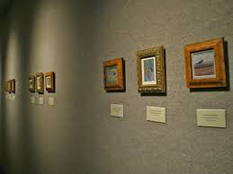
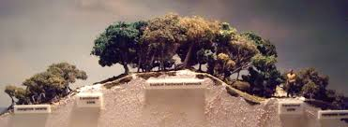

Although we are not all natural artists, you should try your best to create a visually appealing and clear piece of work that accurately and fully represents the requirements written above.

