Mother to Son
Well, son, I'll tell you:
Life for me ain't been no crystal stair.
It's had tacks in it,
And splinters,
And boards torn up,
And places with no carpet on the floor—
Bare.
But all the time
I'se been a-climbin' on,
And reachin' landin's,
And turnin' corners,
And sometimes goin' in the dark
Where there ain't been no light.
So, boy, don't you turn back.
Don't you set down on the steps.
'Cause you finds it's kinder hard.
Don't you fall now—
For I'se still goin', honey,
I'se still climbin',
And life for me ain't been no crystal stair.
Langston Hughes
1922

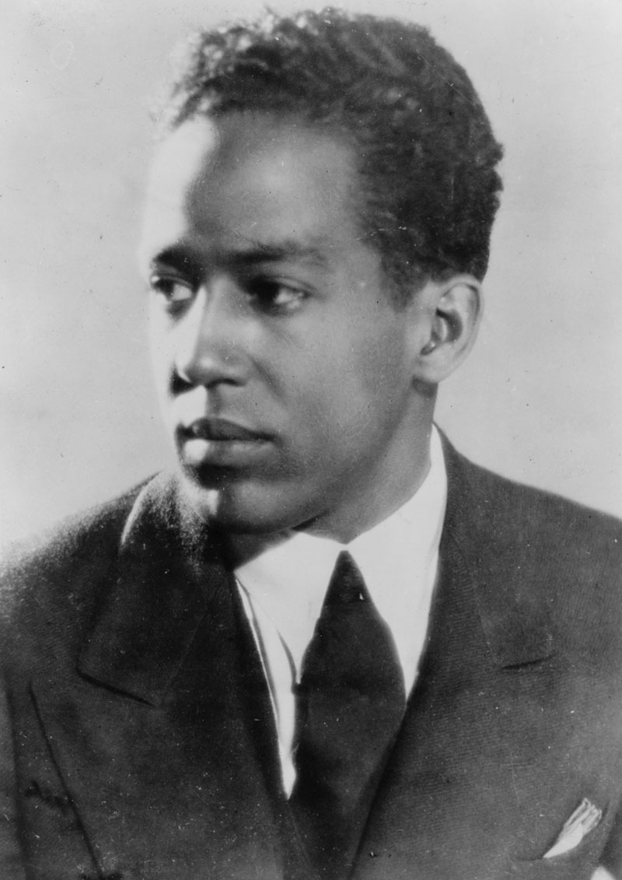
Langston Hughes, born on February 1, 1902, is best known as an American poet, social activist, novelist, playwright, and columnist. He was one of the earliest innovators of the then-new literary art form jazz poetry. Hughes is often remembered for his work during the Harlem Renaissance.

(Hi son. I just wanted to tell you, my life hasn’t been easy, but I’ve always tried my best and you should do that too.)

Mothers Sing a Lullaby

Mothers sing a lullaby
As the dark descends on trees
Shutting out shadows.
The sensuous voices swish and swirl
Around shrubs and overgrown grass
Hiding mountains of decapitated dead
And the glint of machetes
That slashed shrieking throats.
In these camps without happiness
Mothers maintain the melody of life
Capturing wistful wind
To sing strength into the souls of children
Who have never known
The taste of morning porridge
Or heard the chirrup of crickets in the evenings.
Mothers sing a lullaby
For the staring faces
Who cringe at the sound of footsteps
Whose playmates are grinning skeletons.
Mothers become a lullaby
Silencing the sirens of sorrow
Restoring compassion to the nation.

Susan Nalugwa Kiguli
1994 (immediately following Rwandan genocide)

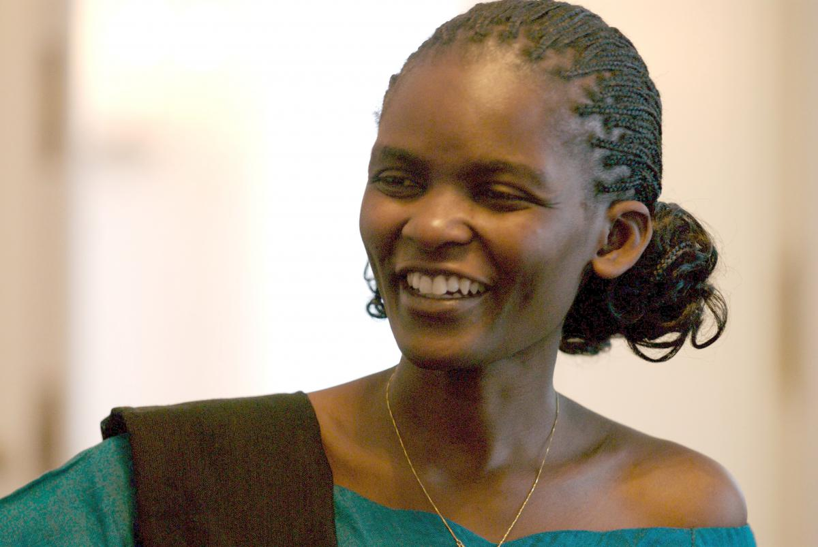
Susan Nalugwa Kiguli, born on June 24, 1969 in Luweero District, Uganda, is an internationally recognized Ugandan poet and literary scholar.
(Mothers were able to still show love and compassion even during genocide.)

