Gateway Lab School 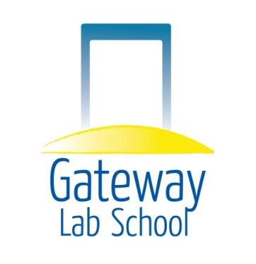

Operational Sustainability Subcommittee

DATE: Wednesday, February 18, 2015 Time 6:00 pm

LOCATION: Panera’s Bread, Kirkwood Highway, Wilmington, DE

AGENDA

Updates

Old Business
- HOS Evaluation

Announcements

Closing of Meeting

