ROP SPORTS HEALTH CARE
Skeletal Anatomy Of The Ankle /Lower Leg
Talus
Tibia
M______________ aspect
L_____________ of the two leg bones
Does not extend as distally as fibula
S_____________ l_________________ bone in body
Primary w_____________ b__________________ bone in leg
Fibula
L_________________ aspect
Functions to provide m______________________ attachments
Extends more distally than tibia
N________-w____________ bearing

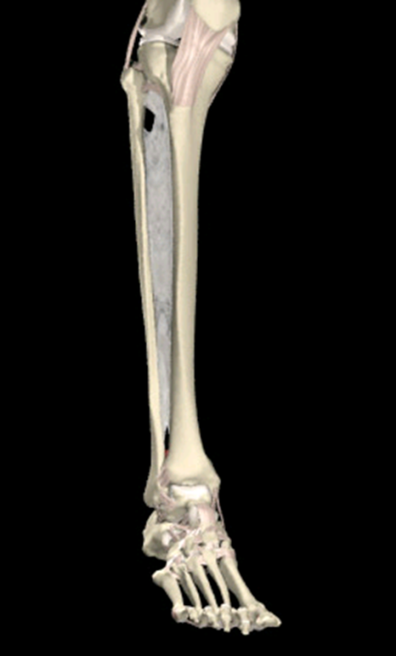
Articulations
Talocrural joint
Made up of the t______________, f__________, and t____________
Talus is w__________ shaped
Lateral malleolus extends more distally than the medial malleolus
Proximal and distal tibiofibular joint is a S____________________ joint.
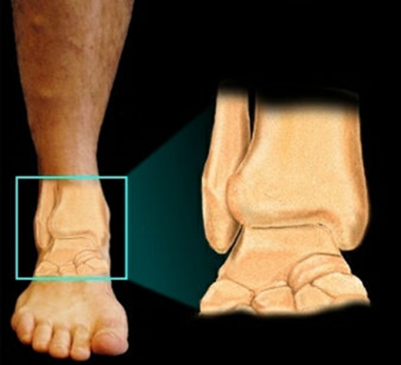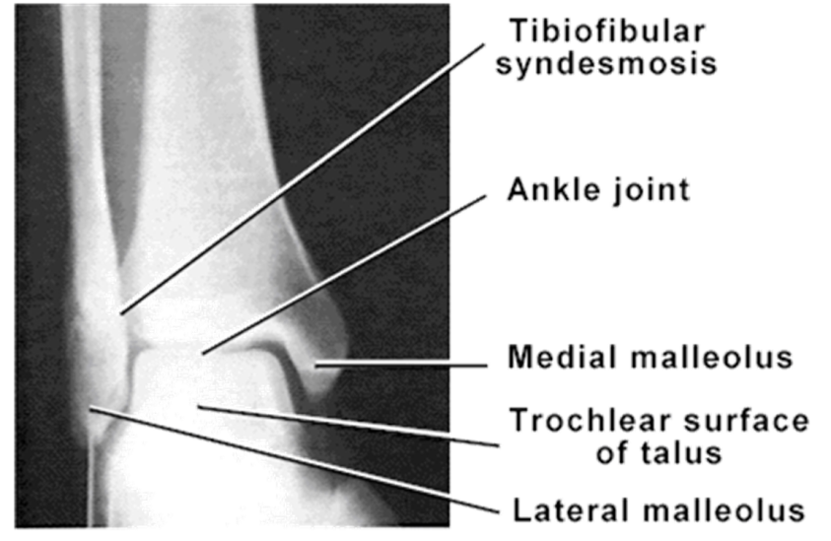
Musculoskeletal Anatomy
C_______________________ of the leg
Anterior compartment
T_____________________ anterior
E________________hallicus longus
E_______________digitorum longus
P_____________ tertius
Anterior tibial a___________ and v___________
D___________ p__________________ nerve

Lateral compartment
P_______________ longus
Peroneus b______________
S____________________ peroneal nerve
Deep posterior compartment
Tibialis p___________________
F_______________ hallucis longus
F_____________ digitorum longus
P_______________ tibial a_____________ and v_________________
T_______________ n_______________

Superficial posterior compartment
G_____________________
S__________________
P_________________

Ligamentous Anatomy of the Ankle
M aspect
D________________ ligament
T__________ and s_____________

L aspect
Anterior talofibular or ATFL
Posterior talofibular or PTFL
Calcaneofibular or CFL
Leg
P_________________ and D_______________ A________________and P_______________ tibiofibular ligaments
Interosseous membrane

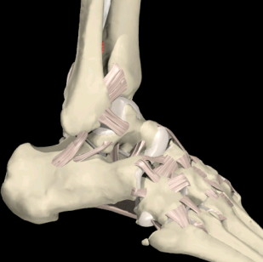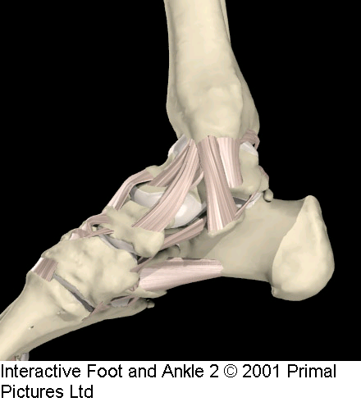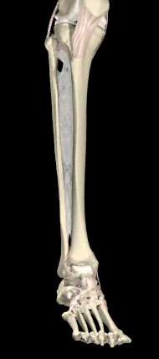
Fractures
A
Piece of tibia/fibula is p___________ off by l____________________
Fairly common
X-rays for all ankle sprains
“Push off” fractures
Piece of tibia/fibula is p________________ off by t___________
Fairly common
X-rays for all ankle sprains

Talus (dome)fracture
Usually from forced d________________________ and i______________________
Occurs at the n__________ of the talus
A_________________ necrosis
Often missed in X-rays
Typically surgical

Tibia
Traumatic fractures are serious due to s____________ of bone
S______________ fractures:
M____________ tibial s______________syndrome or MTSS
“s___________ s______________”
Fibula
Fairly common
N_____-weight bearing; competition p___________________
Stress fractures:
Reasonably common due to m______________ attachments
Both bones
Usually requires s___________________ to stabilize

Strains
- Gastrocnemius/Soleus
  - Muscle b____________
  - Musculotendinous j_______________
- Anterior extensors
  - Often called “shin splints”
  - Hill, climbing, or speed work
  - May lead to c________________ c__________________ s_________________
- Toe flexors
  - Often called “shin splints”
  - P__________________ increases odds
- Achilles tendon
  - S_______________

Achilles tendon rupture
Most common over _______ years old
C_________________ history of inflammation
Sudden p__________ off
Signs and symptoms
    - “I was k_____________ in the back of the leg!!”
    - Immediate pain
    - P_________________ defect
    - Positive Thompson’s test

Sprains
- L_______________ ankle sprains
  - I_______________/p______________ f________________ mechanism
  - Most common injury in body
  - _____________% of all ankle sprains
    - Strong medial ligaments
    - Fibular block
- Ligaments involved
    - A_______________ talofibular
    - C__________________________
    - Posterior talofibular
Mild to severe (_______________)

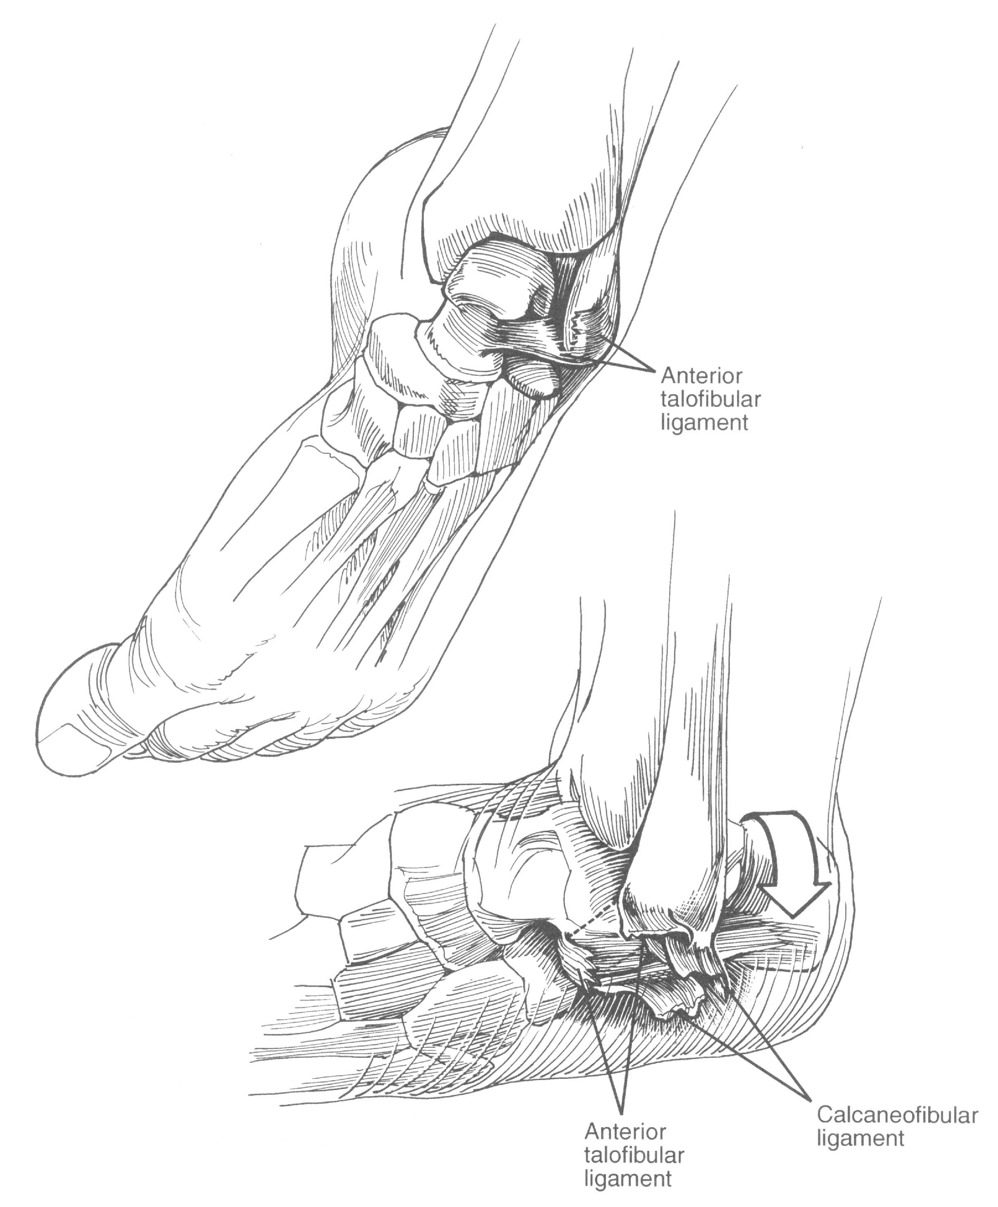

- Medial ankle sprains
E________________ mechanism
  - R__________ (5%)
    - S______________ d______________ ligament
    - F______________ block
  - Deltoid ligaments
  - Mild to severe (______________)
- Syndesmosis sprain
  - F_______________ dorsiflexion and/or e__________________
  - “H___________ ankle s_____________”
  - S______________ to heal
  - Anterior t_________________ ligament and i____________________ membrane

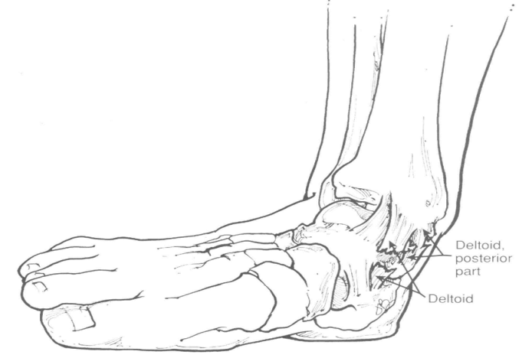
Other Conditions
- P_______________ tendon s____________________
  - R________________ of peroneal r__________________
  - Tendons sublux out from under l______________ malleolus
- A______________ tendonitis/tenosynovitis
  - Inflammation of the t____________(_________________) or s____________ (_________________)surrounding the tendon
  - Causes h__________________ scarring
- C_____________________syndrome
  - Typically anterior or deep posterior compartments
  - Acute
    - Caused by d__________ blow or injury within f__________ compartment
    - Medical e__________________
    - T___________, s____________ appearance of s__________
    - F___________ d____________ if advanced
    - Requires surgical decompression
  - Chronic
    - Muscle h_________________ during exercise
      - D________________ space in compartment
Slow, continual rise in temperature
Treatment???
P.R.I.C.E-

ANTI-INFLAMMATORIES –

DOCTOR REFFERAL

