Reformation Dossiers
Ideas: include thumb drive with audio/video files in some packets, add “real” objects like Luther’s burned Papal Bull, photo of torture instruments for Torquemada, etc.
How to:
- 6 “packets” with copies of one dossier in each packet. Give one to each group and give them 5 minutes to review that one document. Then, pass to the next group until all 6 are examined.
- Complete the final analysis sheet.

Other potential figures if you want more groups:
John Wycliffe
Pope Sixtus IV
John Calvin
Desiderius Erasmus

www.mrroughton.com

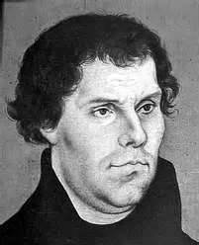

Name: Martin Luther
Born: 1483, Holy Roman Empire
Education: BS and MA from Oxford
Occupation: Catholic Priest, Professor

Actions
- Taught that salvation is not earned by doing good things but instead is given freely by God.
-Helped a group of nuns escape from their convent by hiding them in barrels.
-Later married Katarina Von Bora, one of the run-away nuns.
-Translated the Bible into common German.
-"Why does the pope, whose wealth today is greater than the wealth of the richest, build the basilica of St. Peter with the money of poor believers rather than with his own money?"
-Wrote a series of 95 arguments against the actions of the Pope and passed them around to the people of Germany.
-Argued that since churches were run by people they could not be perfect and could make mistakes.
-Created a series of cartoons making fun of the pope so even those who couldn’t read would understand.
-Told monks and nuns they didn’t have to follow their vows since they came from the church and not from God.
-Argued that using violence to spread Christianity was wrong and actually the work of the devil.
-When sent a warning against his actions by the pope he took the paper and burned it.

Testimony
“As far as Martin himself is concerned, O good God, what have we overlooked or not done? What fatherly charity have we left out that we might call him back from such errors?” – Pope Leo X

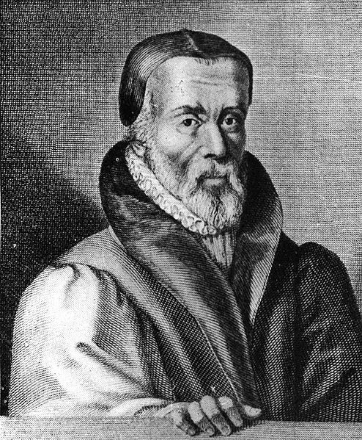
Name: William Tyndale
Born: 1492, Gloucestershire, England
Education: BS and MA from Oxford
Occupation: Scholar and Clergyman

Actions
-Wrote against King Henry VIII saying his divorce went against the Bible.
-A Catholic priest once said to him “We are better to be without God’s laws than the Pope’s.” Tyndale responded by saying “I defy the Pope and all his laws. If God spare my life however many years, I will cause the boy that drives the plow to know more of the scriptures than you!”
-Translated the New Testament into common English for the first time so anyone could read it.
-Known for many famous English phrases from the Bible such as “lead us not into temptation” and “Let there be light.”
-Translated the words for Bishop to be “overseer,” priest to be “elder” and charity to be “love.”
-Argued that all followers of Jesus were his representatives, not just the clergy of the Church.

Testimony
"We cannot underestimate the influence of the genius of Tyndale, the greatest of English Bible translators..." - George Steiner
“He is so skilled in eight languages – Hebrew, Greek, Latin, Spanish, French, Italian, English, and German, that whichever he speaks, you might think it his native tongue!” – One of Tyndale’s Associates

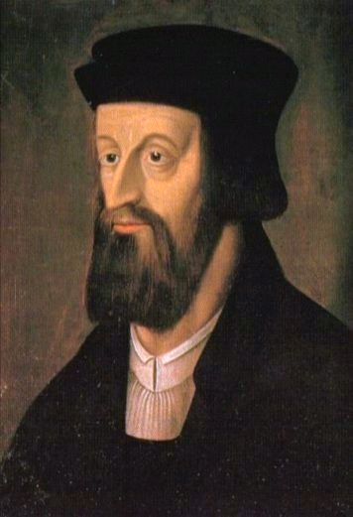
Name: Jan Hus
Born: 1369, Husenic, Bohemia
Education: Master Degree in Theology, University of Prague
Occupation: President, University of Prague, Priest –Bethlehem Chapel

Actions
-Argued no pope should ever lead an army but instead should pray for his enemies.
-Wanted people to read the Bible for themselves and decide what it meant. They did not have to be told by priests.
-Said priests should not be rich or really own much of anything – they should use their money for others.
-Went against indulgences saying repentance forgives sins, not money (indulgences were being sold to pay for the Crusades against the other Pope)
-Followers burned Papal Bulls saying they’d follow Hus and not the Pope.
-Stated the Catholic Church had to be followed only so far as God leads a person to follow it.
-Argued that Jesus Christ was the supreme judge, not the pope.
-Wrote claiming that all believers are part of the church, not just the clergy.
-Promised to take back anything the Church wanted him to - as long as it was proven in the Bible and not just by the pope.
- Once said: "The church makes everyone pay for confession, for mass, for the sacrament, for indulgences, for churching a woman, for a blessing, for burials, for funeral services and prayers. The very last penny which an old woman has hidden in her bundle for fear of thieves or robbery will not be saved. The villainous priest will grab it."

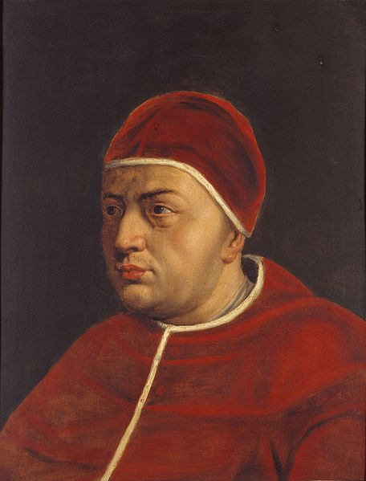
Name: Giovanni di Lorenzo de' Medici
Alias: Pope Leo X
Born: 1475, Florence, Italy
Occupation: Pope 1513-1521

Actions
-Sold indulgences, passes to Heaven, to pay for rebuilding a cathedral.
-Fired many Church leaders and replaced them with his family and friends.
-Pretended to support the free people of Rome against France but secretly made a deal with the French to let them conquer Rome as long as they supported him.
-Had a young boy painted gold and had his pose as a living statue during a party. The boy later died of poisoning from the paint.
-Within 2 years he had spent nearly all of the papal savings – ended up selling off the furniture and jewels.
-Joined up against France when paid a bunch of money by the King of England then ended up spending four times the amount paid and nearly running the church out of money.
-Upon becoming pope said: "Since God has given us the Papacy, let us enjoy it."
-Threw massive parties in the Vatican almost every night.

Testimony
"At the beginning of his time as pope most people found him very holy; however, he was afterwards discovered to be exceedingly devoted – and every day with less and less shame – to that kind of pleasure that for honor's sake may not be named". - Francesco Guicciardini, Historian

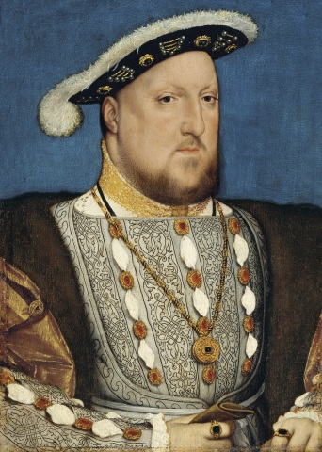
Name: Henry VIII
Born: 1491, Greenwich, England
Occupation: King of England, 1509-1547

Actions
-2 days after becoming king at age 18 he ordered two of his father’s advisors executed. He took their money and gave it back to people who they were believed to have cheated.
-At age 14 he broke off his engagement then later married the woman anyway when he realized it would help him gain power.
-Became friends with King Louis the XII of France. Then he joined with the King of Spain to try to kill him. The war failed and Louis remained king.
-As his wife got old he had an affair with a younger woman. While doing so he became attracted to that woman’s sister named Anne and had an affair with her too.
-Tried to get a divorce from his first wife but she refused to accept it.. He went directly to the church for permission and the Pope said no.
-Henry then quit the Catholic Church and started his own called the Anglican Church. This church was happy to grant him the divorce. The monks that challenged his new church were tortured and killed.
-He then married Anne and lived happily until he decided he didn’t like her attitude and had her killed. He married a new wife 10 days later.
-This wife (number four) died after giving birth. Henry married another young woman, this time without meeting her first. He saw her, said she looked like a horse and divorced her.
-He married with fifth wife and was finally happy. Then he found out she had an affair and so she was killed.
-While he was doing all this he was spending tons of money and nearly ruined the economy of England.

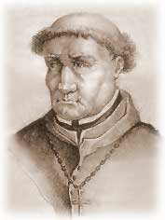
Name: Tomas de Torquemada
Born: 1420, Spain
Occupation: Friar, Grand Inquisitor

Actions
-Served as Grant Inquisitor, the head of the Inquisition – the official court of the Catholic Church.
-One of the main supporters of the Alhambra Decree which kicked all Jews out of Spain.
-Then made a set of guidelines for finding out if people were really Jews:
- "If you see that your neighbors are wearing clean and fancy clothes on Saturdays, they are Jews.
- "If they clean their houses on Fridays and light candles earlier than usual on that night, they are Jews.
- "If they eat unleavened bread and begin their meals with celery and lettuce during Holy Week, they are Jews.

-Wrote new rules for the Inquisition which authorized torture to obtain evidence and confessions from people accused of going against the Catholic church.
-The first level was called the water cure. In this torture the accused has a rag stuffed into their mouth. Then water is slowly poured in to make it feel like drowning. The rag made it impossible to cough or spit the water out.
-Next level was the rack where the accused was tied by the hands and feet and stretched out as far as possible.
-The final step was often strappado, tying a person up by their wrists – dropping them and quickly stopping their fall so their arms are painfully jerked back up.
-Ordered that anyone even accused of being a “fake Christian” have all their property taken from them.
-The accused were given three chances to confess before being tortured.
-Under his command an estimated 2,000 people were burned at the stake

Testimony
"The hammer of heretics, the light of Spain, the saviour of his country, the honour of his order.” – Sebastian de Olmedo, Spanish Historian
Reformation Dossiers
Name: Pope Leo X

Two worst things he did:
1.

2.

Two best things he did:
1.

2.

Did he do more good or more bad? Explain
Name: Martin Luther

Two worst things he did:
1.

2.

Two best things he did:
1.

2.

Did he do more good or more bad? Explain.
Name: Jan Hus

Two worst things he did:
1.

2.

Two best things he did:
1.

2.

Did he do more good or more bad? Explain.
Name: William Tyndale

Two worst things he did:
1.

2.

Two best things he did:
1.

2.

Did he do more good or more bad? Explain.
You are an investigator during the time of the Reformation. Due to budget cuts your department has only enough time and money to arrest the worst suspects. Your team has been asked to review six potential suspects to determine which to arrest. As you investigate each suspect fill in the information requested in each box below.

3. Three of these men were actually ordered arrested (and two of the three were captured and executed). Which three do you think it was? Think historically and logically not just emotionally.
1.

2.

3.
2. If could only arrest one of these men, who would you arrest, why?
1. Which of these six men did the most good in your opinion? Support your answer with evidence.
Name: Tomas de Torquemada

Two worst things he did:
1.

2.

Two best things he did:
1.

2.

Did he do more good or more bad? Explain.
Name: King Henry VII

Two worst things he did:
1.

2.

Two best things he did:
1.

2.

Did he do more good or more bad? Explain.

