Lewis Structures, VSEPR, Polarity, IM Forces

For each of the following molecules, draw the Lewis structure (with any resonance structures, if applicable), indicate the molecular shapes and bond angles, indicate the molecular polarity (if any), and identify the major intermolecular force in each compound. Hint – in this worksheet, as in all chemistry problems you’ll see, polyatomic ions aren’t drawn as big lines of atoms.

1) carbon tetrafluoride

2) BF₃

3) NF₃

4) H₂CS

5) carbonate ion

6) CH₂F₂

7) nitrate ion

8) O₂

9) PF₃

10) H₂S
Lewis Structures, VSEPR, Polarity, IM Forces - Answers

For each of the following molecules, draw the Lewis structure (with any resonance structures, if applicable), indicate the molecular shapes and bond angles, indicate the molecular polarity (if any), and identify the major intermolecular force in each compound. Hint – in this worksheet, as in all chemistry problems you’ll see, polyatomic ions aren’t drawn as big lines of atoms.

1) carbon tetrafluoride
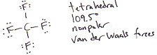

2) BF₃
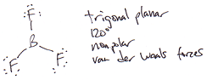

3) NF₃
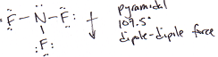

4) H₂CS
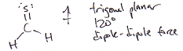

5) carbonate ion
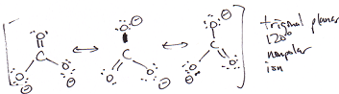

6) CH₂F₂
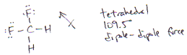

7) nitrate ion
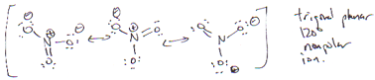

8) O₂
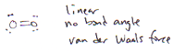

9) PF₃
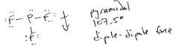

10) H₂S
