LT: 6A Inverse Function

Check to see if the following Functions are inverses of each other.

Level *
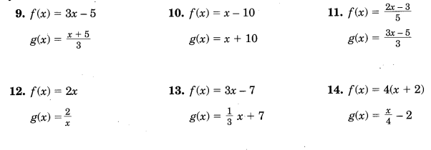
Level **

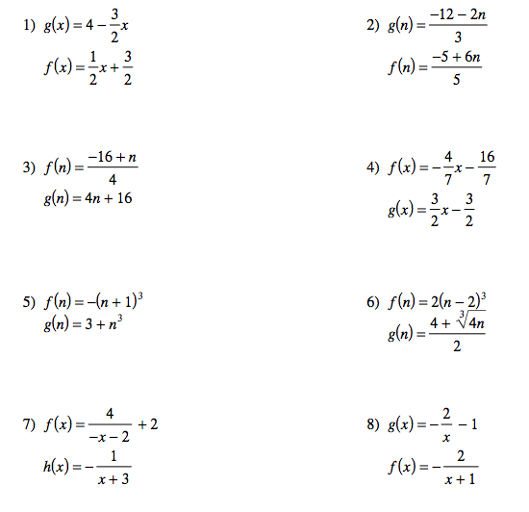

Answers
Level *
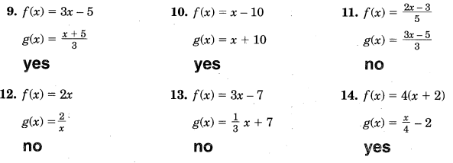
Level **
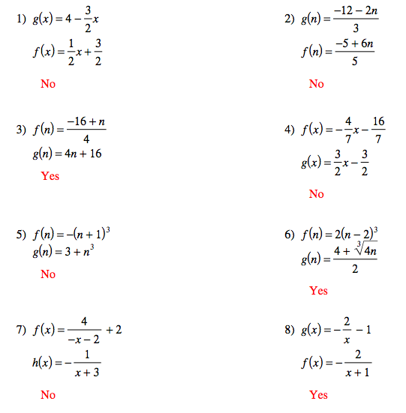

LT: 6A
Graphing Inverse Functions

Level *

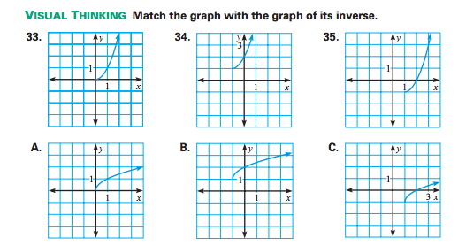
Level **
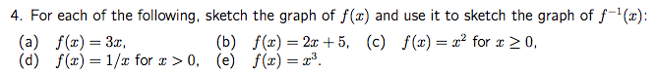

Answer Key
Level *
33.) A
34.) C
35.) B
Level **
