Turrón y mazapán

Cost Plus World Market carries a selection of Spanish foods in their “Spain” section. Call ahead of time to see how much these items cost (ask to talk to the person who works in the “gourmet” section).

Cost Plus World Market  372 4th Avenue (downtown)  619 236-1737 | - Turrón (almond /nougat candies)  - mazapán (marzipan desserts)  - Spanish chorizo (it’s different than Mexican chorizo),  - Paella rice mix

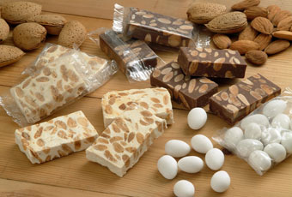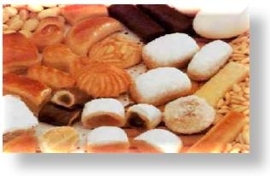

CHURROS con chocolate
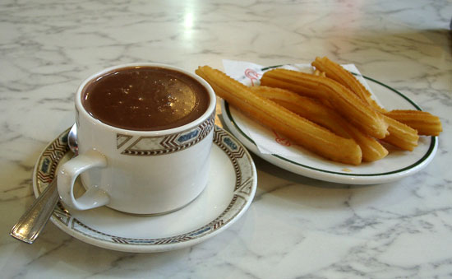 | You can also watch this video on how to make churros http://video.about.com/spanishfood/How-to-Make-Churros.htm  Here's the ultimate recipe to make your own churros at home, just like they are made at the churrería stands in Spain. (Makes one plateful). If you want to buy the churros already made, that is fine. However, try to find churros without the sugar and cinnamon. In Spain the churros are plain and then dipped into the chocolate sauce.
Ingredients:
Vegetable or Olive Oil
1 cup water
1/2 cup margarine or butter
1/4 teaspoon salt
1 cup all-purpose flour
3 eggs
1/4 cup sugar
1/4 teaspoon ground cinnamon (optional)
- Prepare to fry the churros by heating oil in a pan (1 to 1&1/2 inches) to 360 degrees F.
- To make churro dough, heat water, margarine and salt to rolling boil in 3-quart saucepan; stir in flour. Stir vigorously over low heat until mixture forms a ball, about 1 minute; remove from heat. Beat eggs all at once; continue beating until smooth and then add to saucepan while stirring mixture.
- Spoon mixture into cake decorators' tube with large star tip (like the kind use to decorate cakes). Squeeze 4-inch strips of dough into hot oil. Fry 3 or 4 strips at a time until golden brown, turning once, about 2 minutes on each side. Drain on paper towels.
- Note: REAL churros in Spain are made WITHOUT cinnamon and sugar. You need to dip them into the chocolate sauce to ge the sweet flavor

Chocolate dipping sauce – Please do not “invent” your own. Please follow the recipe.
Ingredients: 4 ounces dark chocolate 2 cups milk 1 tablespoon cornstarch 4 tablespoons sugar
Instructions: To prepare the hot chocolate for dipping, place the chocolate and half the milk in a saucepan over very low heat and cook, stirring, until the chocolate has melted. Dissolve the cornstarch in the remaining milk and whisk into the chocolate with the sugar. Cook on low heat, whisking constantly until the chocolate thickens, approximately 5 minutes. Remove and whisk until smooth. Pour chocolate into cups and serve with churros.

ARROZ CON LECHE - RICE PUDDING SPANISH STYLE
NOTE: This is NOT the same as Mexican arroz con leche. Please follow the recipe below in order to receive credit.
http://www.food.com/recipe/arroz-con-leche-spanish-rice-pudding-233971

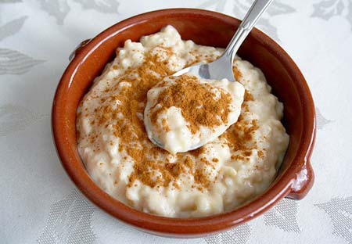
Ingredients:  2 cups milk  1 cinnamon stick  3 slices lemon rind  1 pinch salt  ½ cup short-grain, white rice  3 medium egg YOLKS, beaten  1/3 cup sugar  ¼ cup butter  1 teaspoon ground nutmeg | Instructions:  1. In a large saucepan, slowly bring the milk, cinnamon stick, strips of lemon rind, and salt to a boil.  2. With a slotted spoon, remove the cinnamon and lemon rind.  3. Stir in the rice and egg yolks  4. reduce the heat and allow the rice to simmer for about 15 minutes.  5. When the rice is soft, add the sugar and butter and combine well.  6. Pour the mixture into a serving dish, sprinkle with nutmeg and serve warm  - In a large saucepan,

CREMA CATALANA

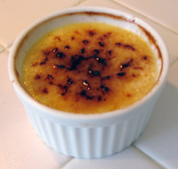 | Only make this if you have ramekins (little ceramic containers). Here is the recipe. It serves four people:  http://dessert.food.com/recipe/crema-catalana-229274  You can also watch this video: http://video.about.com/spanishfood/How-to-Make-Crema-Catalana.htm  INGREDIENTS:  - 1 cup Sugar  - 4 egg yolks  - 1 tbsp Cornstarch  - 1 Stick Cinnamon  - Grated rind of ½ Lemon  - 2 cups Milk
PREPARATION:
This is a great dessert to make ahead of time, since it is very easy and requires 2-3 hours of refrigeration before serving. Make it the day before and leave it in the refrigerator until you are ready to serve. Then, heat the broiler, carmelize the sugar and serve!
Beat Egg Yolks and Sugar
- In a pot, beat together the egg yolks and 3/4 cup sugar until thoroughly blended and the mixture turns frothy. Add the cinnamon stick and grated lemon rind. Pour in the milk. Slowly heat the mixture, stirring constantly, just until thickened. Remove pot from heat immediately.
Tip: As soon as the mixture thickens and you feel resistance while stirring, remove the pot from the heat or the mixture may curdle orseparate! The texture of the finished crema will be grainy instead of smooth and creamy as it should be.
Pour into Ramekins and Refrigerate
- Remove the cinnamon stick and ladle the milk mixture into 4 ramekins (individual serving size). Allow to cool, then refrigerate for at least 2-3 hours.
Carmelize the Sugar and Serve
- Before serving, preheat the broiler. Remove ramekins with the crema catalana from refrigerator and sprinkle the rest of the sugar over each ramekin. When broiler is hot, place the ramekins under the broiler on the top shelf and allow the sugar to caramelize, turning gold and brown. This may take 10 minutes or so, depending on your broiler. Remove and serve immediately.
- If you'd like, you can serve the crema catalana chilled, but we think it has more flavor when served warm from the broiler.

