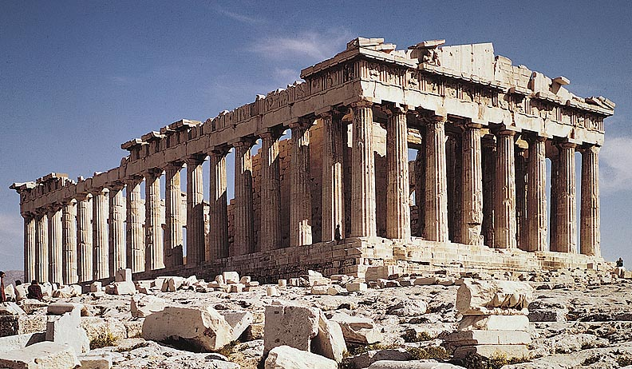

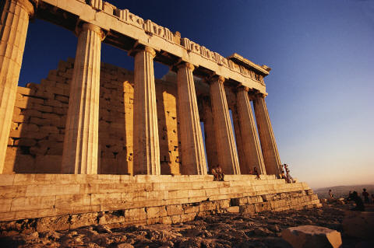

TABLE OF CONTENTS
- COVER PAGE -PG 17
- TABLE OF CONTENTS- PG 18
- GREEK ALPHABET HANDOUT -18B
- ANCIENT GREECE PACKET (WITH ALL THE GODS) 19B
- KWL -20
- APOLLONIAN VS DIONYSIAN HANDOUT -20b
- HEROE’S JOURNEY-21
- PPT ON ANCIENT GREECE- 21B
- HANDOUT ON HEROES,MORTALS, MONSTERS ETC 22
- HANDOUT ASSIGNMENT CHART/ DUE DATES 22B
- PPT ON GREEK GODS

