Name: __________________
Date: ______
Period: ___
Pirates or ninjas? __________

A Disturbance in the Net Force

- You are having car troubles and leave trail of oil drops on the street. Observe the following oil traces and indicate whether your car is being acted upon by an unbalanced force. Provide a reason for your answers.
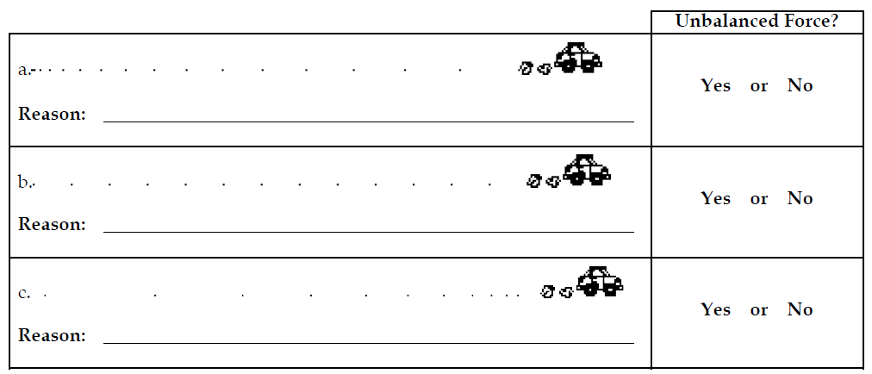

- Each one of the dot diagrams in question 1 can be matched to a force diagram below. The force diagrams depict the individual forces acting upon the car by a vector arrow (yay, vectors!). Match the dot diagrams from #1 to a force diagram.
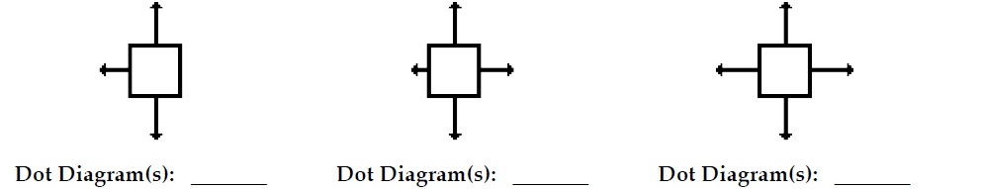

- If the net force acting upon an object is 0 N, then what can be concluded about an objects motion (be very specific)?

- These graphs describe the motion of Mr. Steindamm at various times during his trip to school. Indicate whether Mr. Steindamm’s vehicle is being acted upon by an unbalanced force and give a specific reason in terms of a description of what the car is doing.

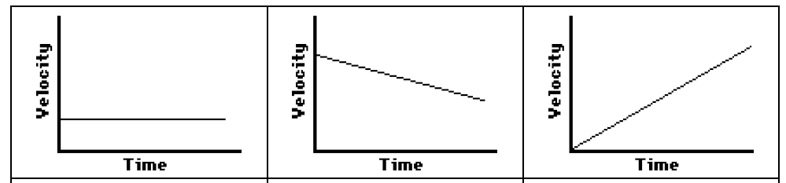

- A free-body diagrams show all the individual forces acting upon an object. The net force is thevector sum of all these forces (ΣF). Determine the net force, state if there is an acceleration, and if the following objects are in equilibrium.

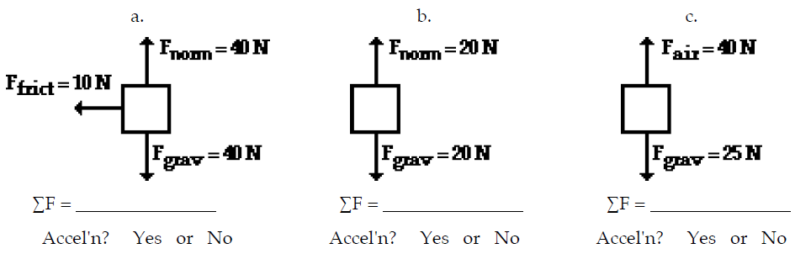
Equilibrium? Yes or No Equilibrium? Yes or No Equilibrium? Yes or No

- During an in-class discussion, Persephone suggests to her lab partner that the dot diagram for the motion of the object in #6b could be
. . . . . . . . . . . .
Anna's partner objects, arguing that the object in #6b could not have any horizontal motion if there are only vertical forces acting upon it. Who is right? Explain.

- During an in-class discussion, Apollo asserts that the object in #6a must be moving to the left since the only horizontal force acting upon it is a "left-ward" force. Is he right? Explain.

