Knights of Feudal Europe

- What is a page?

- Pages spent most of their time with the ladies of the castles
learning what skills?
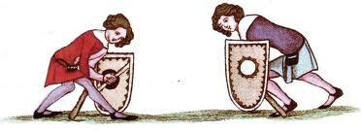

- What was the goal of the page?

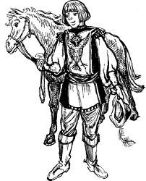
- What type of servitude came after a page?

- Explain four daily responsibilities of a squire?

- What were the two weapons that a squire learned to fight with?
Draw them next to the squire.

- What was the role of a squire in the case of battle?

- Explain the ritual of Knighthood:

- What is Chivalry and what did it require from knights?
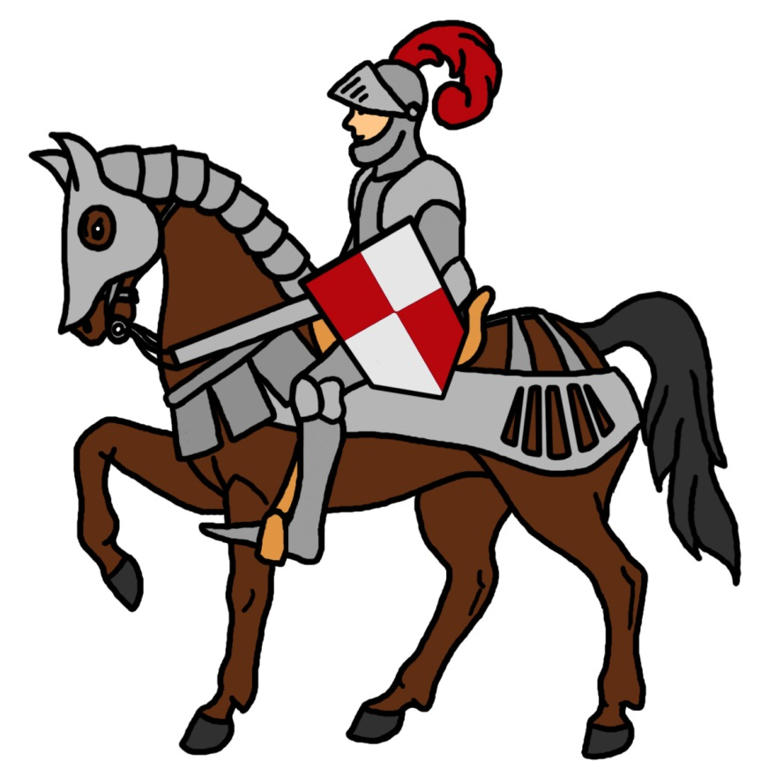

- Write what a knight might say about the purpose of jousting in the
voice bubble above his head.

