Class ESS Block 1-5 section 9.1 Date____________ Name ________________________________ per______
Objectives
- Describe the hypothesis of continental drift.
- Evaluate the evidence in support of continental drift.
- Identify the main objections to Wegener’s hypothesis of continental drift.

Warm-up
- Rewrite the definition for the word Drift.
Definitions “A continuous slow movement from one place to another.”
A continuous slow movement from one place to another
- Write the word Drift in a sentence describing plates on Earth.
My dog’s tail drifts back and forth.
- Write a prediction for what you think continental drift means.
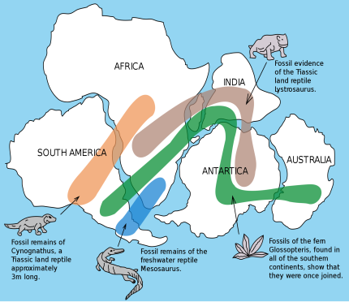
Slow moving continents on water.
Critical Thinking  Charting the Age of the Atlantic Ocean  Procedure  1. The distance between two locations across the Atlantic Ocean, one in South America and one in Africa, is approximately 4300 km.  2. Assume that these two locations were once joined as part of Pangaea.  Analyze and Conclude  - Calculating If the two landmasses moved away from each other at a rate of 3.3 cm/y, how long did it take these two locations to move to their current positions?  4300km 1000m 100cm 1y  1 1km 1m 3.3 cm  = 1.3 x 10⁸ y  - Inferring Do you think the Atlantic Ocean would have formed at a constant rate or would that rate have varied over time? Why?  I believe the rate would vary because of tectonic actions such as volcanoes erupting and earthquakes occurring can release pressure and build pressure up in other areas. | Writing in Science  Descriptive Paragraph Write a paragraph describing Pangaea. Include the location and climate of Pangaea. Use the equator as your reference for position.  Pangaea was a supercontinent made up of all the major continents joined together. It began breaking into smaller continents about 200 million years ago. Pangaea was located near the South Pole. The southern part of Pangaea, made up of South America, Africa, India, Australia, and Antarctica, had a cold climate with large continental glaciers.
Wrap-up

- How does the distribution of Mesosaurus fossils provide evidence for continental drift?
Mesosaurus occurs only in eastern South America and southern Africa.
- How does the location of mountain chains provide evidence of continental drift?
If mountain chains can be continued across present-day oceans, they provide evidence that the areas were once connected.
- Summarize the climate evidence for continental drift.
Glaciers in southern South America, southern Africa, India, and Australia are found in areas that now have tropical climates. There is also evidence for tropical climates and coal swamps in areas that are now at higher latitudes, such as northern Europe and the northeastern United States.
- Why was Wegener’s hypothesis rejected?
He could not provide a mechanism for the movement of the continents.

