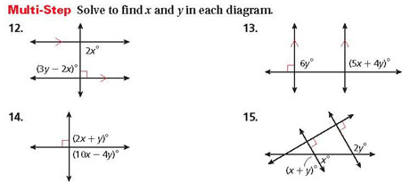
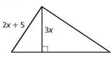
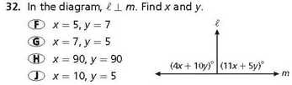
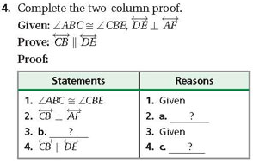
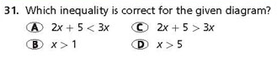
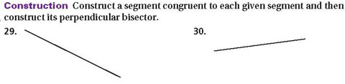
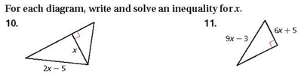
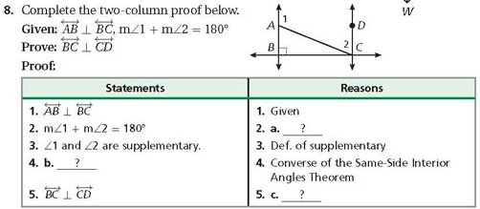
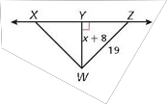
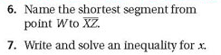
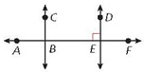
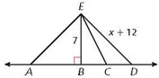
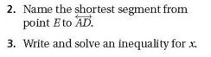
Worksheet Section 3-4 ***** DO WORK ON A SEPARATE SHEET OF PAPER OR ON THE BACK OTHERWISE NO CREDIT******

