CHAPTER 21 SUMMARY – PAGE 550
SECTION 21-1 ECONOMICS & INTERNTIONAL COOPERATION   | SECTION 21-2 ENVIRONMENTAL POLICIES IN THE U.S.  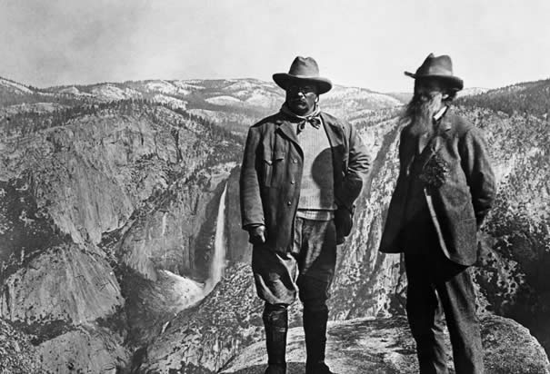 | SECTION 21-3 THE IMPORTANCE OF THE INDIVIDUAL  

CHAPTER 21 SUMMARY – PAGE 550
SECTION 21-1 ECONOMICS & INTERNTIONAL COOPERATION | SECTION 21-2 ENVIRONMENTAL POLICIES IN THE U.S. | SECTION 21-3 THE IMPORTANCE OF THE INDIVIDUAL

CHAPTER 21 SUMMARY – PAGE 550
SECTION 21-1 ECONOMICS & INTERNTIONAL COOPERATION | SECTION 21-2 ENVIRONMENTAL POLICIES IN THE U.S. | SECTION 21-3 THE IMPORTANCE OF THE INDIVIDUAL

CHAPTER 21 SUMMARY – PAGE 550
SECTION 21-1 ECONOMICS & INTERNTIONAL COOPERATION | SECTION 21-2 ENVIRONMENTAL POLICIES IN THE U.S. | SECTION 21-3 THE IMPORTANCE OF THE INDIVIDUAL

