Spring Break Extra Credit

Mission Television is branching out into movie production. They are going to produce movies with a mathematics theme in order to satisfy the intellectual cravings of the general public. You have been appointed Chief Creative Director and it is your job to come up with math-themed movie ideas.

This will be 10 points extra credit towards your tests section of your grade.

You will create a movie poster for one of the movies.
•It has to be math themed
•It has to be based on a real movie (e.g., “Captain America: The Winter Solver” or “The Hobbit: The Factorization of Smaug”)
•It can be hand-written or computer-generated if you’re good with photoshop/indesign
•If it’s computer-generated, it has to be slick, like the one below

Think of clever puns or double meanings of math terms: roots, radicals, sine, tangent, rational, fraction, proportion, factor, sum, product, square, cube, mean, mode, inequality, etc.

Look at real movie posters to get an idea of how they’re done.

Your poster must have:
•Title
•Slogan (“In a world where you can divide by zero, he’s their only hope”)
•Drawing / picture
•Starring actors (their names can be puns as well… “Math Damon” for example)
•Quotes from reviewers (“I was on the edge of my seat!” says Roger Ebert or “I had to sharpen my pencil four times!”)
•ON THE BACK YOU MUST WRITE A 2-4 Paragraph Summary of your movie idea, including plot, characters, etc.
* You can’t do “The Life of $π$” (a gripping story about a boy trapped on a raft with his pet tiger) because that’s too easy.

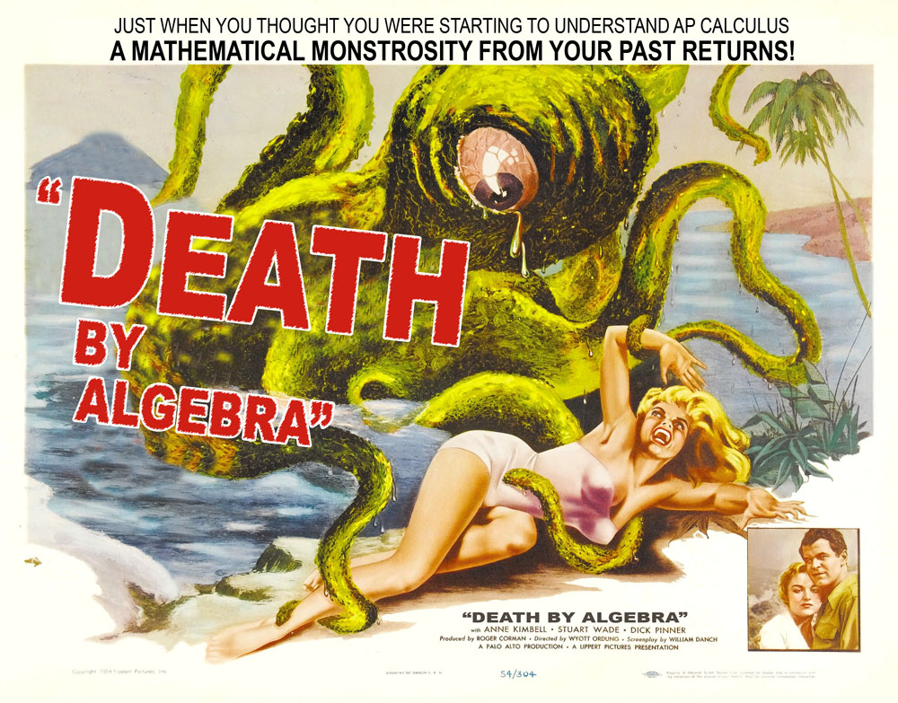

***I will not be available to answer emails during spring break***

