Pre-Algebra
Course 3 Guide
2014-2015

I have read and understand Mrs. Oswald’s course guide.

Student Name: ____________________________________________

Student Signature: ________________________________________

Date: _________________

Parent/Guardian Name: ___________________________________

Parent/Guardian Signature: _______________________________

Date: _________________

Pre-Algebra
Mrs. Oswald ashley.oswald@johnadamsacademy.com
Homework Policy:
(Scholars will have homework almost every night!)
- Late Work can be turned in for half credit or with a “coupon” for full credit. Late assignments will only be accepted up to ONE WEEK after due date!
- Absent scholars are responsible for making up class notes, homework, and grading homework to receive credit.
- Homework is graded out of 4 points:
- 4 points: <7 problems incorrect
- 3 points: 7-10 problems incorrect
- 2 points: >10 problems incorrect, redo for credit
- 0 points: no homework

Grading Policy:
60% Tests
25% Homework
15% ISN Check
Come to class prepared with:

-Pencil
-Eraser
-ISN (Interactive Scholar Notebook)
-Homework
-A good attitude!
We will use
Saxon Math Course 3.
The text is always available on the class webpage and will be downloaded to scholar’s kindles. 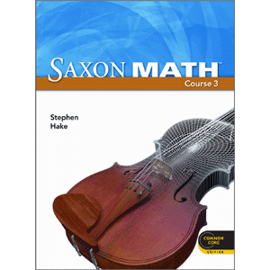
On my webpage you can find…
Homework, Tests, Projects, our Textbook, my contact information, and more!

HELP!
If a scholar is struggling they should ask for help
as soon as possible.
Tutoring for all scholars is Monday-Thursday after school until 4:15.
***
Please know that STUDYING is crucial to being successful in Pre-Algebra!

