Level A  Find the opposite of:  - 5  - -8  - ⅗  - -2.85  - |-4| | Level A  Evaluate each expression:  - |5|  - |-2|  - |⅛|  - -|8|  - -|-4|
Level A  Find the opposite of:  - 9  - -4  - ⅝  - -7.2  - |-3| | Level A  Evaluate each expression:  - |9|  - |-7|  - |⅕|  - -|4|  - -|-3|
Level B  Sue School Martin  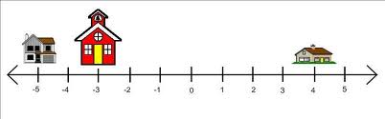  Find the distances:  - From the school to the Sue’s home.  - From the school to Martin’s home.  - From Sue’s home to Martin’s home. | Level B  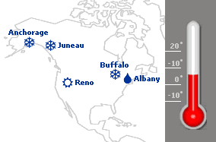  If it is -10° in Buffalo and 35° in Albany, what is the difference in temperature?
Level B  Write the temperatures in order, coldest first.  a) 8°C, -45°C, 0°C, -14°C, -2°C  b) -2°C, 6°C, -3°C, 9°C, -1°C | Level B  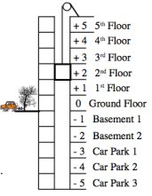  If you are on the 5th floor and want to go to Car Park 2, how many floors will you go down?
Level B  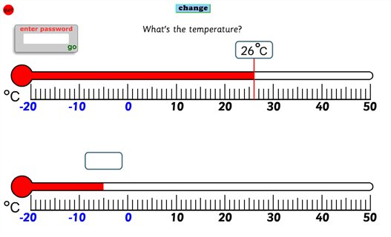  The thermometers above show temperatures in the afternoon (top) and the evening (bottom).  - What is the temperature in the evening?  - What is the difference in temperature from the afternoon to evening? | Level B  Below is a map of an amusement park.  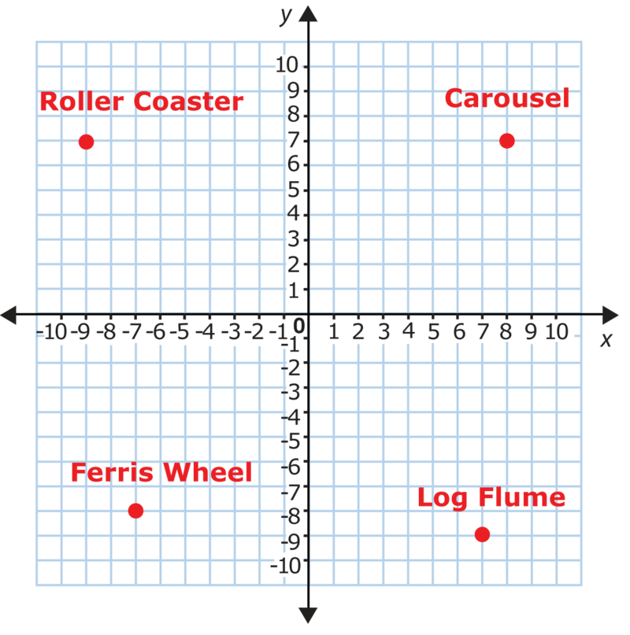  - Name the ordered pair that represents the location of each of these rides.  - Find the distance from the roller coaster to the carousel.
Level B  Triangle has vertices , and .  - Graph triangle on a coordinate plane.  - Label the coordinates of its vertices. | Level B  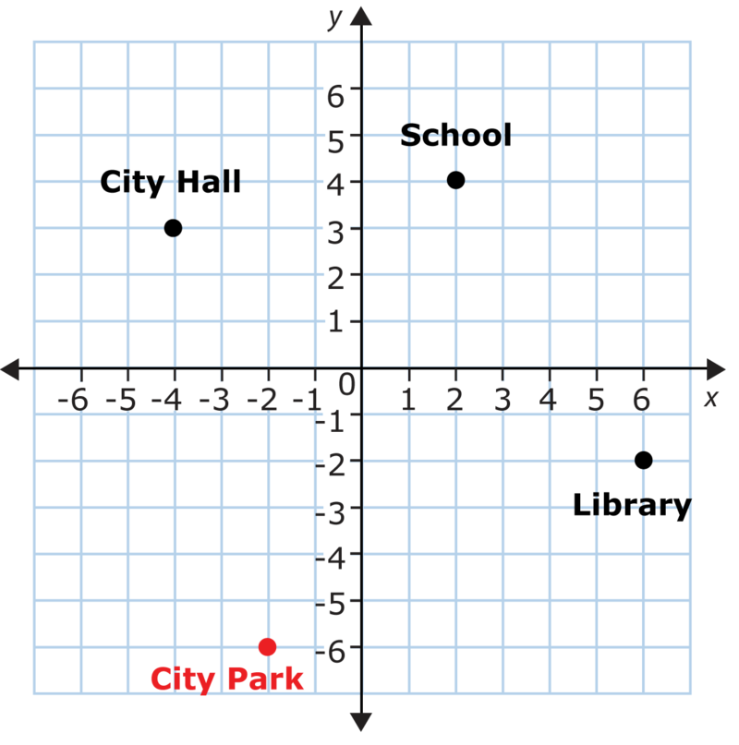  This coordinate grid shows locations in Jimmy's city.  Identify the ordered pairs that represent the different locations of the city.
Level C  Rectangle . is graphed on this coordinate plane.  Find the length and width of the rectangle, and then find the area and perimeter of the rectangle.  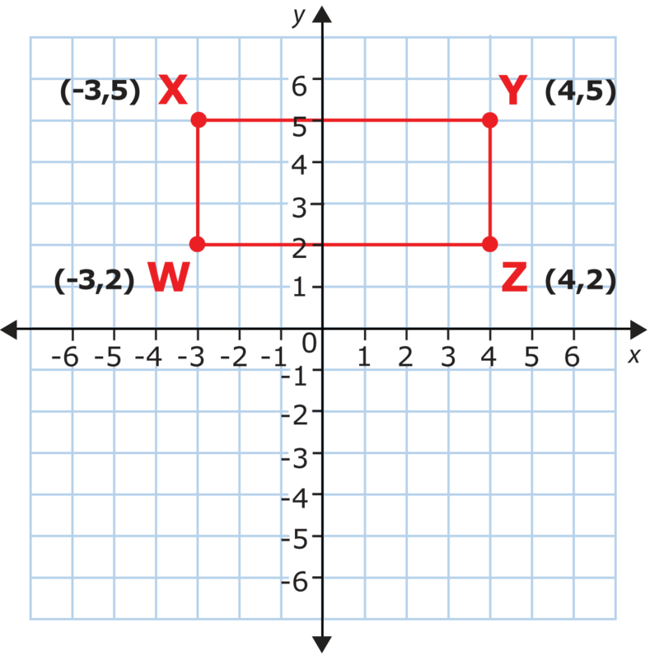 | Level C  Square is graphed on the coordinate plane below.  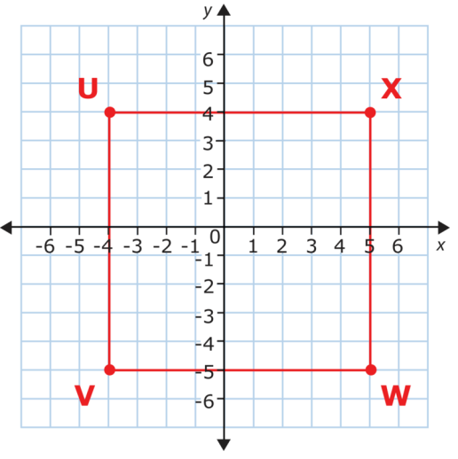  - Find the length of one side of this square.  - Find the area of this square.  - Find the perimeter of this square.
Level C  Put these numbers in order from least to greatest by graphing on a number line:  -9, |-3|, 6 , -|-6|, 0, 2, -4 | Level C  Put these numbers in order from least to greatest by graphing on a number line  -4, |-9|, -5 , -|-3|, ½ , 1, -6

Level D  Points and , shown below, are three vertices of a rectangle.  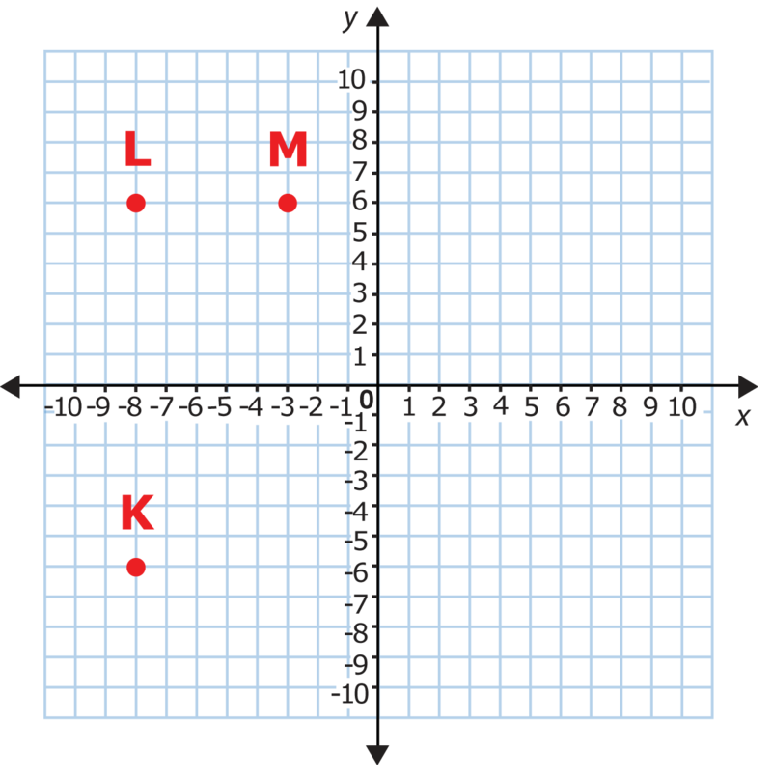  - Draw these vertices on your graph.  - Plot the fourth vertex of the rectangle on the grid. Name it vertex and identify its coordinates. Then connect the vertices to form rectangle .  - Find the length and width of rectangle .  - Find the area of rectangle .  - Find the perimeter of rectangle . | Level D  Points and , shown below, are three vertices of a square.  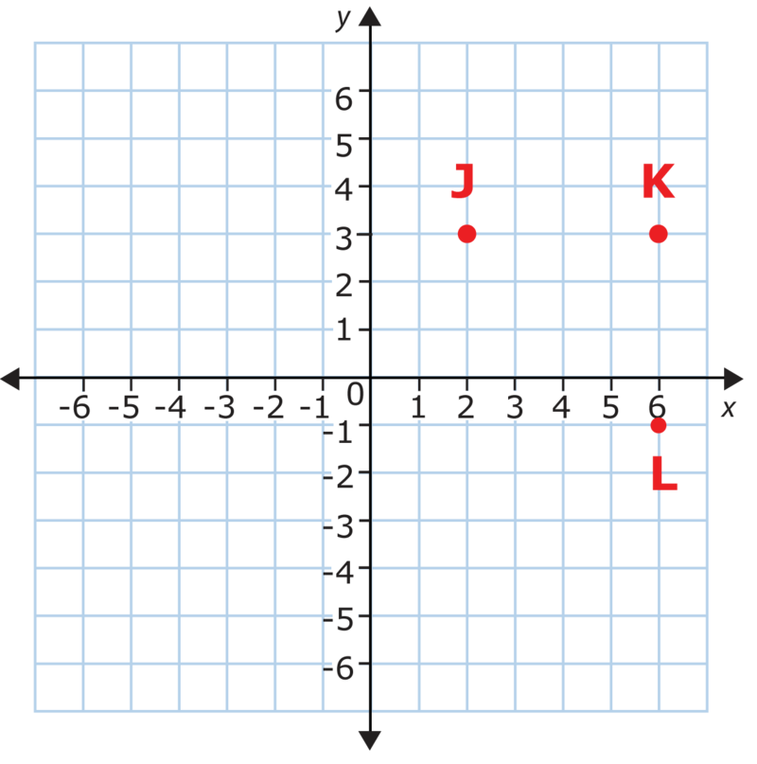  - Draw these vertices on your graph.  - Plot the fourth vertex of the square on the grid. Name it vertex and identify its coordinates.  - Find the area of square .  - Find the perimeter of square .
Level D  Put these numbers in order from least to greatest:  6¼, |-6 ⅝|, 6.25, 6.05, 5.998, -6.4, |-6.4| | Level D  Put these numbers in order from least to greatest:  3⅗, |-3 .29|, 3.05, 3½ , 3.001, -|3.6|

