bd
bd
Email to friends
Home
Mail
News
Sports
Finance
Weather
Games
Groups
Answers
Screen
Flickr
Mobile
More
Celebrity
Shine
Movies
Music
TV
Health
Shopping
Travel
Autos
Homes
Yahoo News Yahoo News
<style>#yucs #yucs-logo-ani {visibility: visible;position: relative;clip: auto;}</style>
Top of Form
Search News
Search Web

Bottom of Form
Sign In
Mail
Help
Account Info
Help
Suggestions
Yahoo

close button
Mobile App Promotion
Send me a link:
Phone Number 
*Only U.S. numbers are accepted. Text messaging rates may apply.
Please enter a valid phone number.
Please enter your Phone Number.
Send
Thanks! A link has been sent.
Done
News Home
U.S.
World
Politics
Tech
Science
Health
Odd News
Local
Dear Abby
Comics
ABC News
Yahoo Originals
Odd News Videos
Trending Now
The Sideshow
Photos
Featured
#BringBackOurGirls
 
Auto Dealers Cut Prices on New Cars & Trucks

The most memorable lines from 2014 commencement speeches

By Dylan Stableford, Yahoo News 5 hours ago Yahoo News

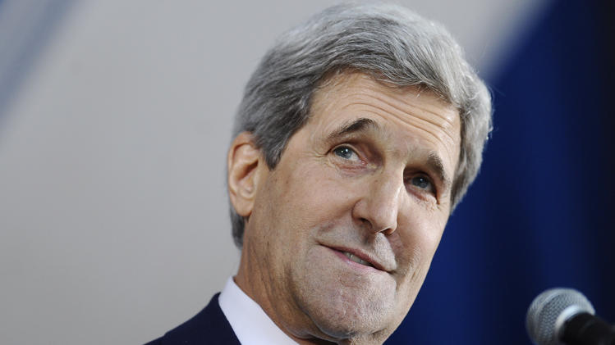
.

.

.
.
Secretary of State John Kerry returned to his alma mater of Yale University on Sunday to take a swipe at disgraced Los Angeles Clippers owner Donald Sterling.
"You are graduating today as the most diverse class in Yale's long history," Kerry said. "Or, as it's called in the NBA, Donald Sterling's worst nightmare." According to the Associated Press, the comment drew laughs from the crowd, which included graduates from 61 countries.
Kerry's zinger was one many memorable moments from the 2014 crop of commencement speeches.
At Howard University earlier this month, music mogul Sean "Puff Daddy" Combs quoted the late rapper Biggie Smalls in his speech to graduates.
“It was all a dream," Combs said in his speech on May 10. "I used to read Word Up magazine.”
Combs, who left Howard before earning his bachelor’s degree, recalled his time at the historically black college.

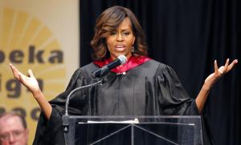

First lady Michelle Obama speaks during Topeka Public Schools Senior Recognition Program in Topeka, …
“My mind was blown when I saw so many beautiful shades of brown," Combs said. "I never heard so many accents, never seen so many beautiful women — and we all know Howard has the most beautiful, intelligent women in the world.”
On Friday, first lady Michelle Obama gave an impassioned speech on diversity to high school graduates in Topeka, Kansas, where the landmark Brown v. Board of Education case started.
“You all are the living, breathing legacy of this case,” Obama said. “Many districts in this country have pulled back on efforts to integrate their schools. Many communities have become less diverse."
Obama also delivered the commencement address to graduates of Dillard University in New Orleans.
“No dream is too big, no vision is too bold," she said on May 10. "As long as we stay hungry for education and let that hunger be our North Star, there is nothing, graduates, nothing, that we cannot achieve.”

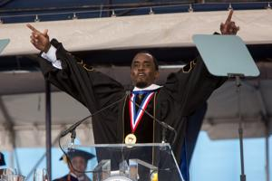

WASHINGTON, DC - MAY 10: Entrepreneur and philanthropist Sean "Diddy" Combs delivers the c …
At at the University of Massachusetts Lowell on Sunday, Bill Nye had a similar message for graduates: "Change the world."
"I'm not kidding. Change the world in new, exciting and big ways," Nye, better known as "The Science Guy," said. "Keep reaching. Keep seeking. Keep using your abilities to bring out the best in those around you, and let them bring out the best in you."
Nye also railed against climate-change deniers. "Conspiracy theories are for lazy people," he said. "People that don't want to get down to the business at hand. ... Instead of just doing less, we have to find ways of doing more with less. That's the key to the future." Also, he added, "if you smell fresh paint, don't walk under the ladder."
Attorney General Eric Holder also brought up the Sterling scandal in a speech to graduates at Morgan State University in Baltimore on Saturday, saying "subtle racism" still exists in the United States.
“Over the last few weeks and months, we’ve seen occasional, jarring reminders of the discrimination and the isolated, repugnant, racist views,” Holder said. “These outbursts of bigotry, while deplorable, are not the true markers of the struggle that still must be waged. ... The greatest threats do not announce themselves in screaming headlines. They are more subtle. They cut deeper.”

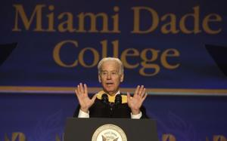

Vice President Joe Biden, center, speaks during a graduation ceremony at the Miami Dade College in M …
On May 3, Vice President Joe Biden delivered the commencement speech at Miami Dade College in Florida, the nation's largest community college.
“My name is Joe Biden, I am Jill Biden’s husband," Biden joked. "On every community college campus, that’s how I’m known.” (In her own commencement speech at Villanova, Jill Biden told the graduating class, "Show your heart to the world.")
The vice president then urged Congress to act on immigration reform. “It’s time to get done what an overwhelming number of Americans want to do," Biden said. “Act now and take these people out of the shadows.”
Jill Abramson, who was fired as executive editor of the New York Times last week, honored her commitment to speak at Wake Forest's graduation on Monday.
"What's next for me? I don't know," Abramson said. "So I'm in the same boat as many of you!"

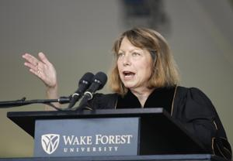

Jill Abramson, former executive editor of The New York Times, speaks at the commencement ceremony at …
Puff Daddy was among several unconventional choices for commencement speakers.
On May 10, Tiger Woods’s ex-wife, Elin Nordegren, received a roar of applause from Rollins College graduates when she mentioned her divorce.
“When I entered my student adviser's office in the fall of 2005, I was 25 years old. I had just recently moved to America. I was married without children,” Nordegren said, according to ABC News. “Today, nine years later, I’m a proud American, and I have two beautiful children — but I’m no longer married.
"It was right after I had taken Communication and the Media" class, she said, "I was unexpectedly thrust into the media limelight. And I probably should have taken more notes in that class."
At the University of Colorado Boulder, the May 9 commencement speech was delivered by Eric Stough, animation director for Comedy Central's "South Park" and a CU grad.
"Good morning, class of 2014," Stough, better known as the voice of several characters on the show, said. "As Mr. Hankey, the Christmas poo, would say, 'Howdy ho!'"
Stough, the voice of "Butters," also had a serious message for graduates about to enter the real world: "We need you. Your diploma is an inanimate object, so be the animator, and bring it to life."
____________________
In my university graduation, the university president gave the speech as it was his first year there. He told the story that in his first day, he was trying to get into the campus parking structure, there was a long line as the entrance arm would not go up no matter how many times you swipe the pass. He got out of his car, walked to the front to see what the problem was and when told he had a simple solution. He pushed the arm until it broke. As the president, who was going to argue.

“When you graduate from college, they tell you to follow your dreams. Does anyone say you have to wake up first?”
― Bill Cosby

