Slide | Notes | Critical Thinking Question
A:  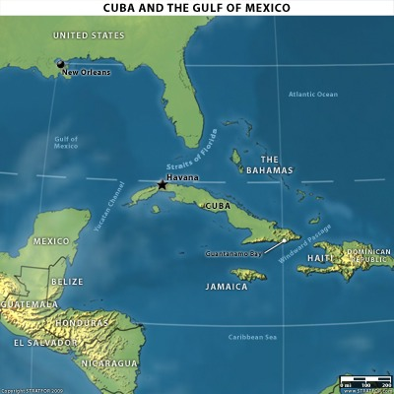 |  | Why were the U.S. owned sugar plantations in Cuba?
B: Maine  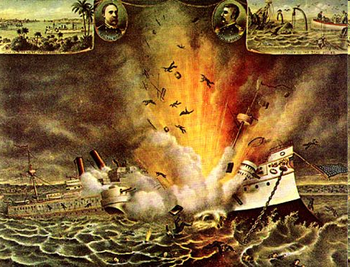 |  | Why do you think the ship was destroyed? Who did it?
C: News headline  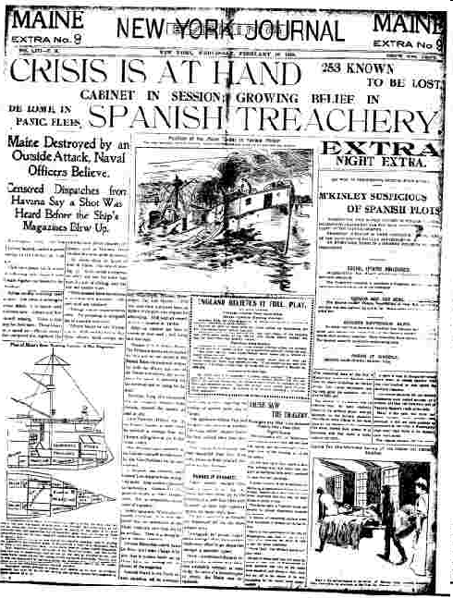 |  | According to the headline who is being blamed for the Maine explosion? Do you believe headlines on newspapers when you read them?
D. Spanish Brute  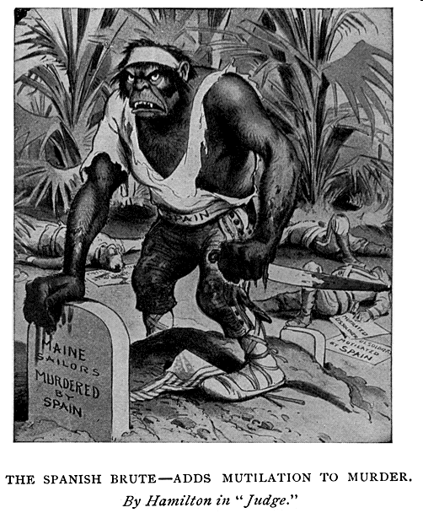 |  | What do you see in the cartoon? Why is it leaning on a tombstone? How did this affect Americans’ attitude toward the Spanish?
E: Outbreak of war  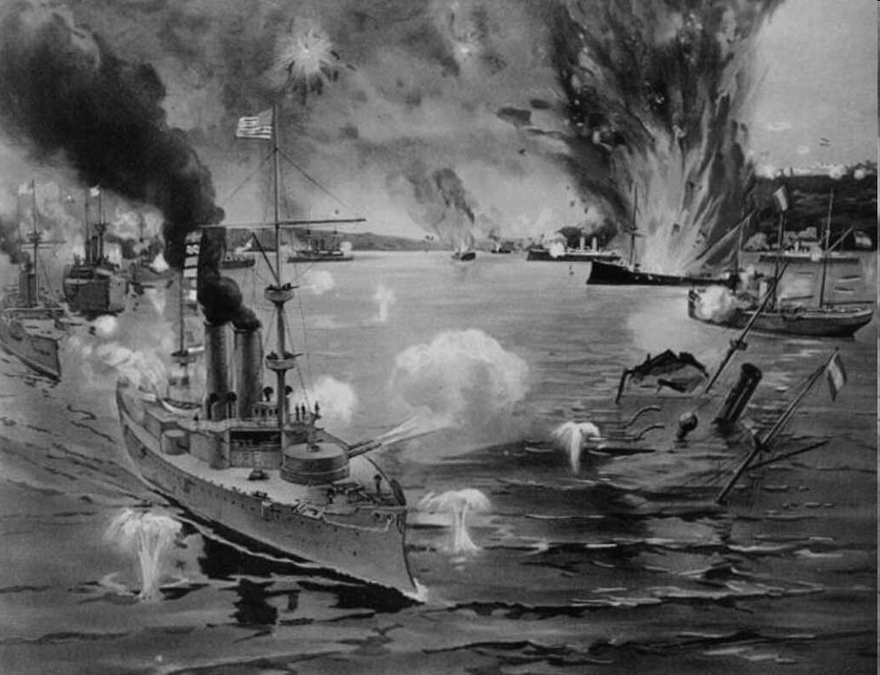 |  | Who appears to be winning?
F: Rough Riders  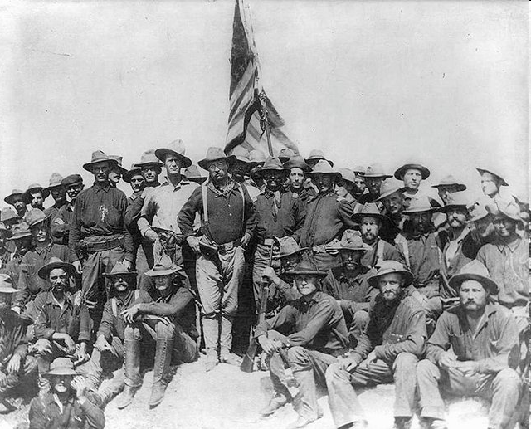 |  | Why are they carrying a flag? What do you think they have just done?
G: Colored Calvary  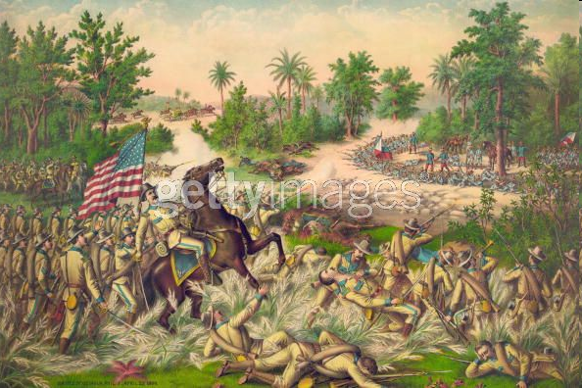 |  | Why did so many soldiers die from disease and tainted meat?
H: Uncle Sam  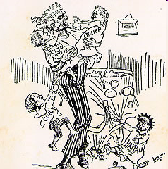 |  | What is happening in this cartoon? What was the artist’s message?

