Resources  Raw materials, fields, forests, farms | Tomatoes  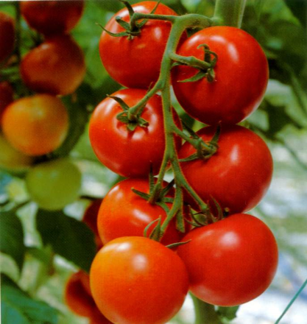 | Tomatoes | Tomatoes
Manufacturing  Production and processing | Tomato sauce and bottling  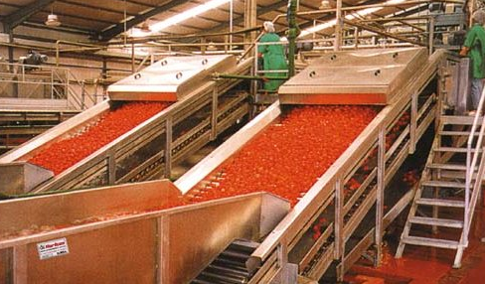 | Tomato sauce and bottling | Tomato sauce and bottling
Distribution  Shipping and transportation, delivery to customers | Trucking deliveries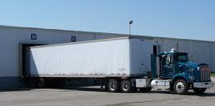 | Trucking deliveries | Trucking deliveries


