Gateway Lab School 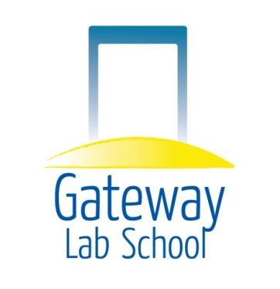

Operational Sustainability Subcommittee

DATE: Wednesday, April 1st, 2015 Time 6:00 pm

LOCATION: Panera’s Bread, Kirkwood Highway, Wilmington, DE

AGENDA

Updates

Old Business
- Discuss disbanding of the Instruction and Learning Committee

- Discuss disbanding of the Instruction and Learning Committee

- Alternative Framework Taskforce

- Letter to Advisory Council

New Business

Announcements

Closing of Meeting

