Treasure Fleet of Admiral Zheng He  “Of late we have dispatched missions to announce our Mandate to foreign nations and during their journeys over the oceans they have been favoured…They have escaped disaster and misfortune, journeying in safety to and fro….  - Emperor Zhu Di, AD 1409  Zheng He's treasure ship, illustrated above was estimated to be four hundred feet in length. Compare to Columbus's St. Maria (85 ft), illustrated by Jan Skina | 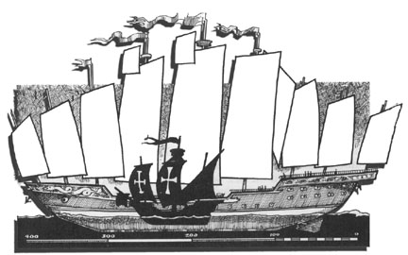
By 1420, China’s navy was the largest in the world, with 400 large war junks stationed at Nanking, 1,350 warships, river and canal patrol boats stationed elsewhere, 3,000 merchant vessels that could be converted into fighting ships if needed, 400 huge grain transports, and 250 “treasure ships,” overseas warships that brought back riches from far flung missions of trade and diplomacy.
Under the command of Admiral Zheng He, a fleet of these huge junks- some over 200 feet long - armed with cannon, rockets, and guns, carried Chinese naval power and trade throughout Southeast Asia and into the Indian Ocean, pushing back pirates and reopening trade with India, Arab East Africa, and the Ottoman Empire between 1405 and 1433. These large warships may have even been larger, but in the absence of archaeological remains, archaeologists and historians argue over the size of Zheng He’s ships. Some insist that the ships could have been as long as 440 feet, with a 180-foot width or beam.
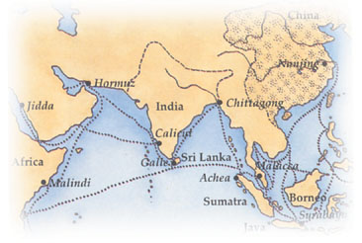
Routes taken by Zheng He. He was dispatched on his first expedition by the Ming emperor (1405). He visited Java, Sumatra, Malacca, Sri Lanka and India. He had a fleet of 317 ships, manned by 27,870 men. He also visited Arabia and the east coast of Africa.
The argument rages on, aided or confused by the discovery of a gigantic rudder-post believed to be from one of the giant warships. Excavated from the mud in a backwater of the one of the Ming naval shipyards at Nanking, the rudder-post is 36.2 feet long and 1.25 feet in diameter. Using these measurements, naval architects estimate that the rudder attached to the post was nearly half its length in height and breadth, or 452 square feet of wood. That means that thirty men could comfortably lie down on it! The ship to which such a rudder belonged would, following the rules of thumb for Chinese ship construction, be at least 400 feet long. One rudder post, as a solitary find, and possibly never fitted to a ship, does not represent a fleet. But it is a tantalizing hint of a navy of gigantic ships that outweighed, out-gunned and out-classed anything afloat in a European navy of the time.
The European powers, just then adapting cannon to warships and starting the progression toward large warships of their own, never came into contact with the “treasure ships.” After 1433, a new emperor, fearing the perils of overseas contact, withdrew the overseas and coastal navy and scrapped it as China withdrew into its borders to once again confine much of the trade and traffic to rivers and canals. Chinese merchant junks on the high seas and coast were left to the mercy of Indonesian, Vietnamese and Japanese pirates. The seas were left open to the arriving Europeans – the Portuguese, Spanish and Dutch, who by the early 16th century seized control of the overseas trade in spices, silks and other commodities with ships that could not have withstood the might of the Ming navy at the height of Chinese naval power decades earlier.
Had Zheng He’s “treasure ships” remained on the seas, the history of the world might have been very different. China entered a period of naval decline and ultimately a time of humiliation by foreign powers, particularly during the Opium Wars (1839-1842) and the subsequent interventions of Britain, Germany, Japan and Russia. In the 20th century, China finally emerged from what some termed “a long sleep” and is now one of the world’s largest naval powers and sea trading nations.

