Physical Science STP

Astronomy Study Guide

Galaxies
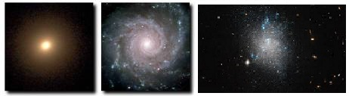
Galaxies are clusters of billions of stars that can various shapes:

Elliptical Spiral Irregular

The Sun
Compared with everything else in the solar system, the sun is huge – I mean, really, really big. In fact, the Sun makes up 99% of the mass of the solar system.
The sun produces energy through nuclear fusion – NOT fission. Memory trick: the sun has one s, and so does fusion. Fusion happens in the core (center) of the sun.
The sun is just one of many billions of stars in the Milky Way galaxy.

Measuring Space Distances
Astronomical Unit (AU): The distance between the Sun and the Earth. It is used to measure distances within a solar system.
Light-Year: The distance light travels in a year. It is used to measure distances between stars.

Star Evolution
Smaller stars eventually turn into white dwarf stars. Larger starts turn into black holes.
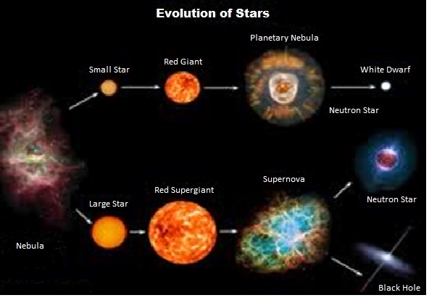

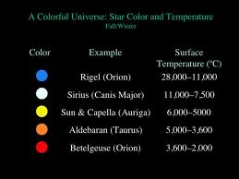

The Universe
Different stars have different sizes, temperatures, color, brightness, and composition.
The color of a star depends on its temperature.
The brightness of a star depends on its size and temperature.
The apparent brightness of a star is how bright it is seen from Earth.

Objects in the Solar System
All objects in the solar system orbit the sun in elliptical (oval) orbits.
Comets: Dirty snowballs about the size of a mountain. They have a nucleus in the middle (most dense), a coma of gas and dust (medium density), and a tail of gas and dust (lowest density). They come from the Kuiper belt or Oort cloud (very far away).

Asteroids: Giant space rocks, from about 1 kilometer to hundreds of kilometers in diameter. Most live in the asteroid belt between Mars and Jupiter.

Relative Sizes: Asteroids are the largest objects, but comets and asteroids are often similar in size. Meteoroids are much smaller than either comets or asteroids.

Stars (and star-like objects) provide all of the light in the universe. All other objects shine because of reflected light and NOT because they emit their own light.

Planets like the Earth move through space in two ways – rotation (spinning) and revolution (moving in an elliptical orbit around a star).
Craters: The result of meteor impacts.

The Moon, Tides, Eclipses, and the Seasons
The Earth has seasons because the axis is tilted as it revolves around the sun.
The Moon: The Moon revolves and rotates at the same rate. This is why the same side of the Moon always faces the Earth. The phase of the moon you see depends on how much of the sunlit side of the moon faces the Earth. The Moon is about ¼ the diameter of the Earth.
The changing positions of the Sun, Earth, and Moon cause the phases of the moon, the tides, and eclipses.
The tides are caused mainly by differences in how much the moon’s gravity pulls on different parts of the Earth.
Solar Eclipse: Moon’s shadow falls on the Earth.
Lunar Eclipse: Earth’s shadow falls on the Moon.

Physical Science STP Astronomy Practice
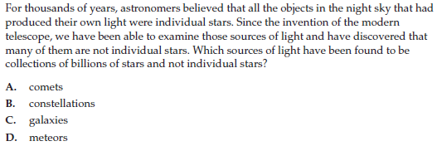
1)

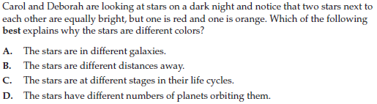
2)

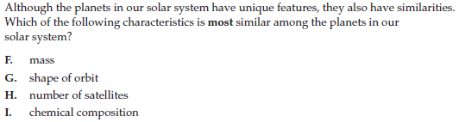
3)

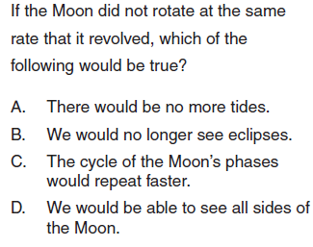
4)

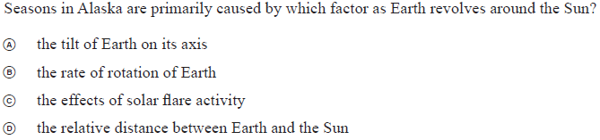
5)

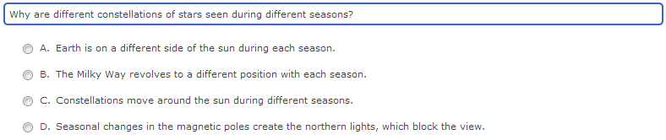

6)

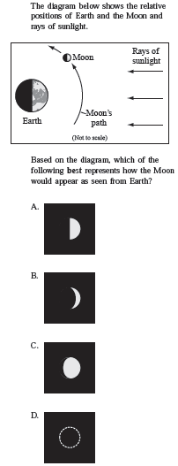
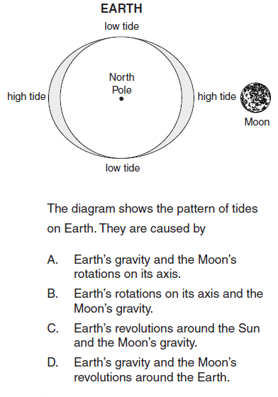
7) 8)

