Name: ______________________________________________ Period: _______
Absolute Value

- How would you define absolute value?

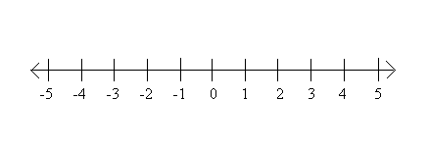
- Evaluate the following expressions and plot each on the number line below.
A = │3│ B = │-4│ C = │-2│ D = │0│ E = │½│

- Put these values in order from least to greatest: - 3 , │ 6 │ , │- 4│ , 5 , 0 , │- 1│

- Insert the correct symbol (<, >, or =)

  - 0 ___ │- 1│ b. -9 ____ │- 9│ c. │3 │ _____ │-3│

- Sara and Jake both ride their bikes to the library. When it was time to go home, Sara makes a left out of the parking lot and rides 2 miles west of the library. Jake makes a right out of the parking lot and rides 2 miles east of the library.
  - Who lives further away from the library? How do you know?

  - Using the information from the problem above, if 0 represents the library, place dots on the number line below to show the location of the library, Sara’s house, and Jake’s house.

  - What is the distance between Sara and Jakes homes?

- In the equation, │x│ = 8, what is true about x? (Circle all that apply).
  - x must be 8
  - x can be – 8 because it is 8 units away from 0.
  - x can be 8 because it is 8 units away from 0.
  - x can be any value.

