- 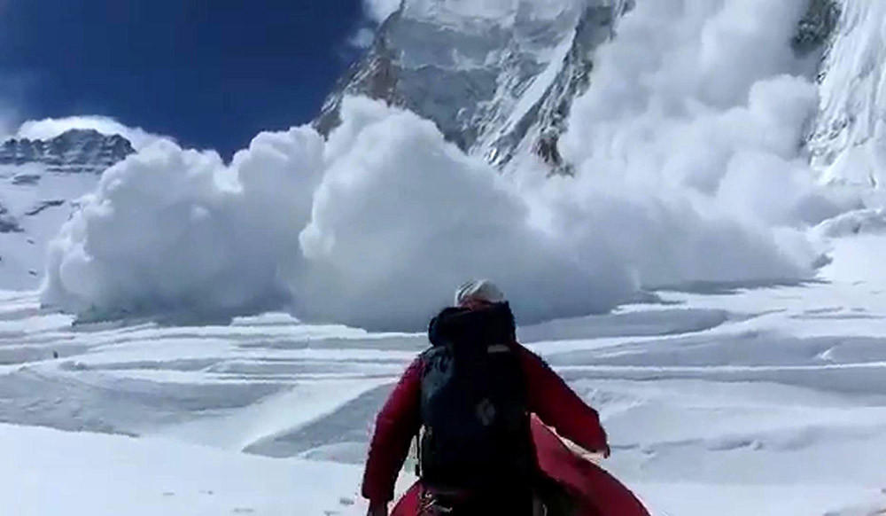
The avalanche that killed at least 13 sherpas is pictured as it barrels down a mountain in the Mt. Everest Region on April 18. (Buddhabir Rai, AFP/Getty Images)



Twelve guides die in Mt. Everest avalanche

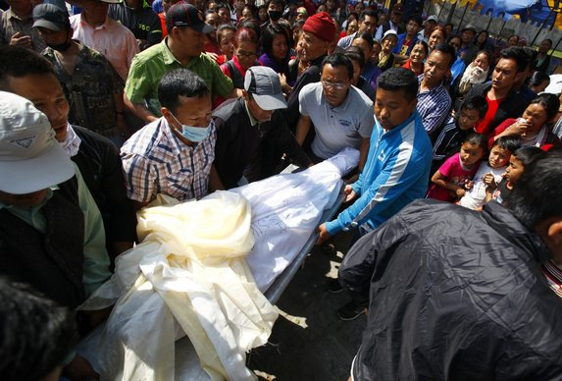
CAPTIONS

1/9
By Shashank Bengali
April 18, 2014, 11:55 a.m.
MUMBAI, India – A predawn avalanche on Mt. Everest killed at least 12 Nepalese guides in the single deadliest accident on the world’s tallest peak, officials said Friday.
The guides were preparing ropes and ferrying supplies for commercial climbers southwest of the summit when the avalanche occurred at an elevation of about 20,000 feet, Nepalese tourism officials said.
About two dozen guides, many of them members of the ethnic Sherpa community, were swept away, triggering a major search-and-rescue operation involving helicopters and Nepalese military forces. Twelve bodies were recovered and eight guides were found injured by rescuers picking through the thick ice and snow.
- Also
- 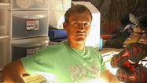Chad Kellogg dies at 42; elite mountain climber
- 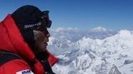Japan's Yuichiro Miura becomes oldest person to climb Mt. Everest
Several more guides were missing, the local Himalayan Times newspaper reported.
The avalanche took place along a route used to ascend Everest, in an area just below Camp 2 known as the “popcorn field” because of its jagged chunks of ice. About 100 guides were reportedly trapped above the site and were cut off from returning to camp.
An Australian climber who witnessed the avalanche, Gavin Turner, said it “came out of nowhere” and that he was immediately surrounded in a cloud of snow and dust. Then he heard a large thud, he told ABC News.
“Without warning, a large chunk of ice broke loose,” said Turner. “There were a few seconds of panic where I thought this is going to collect us.”
The guides were preparing a route ahead of the start of the climbing season on Everest, which attracts the world’s foremost mountaineers as well as wealthy tourists who fork over upward of $30,000 for a chance at the summit. The guides are the engine of the industry, porting heavy packs and supplies for less experienced climbers and even veterans challenged by Everest’s forbidding conditions.
In recent years, Nepal has cut the fees in a bid to lure more climbers, earning criticism from some who worry that the mountain already sees too much traffic. More than 4,000 people attempted the climb in 2013, according to official statistics.
The previous deadliest incident on Everest occurred in 1996, when eight climbers were killed in a two-day snowstorm that was recounted in journalist Jon Krakauer’s book “Into Thin Air.”
http://www.latimes.com/world/worldnow/la-fg-wn-mount-everest-avalanche-20140418,0,4757731.story#ixzz2zXoPTbVy

Avalanche on Mt. Everest Kills 12, 3 Still Missing
The Atlantic Wire via Yahoo! News Apr 17 10:30pBREAKING: Nepal tourism official says 6 Nepalese guides dead, 9 missing in Mount Everest avalanche— The Associated Press (@AP) April 18, 2014
Discovery Cancels Everest Jump In Wake Of Avalanche Deaths
Deadline Hollywood Apr 20 12:49pm
“In light of the overwhelming tragedy at Mt Everest and respect for the families of the fallen, Discovery Channel will not be going forward with Everest Jump Live ,” the network said in a statement early Sunday afternoon, adding, ” Our thoughts and prayers go out to the whole Sherpa community.” On Friday morning NBC News, whose Peacock Productions is producing Discovery’s Mount Everest live jump ...
- Everest Climbing Season in Doubt as Sherpas Issue Ultimatum ...
time.com/69829/everest-climbing-season-in-doubt-as... Cached
Everest Climbing Season in Doubt as Sherpas Issue Ultimatum to ... threatening to boycott the upcoming spring climbing season if their demands are not met, ...

KATHMANDU — Rescuers have given up searching for three sherpa guides missing two days after the deadliest ever accident on Nepal's Mount Everest killed at least 13 and shocked the mountaineering world.
Snow and huge chunks of ice swept down the perilous and crevasse-riddled Khumbu Icefall on Friday as guides ferried supplies to upper camps for foreign climbers trying to reach the summit of the world's highest mountain.

