Art
During the Asuka Period, the artisans from Baekje provided technological and aesthetic guidance in the Japanese architecture and arts. Therefore, the temple plans, architectural forms, and iconography were strongly influenced directly by examples in the ancient Korea. In deed, many of the Japanese temples at that time were crafted in the Baekje style. The Japanese nobility imported artists and artisans from the Korean Peninsula (most, but not all, from Baekje) to build and decorate their first palaces and temples.
Among the earliest craft items extant in Japan is the Tamamushi shrine, a magnificent example of Korean art of that period. The shrine is a miniature two-story temple made of wood, to be used as a kind of reliquary. This shrine is so named because it was decorated with Korean indigenous iridescent beetle(Tamamushi) wings set into metal edging, a technique also practiced in Korea and this technique of tamamushi inlay is evidently native to Korea. The shrine's ornamental gilt bronze openwork, inlaid with the iridescent wings of the tamamushi beetle, is of a Korean type.

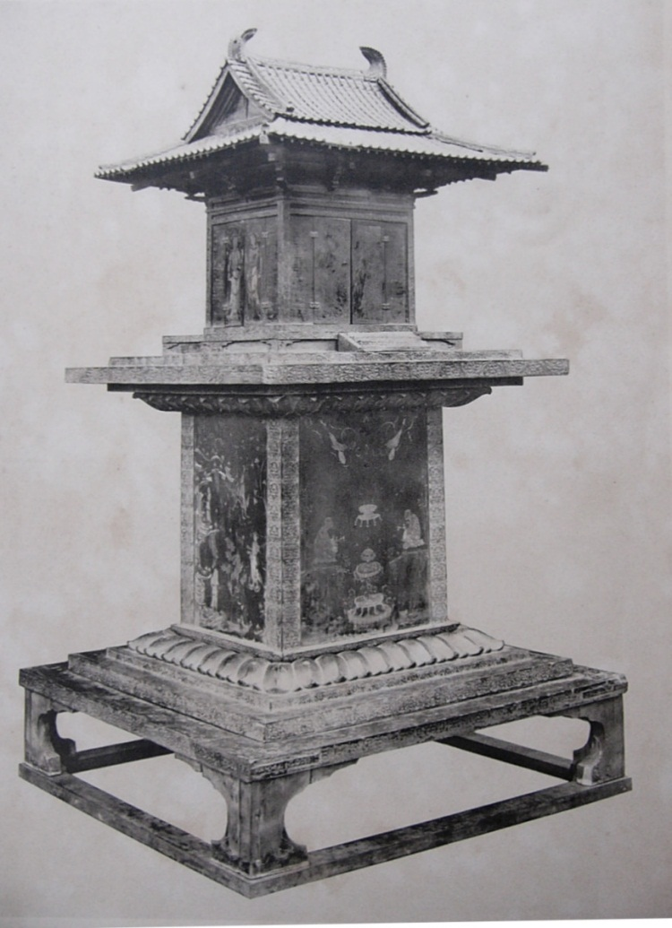

Architecture
The oldest Japanese Buddhist temple, Asuka-dera, constructed by craftsmen from the ancient Korean kingdom of Baekje in 588, was modeled upon the layout and architecture of Baekje.^{[14][15]} And one of the early great temples in Japan, such as the Shitennō-ji Temple was based on types from the ancient Korea.^{[16][17]} In 601, Prince Shōtoku began the construction of his palace, the first building in Japan to have a tiled roof. Next to it he built his temple, which became known as Hōryū-ji. He employed a number of skilled craftsmen, monks, and designers from Baekje for this project.^{[8][18]} The temple became his personal devotional center where he studied with Buddhist priests Hyeja and Damjing from the Korean kingdom of Goguryeo; it also housed people who practiced medicine, medical knowledge being another by-product of Buddhism. Next to the temple there were dormitories which housed student-monks and teacher-monks.^{[19]}
The first Horyu-ji burned to the ground in 670. It was rebuilt, and although it is thought to be smaller than the original temple, Horyu-ji today is much the same in design as the one originally built by Shotoku. Again, the temple was rebuilt by artists and artisans from Baekje.^{[19]} The bracket work of a Baekje gilt bronze pagoda matches the Hōryū-ji bracket work exactly.^{[20]} The wooden pagoda at Horyu-ji, as well as the Golden Hall, are thought to be masterpieces of seventh-century Baekje architecture.^{[19]} Two other temples, Hokki-ji and Horin-ji, were also probably built by artisans of Korea’s Baekje kingdom.^{[21]}

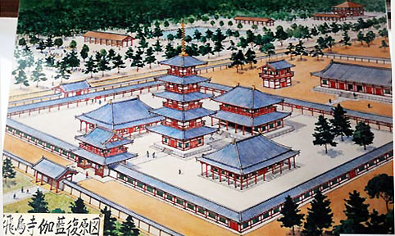

Sculptures
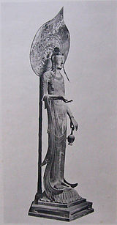
Kudara kannon
One of the most famous of all Buddhist sculptures from the Asuka period found in Japan today is the "Kudara Kannon" which, when translated, means "Baekje Guanyin."(Kudara is the Japanese name for Baekje^{[22]}) This wooden statue was either brought from Korean Baekje or carved by a Korean immigrant sculptor from Baekje.^{[23][24][25]} Ernest Fenollosa, American scholar of Asian cultures, describes the Kudara Kannon as “the supreme master piece of Corean creation”.^{[26]} It formerly stood as the central figure in the Golden Hall at the Horyu-ji. It was moved to a glass case in the Treasure Museum after a fire destroyed part of the Golden Hall in 1949.^{[citation needed]} "This tall, slender, graceful figure made from camphor wood is reflective of the most genteel state in the Three Kingdoms period. From the openwork crown to the lotus pedestal design, the statue marks the superior workmanship of 7th century Paekche artists."^{[27]} The first and foremost clue that clearly indicates Baekje handiwork is the crown's design, which shows the characteristic honeysuckle-lotus pattern found in artifacts buried in the tomb of King Munyong of Baekje (reigned 501-523).^{[1]} The number of protrusions from the petals is identical, and the coiling of the vines appears to be the same. Crowns of a nearly identical type remain in Korea, executed in both gilt bronze and granite. The crown's pendants indicate a carryover from shamanist designs seen in fifth-century Korean crowns.^{[27]} Guanyin's bronze bracelets and those of the Four Heavenly Kings at the Golden Hall also show signs of similar openwork metal techniques.^{[citation needed]}

Painting
In 588, the Korean painter Baekga (白加) was invited to Japan from Baekje, and in 610 the Korean priest Damjing came to Japan from Goguryeo and taught the Japanese the technique of preparing pigments and painting materials.^{[37][38]}
In the 15th century, facing slavery and persecution as neo-Confucianism took a stronger hold during the Joseon Dynasty in Korea, many Buddhist-sympathetic artists began migrating to Japan. Once in Japan, they continued to use their Buddhist names instead of their birth (given) names, which eventually led to their origins being largely forgotten. These artists eventually married native women and raised children who were oblivious to their historical origins.^{[39]} Many famous artists in Japan fall into this category. Yi Su-mun, who left for Japan in 1424 to escape persecution of Buddhists, painted the famous "Catching a Catfish with a Gourd". The famous Tenshō Shūbun of Shokoku-ji also arrived on the same vessel as Yi Su-mun.^{[40][41]} The Korean painter Yi Su-mun, who as artist in residence to the Asakura daimyo family of Echizen in central Japan, was to play an important role in the development of Japanese ink painting^{[40]}: He is reputed to have been the founder of the painting lineage of Daitoku-ji, which reached its apex at the time of the great Zen master Ikkyū and his followers.^{[42]} The Soga (曽我派), a group of Japanese painters active from the 15c through the 18c, also claimed lineage from the Korean immigrant painter Yi Su-mun, and certain stylistic elements seen within the paintings of the school suggest Korean influence.^{[43]} Muncheong (or Bunsei in Japanese) was another Korean immigrant painter in the 15th century Japan, known only by the seal placed on his works extant in both Japan and Korea.^{[44][45]}

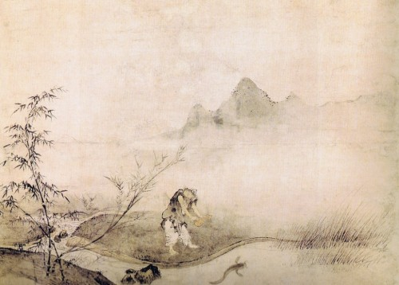

Technique
Various metal-working techniques such as iron-working, the cuirass, the oven, bronze bells used in Yayoi period Japan essentially originated in Korea.^{[46]} During the Kofun period, in the fifth century, large groups of craftspeople, who became the specialist gold workers, saddlers, weavers, and others arrived in Yamato Japan from the Baekje kingdom of Korea.^{[47][48]}

Iron ware
Iron processing and sword making techniques in ancient Japan can be traced back to Korea. "Early, as well as current Japanese official history cover up much of this evidence. For example, there is an iron sword in the Shrine of the Puyo Rock Deity in Asuka, Japan which is the third most important historical Shinto shrine. This sword which is inaccessible to the public has a Korean Shamanstic shape and is inscribed with Chinese characters of gold, which include a date corresponding to 369 A.D. At the time, only the most educated elite in the Paekche Kingdom knew this style of Chinese writing"^{[1]}
"Inariyama sword, as well as some other swords discovered in Japan, utilized the Korean 'Idu' system of writing." The swords "originated in Paekche and that the kings named in their inscriptions represent Paekche kings rather than Japanese kings." The techniques for making these swords were the same styles from Korea.^{[1][49]}

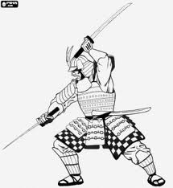

Shipbuilding
The ancient Japanese learned shipbuilding techniques under the direction of Korean engineers from the kingdom of Silla.^{[56][57]} An immigrant group 'the Inabe', closely associated with shipbuilding, was made up of carpenters who had come to Japan from Silla.^{[58][59][60]}
In the 9th century, conditions of sea travel from Japan to Tang dynasty of China improved because the relations with Unified Silla were now such that Japanese could take advantage of Korean ships, which were better built and better handled than their own.^{[61]} Evidently, the Ennin's Diary suggests that Koreans were active in the international trade in the late Silla period and were considered the best sailors with the best ships of the day.^{[62][63]} The monk Ennin noted Sillan vessels not only in a Japanese harbor or traversing the Yellow Sea but also carrying cargoes of charcoal from Shandong to Shuzhou within China.^{[64][65]} At this time, the Japanese also recognized the superiority of Korean shipbuilding,^{[61]} as we know of the Japanese envoys as well as student monks preferred to abandon their Japanese ships by obtaining ships constructed from Silla and also from orders sent in 839 by the Japanese court instructing Kyushu that the new ship should be built to the specifications of Silla Ships to stand up the storms.^{[66]}

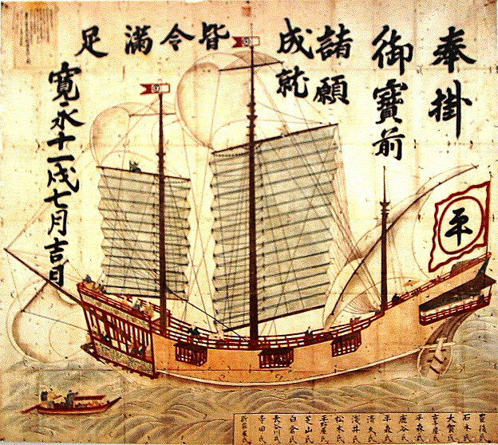

Navigation
Ancient Koreans were commercially active throughout East Asia, and their mastery of navigation allowed them to pursue trade interests as far away as the East Indies.^{[67]} In 526, a Baekje Korean monk Gyeomik traveled to India via the southern sea route and mastered Sanskrit, specializing in Vinaya studies. He came back with a collection of Vinaya texts to Baekje, accompanied by the Indian monk Paedalta(Vedatta).^{[68]} During the later Silla, whence students traveled to Tang China in ships guided by the mariner's compass, in order to gain the knowledge of Chinese ethics and philosophy.^{[69]}
In the 9th century, Japanese had not mastered the skill and knowledge necessary for safe ocean navigation in their part of the world.^{[66][70]} Consequently, the Japanese monk-traveler Ennin tended to rely on the Korean sailors and traders on his travels,^{[62]} at the time when the men of Silla were the master of the seas achieving Korean maritime dominance in eastern Asia.^{[71][72][73]} The monk Ennin’s crossing to China on Japanese vessels and the whole catastrophic maritime record of the mission contrast sharply with the speed and efficiency with which Sillan ships whisked him back home to Japan.^{[70]} Another indication of the gap in navigation skill between the Sillans and Japanese at this time was the employment by the Japanese embassy of 60 Korean helmsmen and sailors to help get the main party safely home.^{[70]}

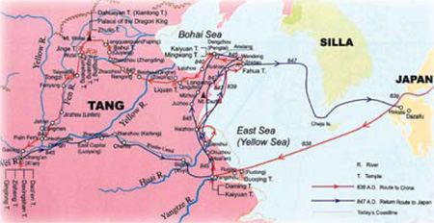

Music
In the field of Korean and Japanese music history, it is well known that ancient Korea influenced ancient music of Japan.^{[85]} Since the 5th century, musicians from Korea visited Japan with their music and instruments.^{[86]} Komagaku, literally "music of Korea", refers to the various types of Japanese court music derived from the Three Kingdoms of Korea and northern Korean state of Balhae,^{[87]} later classified collectively as Komagaku.^{[88]} It is made up of purely instrumental music with wind- and stringed instruments(became obsolete), and music which is accompanied by mask dance. Today, Komagaku survives only as dance accompaniment and is not usually performed separately by the Japanese Imperial Household.^{[89]}

Instruments
As early as the 5th century the Kudaragoto, which resembles the western harp, had been introduced from Baekje to Japan along with Korean music. It has twenty three strings, and was designed to be played in an upright position.^{[90]} And the 12-string long zither Shiragigoto was introduced as early as 5th or 6th century from Silla to Japan.^{[86]} However, today, the two instruments has fallen out of use by traditional music performers.
Some instruments in traditional Japanese music originated in Korea: Komabue is a six-hole traverse flute of Korean origin.^{[91]} It is used to perform Komagaku and Azuma asobi^{[92]}(chants and dances, accompanied by an ensemble pieces). San-no-tsuzumi is an hourglass-shaped drum of Korean origin.^{[86]} The drum has two heads, which are struck using a single stick. It is played only in Komagaku.

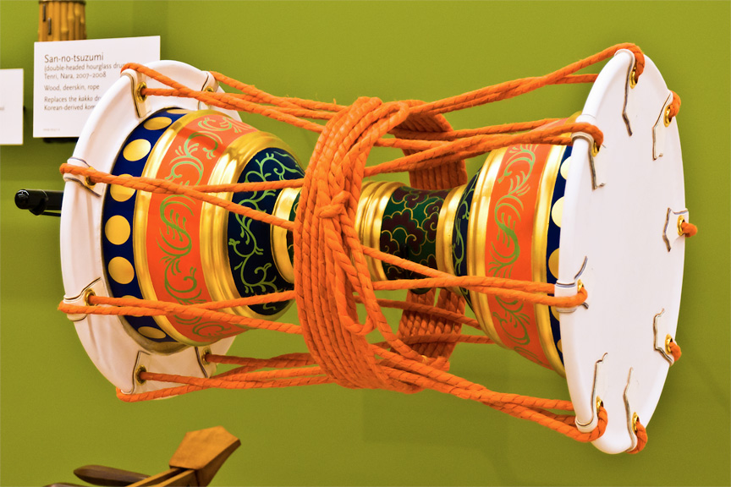

Literature
Yamanoue no Okura was a famous poet in eighth-century Japan, who immigrated from Korean Baekje.^{[93][94][95]} Influenced by the Madhyamika School of Buddhism growing out of his Former Baekje cultural heritage,^{[93]} he addressed social concerns through his poem,^{[96]} unlike other Japanese poets of the time, who spoke for the ethos of land, love, death and devine monarchy.^{[97]} He later became a tutor to the crown prince and Governor of a province in Japan.^{[93]} The reputation of Yamanoue no Okura has sharply risen in the twentieth century,^{[98]} “he became, in the general consensus of sub-sequent centuries of Japanese literary scholarship, one of the most memorable, most influential, and today most often cited poets of the Old Japanese period.”^{[93]}
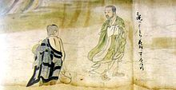
The Kegon Engi Emaki, an emakimono describing the foundation of the Hwaom sect in Silla and the life of two Korean monks of the sect, Uisang and Wonhyo.^{[17]}

Writing systems

Man'yōgana
The Koreans were indeed among the first to adapt Chinese characters for phonetic purposes, producing Idu, Gugyeol, and Hyangchal, who deviced probably the model of the Japanese Man'yōgana syllabaries.^{[102]} The immigrant scholars from Korea were heavily involved in early writing activity in Japan using phonogram orthography, Man'yōgana.^{[103]} And it seems that most linguists in this field tend to accept that Man'yōgana came from ancient Korea or more precisely from Baekje.^{[104]}
Furthermore, some Japanese linguists also suggest that the Katakana system may have influenced by Korea's ancient writing system. Kanazawa Shozaburo(1872-1967), former Professor of Kokugakuin University is of the opinion that the Japanese Katakana were borrowed from Korea.^{[105]} Kobayashi Yoshinori, Professor at Tokushima Bunri University has discovered, in a Korean Buddhist text introduced to Japan in the early eighth century, letters that look like Katakana.^{[106]} He said that the newly discovered Silla scripts, written in 740, may have acted as a source for the origins of Japanese scripts, Kana. He guessed that Silla scripts was imported into Japan, along with Buddha texts during the Nara period.^{[107]}

Jindai moji
Jindai moji, "the god age script," was claimed by a Shinto scholar in the 13th century that Japan had had its own system of writing before the introduction of Chinese characters, and this idea was taken up by several scholars of nationalists persuasion in the Tokugawa period who produced samples of the script to support their claims.^{[108]} The discoveries of many varieties oí Jindai moji, during the late Tokugawa period, were forgeries done by Kokugaku scholars, who were feeling embarrassed about adopting and adapting scripts from other cultures and unwilling to acknowledge that writing was one of the many of cultural appurtenances for which Japan was at first dependent on China and Korea.^{[108][109]} Ironically, several Jindai moji, modeled on the Korean alphabet Hangul, are identical in shape and sound values to their Hangul models, and others are distorted versions.^{[109]}
