School/Program of Choice Annual Evaluation Report

School/Program of Choice | Adams Montessori Program | School Year: | 2014-2015

Student Demographics:
 | 2012-2013 (1st-4th) | 2013-2014 (1st-5th) | 2014-2015 (1st-6th)
# of students enrolled | 28 students | 43 students | 51 students
% of males enrolled | 40% | 42% | 39%
% of females enrolled | 60% | 58% | 51%
% Laotian | 0% | 0% | 1.96%
% Korean | 0% | 4.65% | 3.92%
% Arabic | 0% | 4.65% | 0%
% Asian | 0% | 4.65% | 3.92%
% Chinese | 3.57% | 2.32% | 1.96%
% Black or African American | 0% | 0% | 1.96%
% Hispanic or Latino | 46.43% | 39.53% | 45.09%
% White | 50% | 44.19% | 41.17%
% of low SES students | 36% | 58% | 39%

Recruitment Practices:
Adams Elementary School recognizes that all children learn differently. Therefore, we have created two diverse Montessori classrooms to serve 1-3rd grade students and 4-6th grade students. The Montessori classrooms contain 24-30 children at Adams School that serves as both a GATE and an Intervention classroom.

Students are placed in the Adams Montessori program based on parent request and teacher recommendation; with enrollment aligned with the district transfer request deadlines (currently February 17th). If there is more interest in the program than there are spaces available, then Adams-boundary students will have first priority. A lottery may be held if necessary.

Funding Sources:
The Adams Montessori program ties in with the SBUSD mission to ensure the educational success of all students, which recognizes that all students do not learn the same way. Teachers in the program must hold both a California credential and a Montessori credential (AMI or AMS). The Montessori teachers are funded through the SBUSD. The classroom materials have been funded through site categorical and lottery funds. A part-time curriculum specialist is funded through site categorical funds to support the multi-age classrooms.
Student Academic Data:
Adams Montessori students are high achieving in academics. Students consistently excel in district formative and summative assessments. The Renaissance Learning STAR Reading and STAR Math scores for the Montessori students in both 1-3rd grade and 4-6th grade classrooms indicate both a High Growth and High Achievement rate for all students.
About STAR Reading: The criterion referenced STAR Reading test is generally administered to K-12 students who have a reading vocabulary of at least 100 words. The student should have at least a beginning reading level around the mid-first grade. A good measure to see if a student is ready to take the STAR Reading assessment is through the practice test. Students that can work through the practice questions unassisted should be able to take the STAR Reading test. The STAR Reading is a computer adaptive reading test and database that has fill-in- the blank questions. Students answer 25 or more questions on a computer or an iPad. The assessment takes about ten minutes to answer all of the questions.
The STAR Reading assessment is also linked to the Renaissance Learning Accelerated Reader assessment that generates a comprehension assessment for students to take after he/she has completed a book. The principal sets student reading goals at the following targets: All students are to read within their Zone of Proximal Development (ZPD), 30 minutes daily, score 85% or higher on the comprehension assessment with 50% of all reading being non-fiction for month. The principal provides incentive parties at the end of every month for students who meet the above criteria. All of the Montessori students consistently hit their reading goals for the month. All of the 4-6th grade students have hit their reading target, every single month for the 2014-2015 school year.

Table 1.0: STAR Reading Student Growth Progress, Lower Elementary
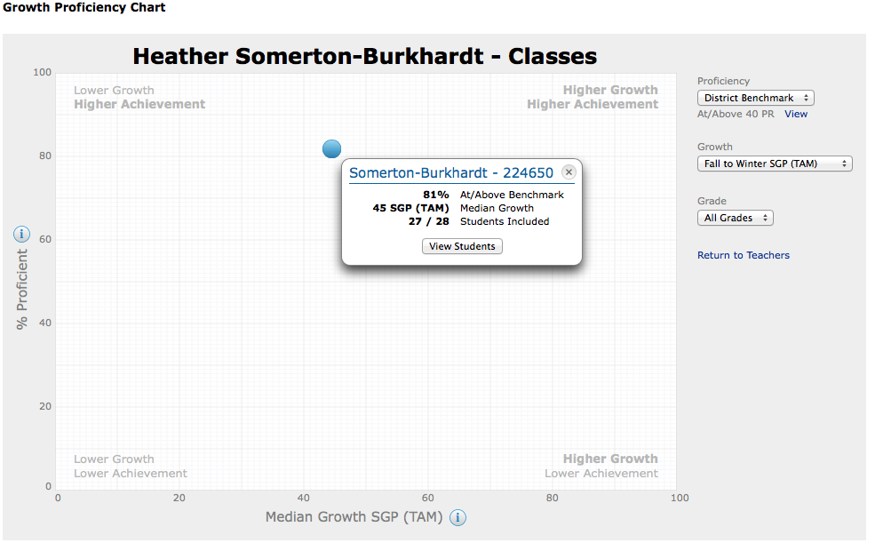

Table 2.0: STAR Reading Student Growth Progress, Upper Elementary
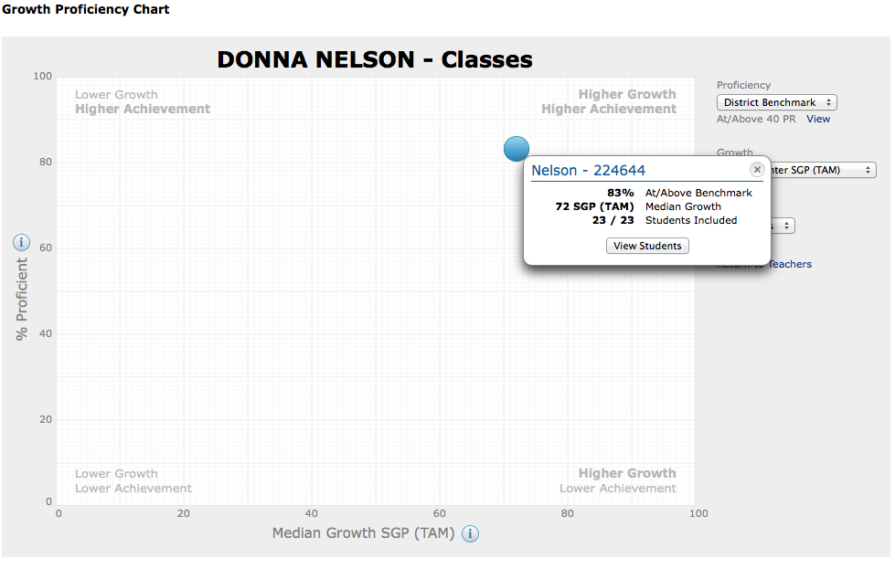

Tables 1.0 and 2.0 indicate that over 80% of the students are scoring proficient or above on Common Core Reading Standards according to the Renaissance Learning STAR Reading assessment. The expected student growth progress across the nation is between 40-60 SGP. The 1-3rd grade students are displaying median student growth (45 SGP) from the Fall to Winter progress, while the 4-6th grade students are above the expected student outcome (72 SGP). It is important to note that both cohorts of students are showing high growth and high achievement.

About STAR Math: The criterion referenced Renaissance Learning STAR Math is administered at the beginning of the year to serve as a baseline as well as quarterly to measure student learning on the CCSS in Mathematics. STAR Math is a nationally normed, computer adaptive test that informs the teacher on student mastery on each of the domains. The results are used to support intervention/enrichment. STAR Math is also used in conjunction with the Accelerated Math program as a supplemental program to support student learning at his/her ability in the upper elementary classroom.

Table 3.0: STAR Math Student Growth Progress, Lower Elementary
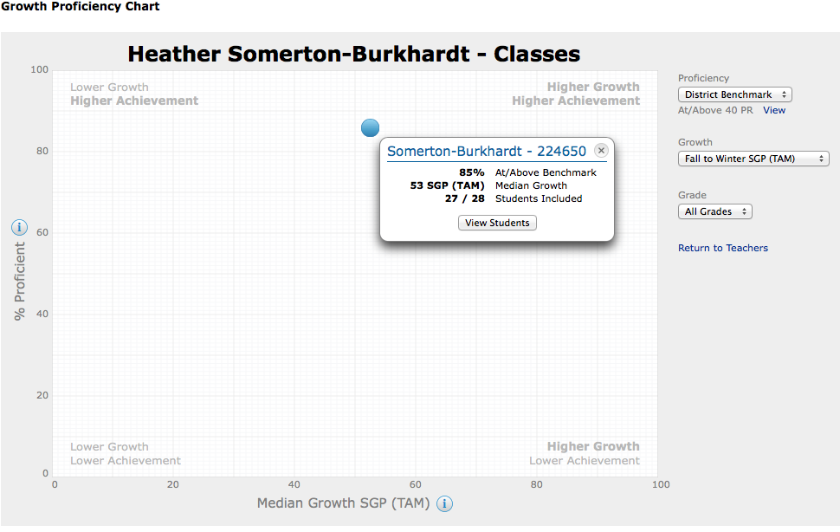

Table 4.0: STAR Math Student Growth Progress, Upper Elementary
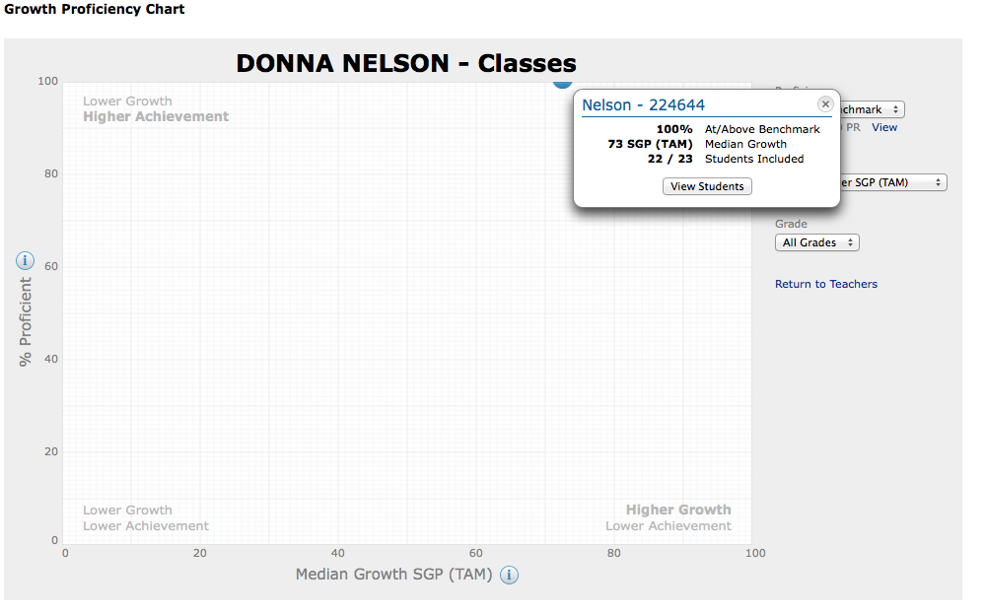

Tables 3.0 and 4.0 indicate that over 85% of the lower elementary students are scoring proficient or above on Common Core Mathematics Standards according to the Renaissance Learning STAR Math assessment, while 100% of the upper elementary students are scoring proficient or above. The expected student growth progress across the nation is between 40-60 SGP. The 1-3rd grade students are displaying median student growth (53 SGP) from the Fall to Winter progress, while the 4-6th grade students are above the expected student outcome (73 SGP). It is important to note that both cohorts of students are showing high growth and high achievement.
Extra-curricular Activities:
- Donna Nelson, the upper elementary teacher, volunteers her time to teach Saturday school from 1-4pm to students that need extra help in math.
- Both teachers’ supports students as needed in reading/math before and after school.
- The 4-6th grade students run the Adams student store (order items, price, sell items and figure out profits) on Wednesdays.
- Monthly poetry recital and family potluck, 1-3rd grade.
- Collaborated with the second grade teachers at Adams to raise $1000 for a family in need through an afterschool bake sale.
- Montessori students create a square at the I Madonnari festival, sponsored by the SB Rotary North.
- Two night camping trip to El Capitan in the fall to work on science objectives, 4-6th grade.
- Two night camping trip in the Spring to Santa Ynez to work on science objectives and review the American West in the 1800’s, 4-6th grade
Community Partnerships:
Santa Barbara Montessori School
Accomplishments/Successes:
- Nicola Parker received a $100 grant to purchase materials for the 3D printer. She is making objects to sell with the printer to raise money to help ResQcats.
- Montessori students have read over 1,575 AR books with 21,048,784 words this year so far. The average reading level of the 4th, 5th and 6th grade students is 6.3 with 92% accuracy on comprehension tests. The students have met the common core expectations with 45% of the reading being fiction books and 55% nonfiction.
- Every 4-6th grade Montessori student is currently at or above the benchmark in mathematics. Many students have made over 2 years growth this year. When tested in January the class average math growth from September was 1.7 years.
Future Development Goals:
- To continue to serve as a demonstration space to provide traditional classroom teachers with ideas and lesson plans for working with students in classes with multiple grade levels and for differentiating instruction across a wide range of ability levels and interests.
- To create a Transitional Kindergarten /Kindergarten (Primary classroom) Montessori classroom that will feed into the lower elementary classroom.

